6th Grade English
Reading Comprehension #1
Name: ____________

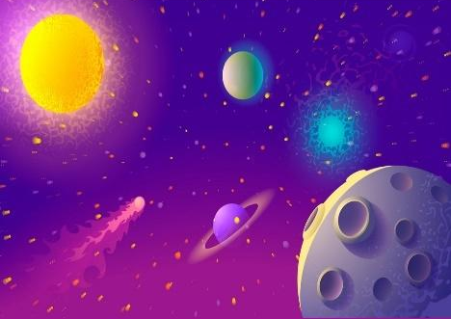
WHAT IS SPACE?

Space is an area. From our point of view, as Earthlings, it starts about 100 kilometres (60 miles) above our planet Earth. Up there, beyond our atmosphere, there is no air to breathe or to allow light to pass through.
In that area, blue becomes black because there are not enough oxygen molecules to make the sky blue. Furthermore, space is a vacuum. This means that sound cannot travel because molecules are not close enough together to transmit sound between them. That's not to say that space is empty, however. Gas, dust and other bits of matter float around "emptier" areas of the universe, while in more crowded regions there are planets, stars and galaxies. No one knows exactly how big space is. The difficulty arises because of what we can see through our telescopes and other devices. We measure long distances in space in "light years.’’
A light year represents the distance it takes for light to travel in a year and that is about 5.8 trillion miles, or 9.3 trillion kilometres. From light that is visible in our telescopes, we have charted galaxies reaching almost as far back as the Big Bang, which is thought to have started our universe 13.7 billion years ago.
This means we can "see" into space to a distance of almost 13.7 billion light-years. However, astronomers are not sure if our universe is the only universe that exists. There may be more universes! This means that space could be a lot bigger than it appears to us and certainly, bigger than we can imagine. And then, the big question: what comes after Space? More Space, I guess!

- Where does Space begin, from our point of view? ___________________________________________________________
- Who are ‘Earthlings’? ____________________________________________________________
- Why would humans not be able to breathe in Space? ____________________________________________________________
- Why does Space look black and not blue? _____________________________________________________________

- What is a vacuum? _____________________________________________________________

- What is there in the ‘emptier’ parts of Space? _____________________________________________________________

- What is there in more crowded areas of Space? _____________________________________________________________

- Which is the biggest: a planet, a star or a galaxy? _____________________________________________________________

- How big is Space?
_____________________________________________________________

10.How do we measure distance in Space?
_______________________________________________________________

11.When did the Big Bang happen? _______________________________________________________________

12.What are astronomers not sure about? _______________________________________________________________

13.What is the big question, according to this author?
_______________________________________________________________

If you had the chance to go up into Space, would you take it? Why or why not?
________________________________________________________________
________________________________________________________________
________________________________________________________________
________________________________________________________________
________________________________________________________________

