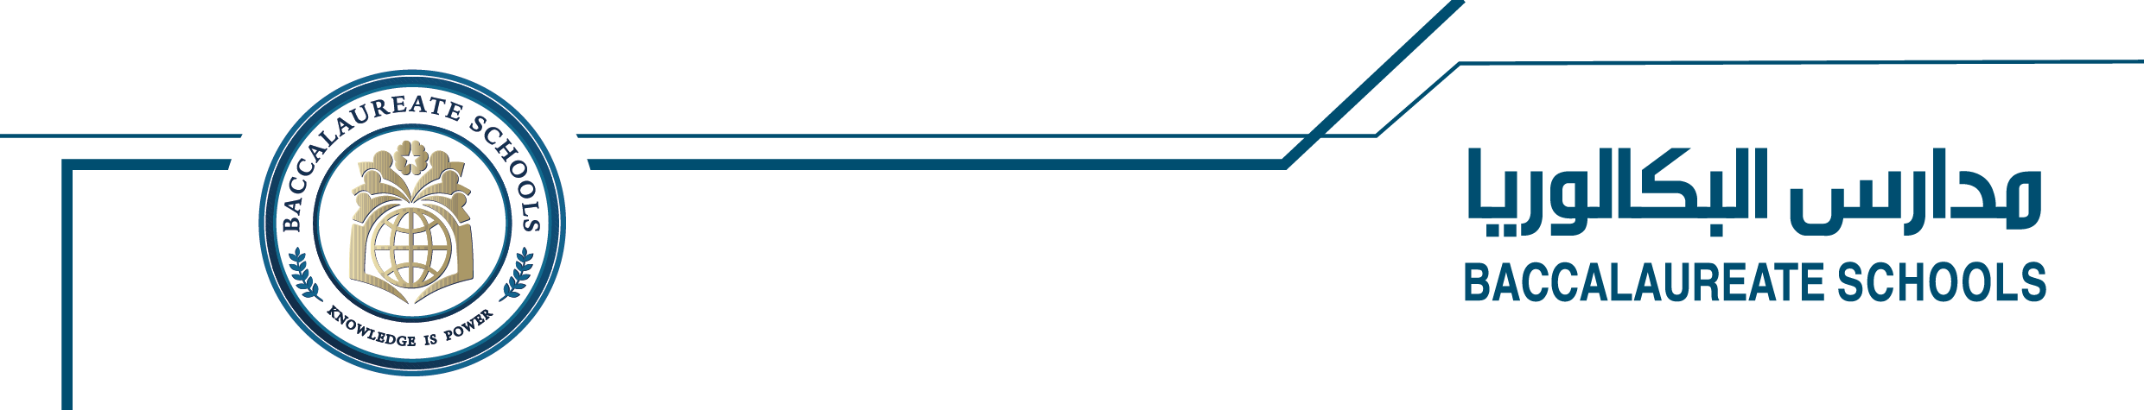
6th Grade English
Unit 1 Generation
The Declaration of the Rights of the Child
UN Goals Comic Strip

Directions:
1. Students will create an engaging comic strip based on the UN Goal topic they chose to present. You can either draw or use stickers to craft a quick story, similar to the example comic strip provided.

2. Each student has been given a blank comic strip template to work on.
