
7th Grade English
Urban Farming Presentation
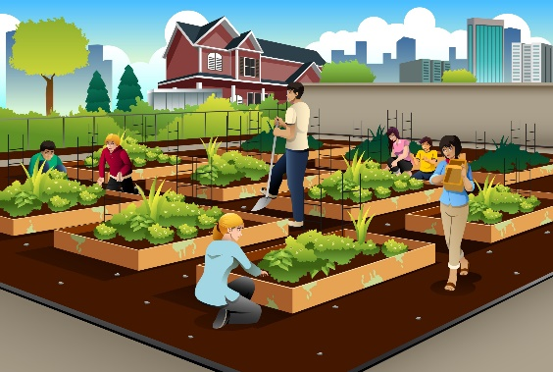
Presentation Instructions: Urban Farming
Goal:
You will create and present a short presentation that explains Urban Farming and why it is important in modern communities.

Presentation Requirements:
1. Introduction
Begin by including:
- A definition of urban farming
- Where it usually happens (ex: cities, rooftops, balconies, indoor spaces, etc.)
2. Key Information
Include at least three of the following:
- Why urban farming exists
- Types of urban farming (ex: hydroponics, vertical farming, rooftop gardens, aquaponics, etc.)
- How small-space farming works
- Environmental/community benefits
- Challenges or limitations
- Examples from real cities or countries

3. Real-Life Photos (Required!)
You must include 2–3 photos that you have taken of real farming.
Your photos can show farming:
- inside your home (ex: herbs, seedlings, hydroponics)
- in your yard
- on balconies or rooftops
- in your neighborhood
- at a local/community farm
- at a family farm

If you do not have farming at home:
You may take pictures anywhere plants are being grown nearby (ex: community gardens, greenhouses, school garden).

4. Conclusion
End your presentation with:
- a short summary of your key points
- one interesting fact, question, or recommendation

Presentation Format Options:
You may choose one of the following formats:
- Poster Board
- PowerPoint
- Canva Presentation

Speaking Expectations:
When presenting, you should:
- speak clearly
- make eye contact with the class
- not read directly from the slides or poster

Time Limit:
- 3 to 5 minutes per student

