Name:____________________________

THE NEWS TODAY
Vol.
19
Tuesday,
November 09,
2010
Latest News & Bulletin Updates

TheNewsToday.com
$3.25

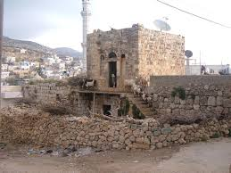
History of my Town and where I'm from <3!!

By Mirna Zaqief !
The history of Qarawat Bani Zied,

In 1945, the village of Qarawat Bani Zeid in the sub-district of Ramallah had a population of 500, all of whom were Palestinian. The population of Qarawat Bani Zeid was not displaced during 1947-1949. Nakba Today , Qarawat Bani Zeid falls within the West Bank, which has been subjected to Israeli military occupation since 1967.
By 2016, the population of Qarawat Bani Zeid has become 3,3730, all of whom were Palestinian.
Qarawat Bani Zeid is a Palestinian village in the Ramallah and Al-Bireh governorate, located 22 kilometres northwest of Ramallah in the Northern West Bank. According to the Palestinian Central Bureau of Statistics, Qarawat Bani Zeid had a population of 3,415 inhabitants in 2017
Qarawat Bani Zeid village was named after the tribe of Bani Zeid. The establishment of the village dates back to more than 500 years ago, and its residents are originally from Egypt and Yemen.
The health status,
There are a few healthcare facilities in Qarawat Bani Zeid village: a governmental physician clinic, a private dentist clinic, a health center run by a charitable society, and a private pharmacy. In case of the absence of required health services and in emergencies, residents of Qarawat Bani Zeid go to Salfit Governmental Hospital or Ramallah Governmental Hospital, 10km and 30 km from the village respectively .

Praesent vitae gravida ipsum. Quisque erat orci, suscipit nec ex vel, vulputate bibendum quam. Morbi orci lectus, gravida sit amet libero nec dictum.

Tradition that I do in my village
A happy moment in America during COVID-19

A happy moment for me was when COVID started and there was no school for weeks and I would be able to stay home and stay at my friends house . I had many sleep overs and I would always be eating without being bothered by doing homework, online classes are so much easier cause I can sleep and then just ask my friend what happened when I'm actaully awake not seven in the morning.! So if I could choose on thing to talk about it would be this <3
B
Things I do in my village is I go to this one house and alll my friends seat down and we play every year April 6 it one of the days where I have tons of fun playing with my cousins and more. My family in Qarawat Beni Zeid are into chopping of goat heads and sheep heads and eat them after but everytime I go to qarawat I always eat dweli.
I hardly go to my village so I have no clue what to talk about so I'm sorry !
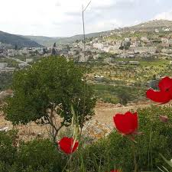

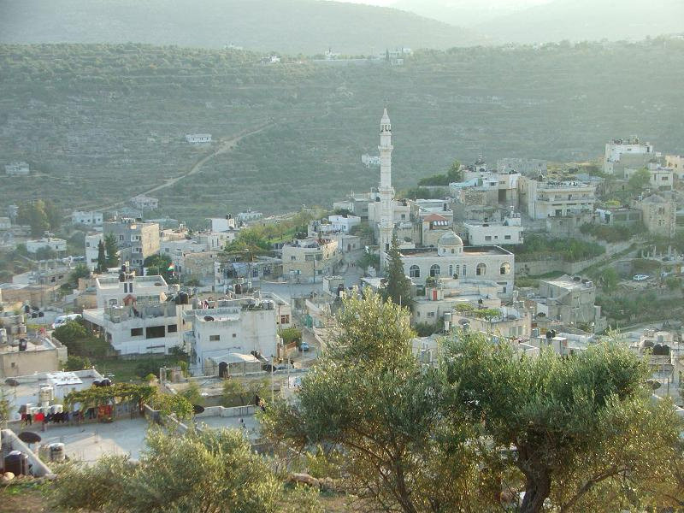

Made by: Mirna zaqief
Page 01

By Lorem Ipsum
Mauris placerat eleifend felis, egestas interdum velit finibus vel. Mauris varius velit nec nulla mollis suscipit. Nulla nec quam sit amet elit feugiat euismod pellentesque at elit. Sed sed tincidunt nibh, quis ullamcorper ex. In malesuada diam at enim sagittis condimentum. Phasellus urna eat, sodales luctus semper nec, tincidunt sed ante. In ornare lorem nec semper auctor. Donec neque quam, vulputate in odio in, scelerisque varius ipsum. Phasellus mi metus, eleifend vitae quam sed, maximus ullamcorper leo. Nam vitae dui nec felis consectetur viverra imperdiet id purus. Vivamus metus ante, vestibulum sed ultrices vestibulum, finibus eget ligula. Duis est mi, rhoncus eu. Nunc ut sem sagittis, fringilla nisi eget, efficitur elit. Vivamus porttitor lacus leo, quis lobortis tellus commodo sed. Nunc laoreet porta arcu sagittis maximus. Ut feugiat ornare augue. Duis cursus, nisi vitae volutpat hendrerit, enim velit varius velit, nec tempor dui justo quis elit proin aliquam ligula non In dictum non consect. Page 04


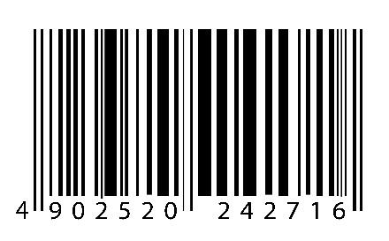
Curabitur vehicula ipsum ac urna venenatis fringilla. Mauris dapibus tincidunt leo.

Mauris Placerat Eleifend Felis egestas interdum velit finibus vel. Mauris varius velit nec nulla mollis suscipit. Nam vitae dui nec felis consectetur viverra imperdiet id purus. Page 04
Maecenas Placerat Purus
Nec mollis mauris placerat eleifend felis egestas risus sed vulputate odio ut enim blandit volutpat maecenas volupt commodo. Page 03
Weather Forecast
High 32⁰
Low 12⁰
Partly Sunny

