
Teacher: Jana Ali Force and Motion Worksheet Grade 3A
Name: Date:

Question1: Describe the relative motion of the plane related to the red car.
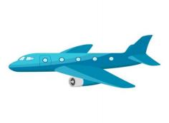



--------------------------------------------------------------------------------------------

Question 2: Look at the pictures. Choose the right force:
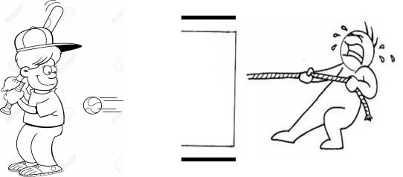
(Hit the baseball, close the door) (Bounce the ball, pull the rope)

Question3: Match each picture with its pattern:
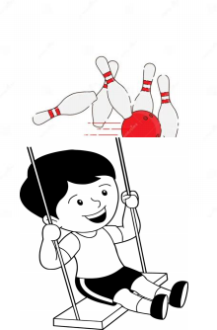

Bouncing

Swinging

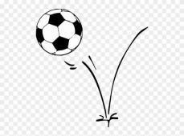
Rolling

Best Wishes

