
Third Grade
Topic 1:Lesson 1: Relate Multiplication and Addition.
Name:…………………………

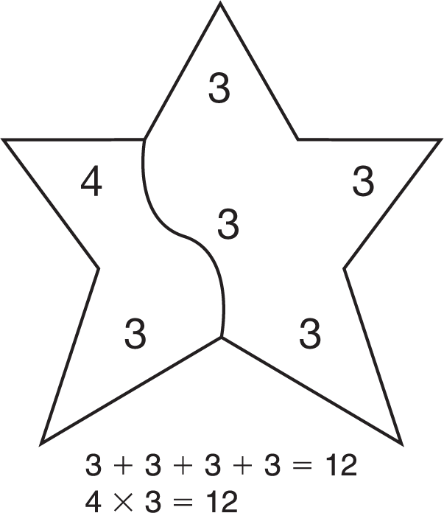
Separate the Shapes
Draw one line to separate the numbers. The sum of the numbers in one part must be equal to the product of the numbers in the other part. Then write an addition and a multiplication sentence to show the number
in each part. An example has been done
for you.

1.
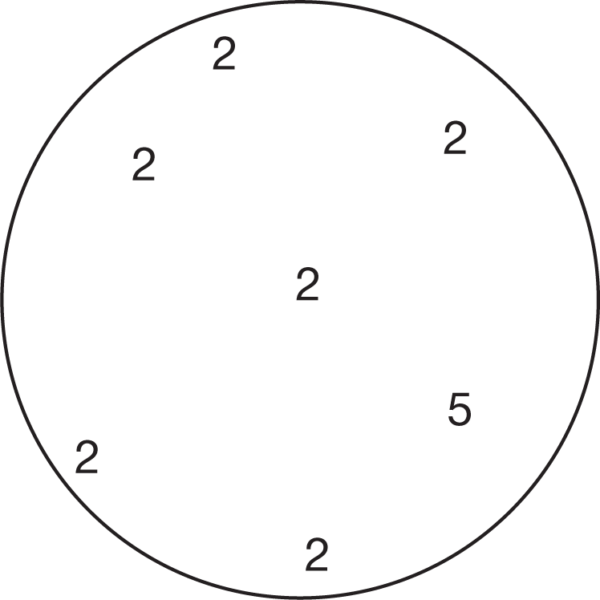

2.
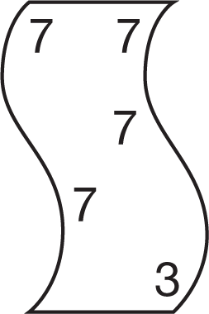

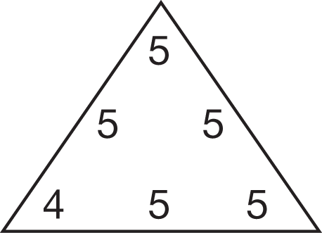
3.

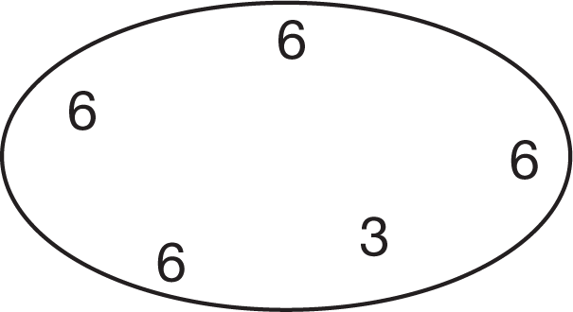
4.

