Name |  |  |  | Date
1-1: Numbers Through One Million Worksheet ( 4th Grade )
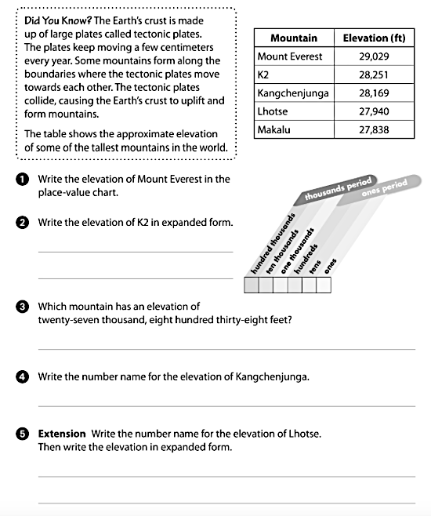

GOOD LUCK
Mr. Mohamad Mansour

