Name |  |  |  | Date

1-2: Place Value Relationships Worksheet ( 4th Grade )

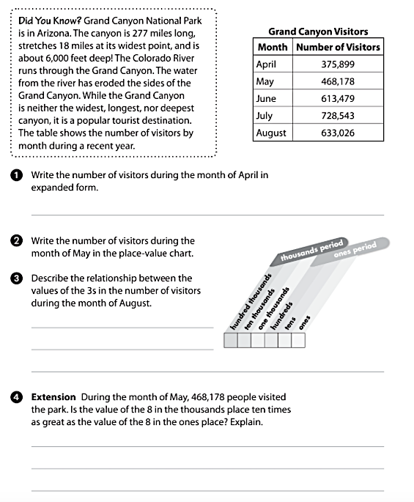

GOOD LUCK
Mr. Mohamad Mansour

