Name |  |  |  | Date

1-3: Compare Whole Numbers Worksheet ( 4th Grade )

1. The greater than symbol (>) is used to show the number to the left of the symbol has a greater value than the number to the right of the symbol.
Use the greater than symbol to compare 28 and 23. _____________
2. The less than symbol (<) is used to show the number to the left of the
symbol has a lesser value than the number to the right of the symbol.
Use the less than symbol to compare 28 and 23. _____________
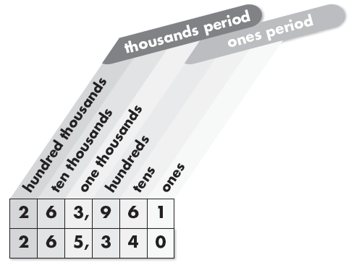
Use the place-value chart to compare 263,961 and 265,340. Begin comparing at the left.
3. What is the value of the 2 in both
numbers? the 6 in both numbers?
____________________________

4. Which is the first place value in both
numbers that has different digits?
____________________________

5. The number with the greater digit in the
____________________________ is the
greater number. Use the greater than
symbol to compare the numbers.

____________________________
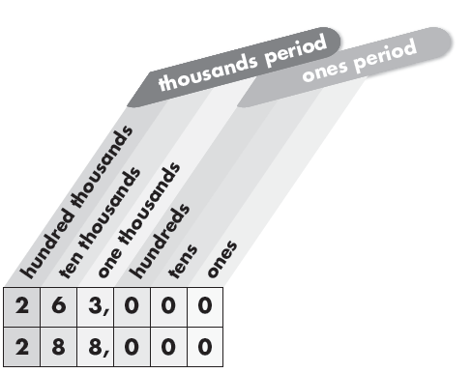
Use the place-value chart to answer the questions.
6. Which is the greater number?
____________________________
7. Which is the lesser number?
____________________________

8. Write three comparisons using the numbers below.
34,930 34,390 34,093

GOOD LUCK
Mr. Mohamad Mansour

