
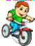
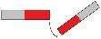
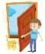

Third Grade
Topic 1:Lesson 3: Forces and Motion.
Name:…………………………

Contact or non-contact?


A contact force happens between things that are touching. An non- contact force can attract or repel things without touching them.

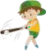

For each force, write contact or non-contact.

Gravity pulling you toward Earth
Hitting a ball with a bat
Static electricity pulling up your hair
Two magnets repelling each other
Pedaling a bicycle
Pulling a door open

If you blow on balloons and they move, is that a contact or non-contact force?

