

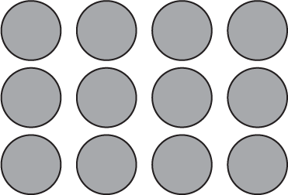

1. The Commutative (Order) Property of Multiplication states that numbers can be multiplied in any order and the product is the same.
Third Grade
Topic 1:Lesson 3: Arrays and Properties
Name:…………………………

Vocabulary
Write the multiplication equation represented by each array.
Array A
Array B
Array A:
Array B:

2. Look at the top array of muffins.
Complete the sentences.
The muffins are in rows.
There are muffins in each row.
3. Complete the addition and multiplication equations to find the total number of muffins in the top array.
3 + + + + =
5 × =
4. Look at the bottom array of muffins.
Complete the sentences.

The muffins are in rows.
There are muffins in each row.
5. Complete the addition and multiplication equations to find the total number of muffins in the bottom array.
5 + + =
3 × =
On the Back!
6. Draw an array to show 7 × 4 and an array to show 4 × 7. Write an addition equation and a multiplication equation to find the total number of objects in each array.

