
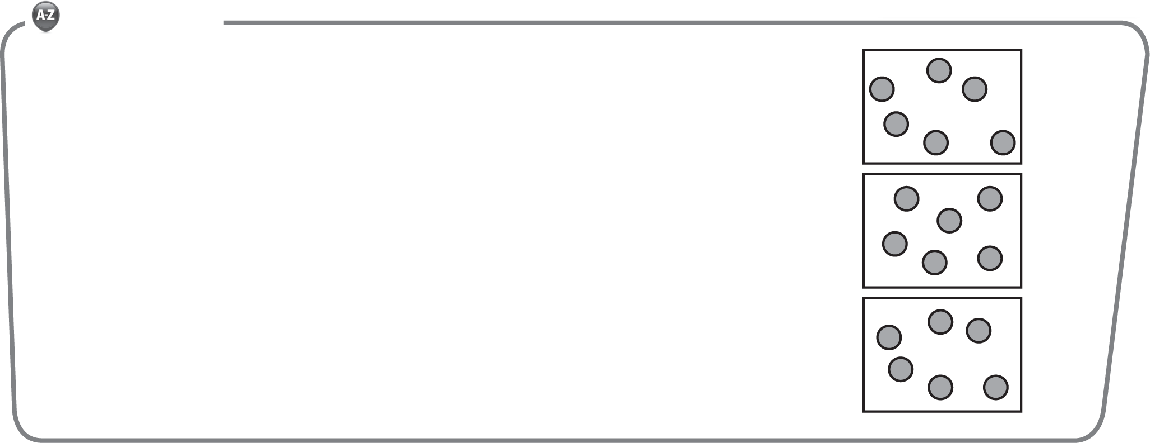
1. Division is an operation that tells how many equal groups there are or how many are in each group.
Third Grade
Topic 1:Lesson 4: Division: How Many in Each Group?
Name:…………………………

Vocabulary
There are 18 counters. They have been put into 3 equal groups. How many counters are in each group?
The counters have been put into equal groups.
There are counters in each group.
So, 18 ÷ 3 = .
2. There are 24 medals to give to 4 teams. Each team receives the same number of medals. How many medals does each team receive?
Use the bar diagram to solve.
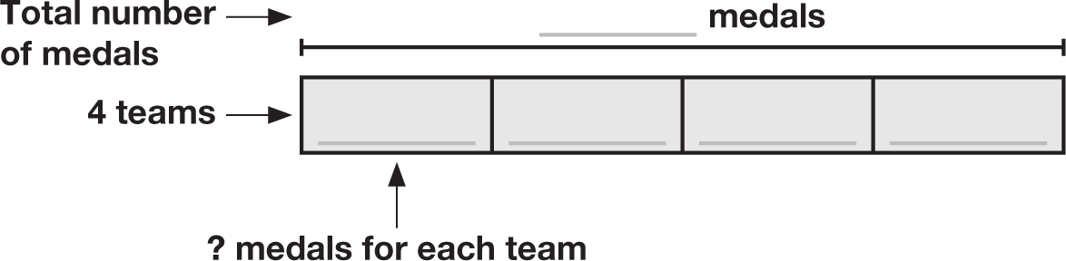
So, 24 ÷ 4 = .

On the Back!
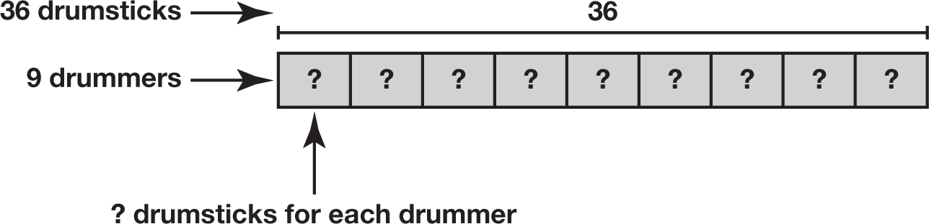
3. Mrs. Schultz has 36 drumsticks to give to 9 drummers. Each drummer will receive the same number of drumsticks. How many drumsticks will each drummer receive? Use the bar diagram to solve.

