Name___________________________ Study Guide Date____________________________ Grade 7
Please do not only study from the study guide, use your books and worksheet as well.
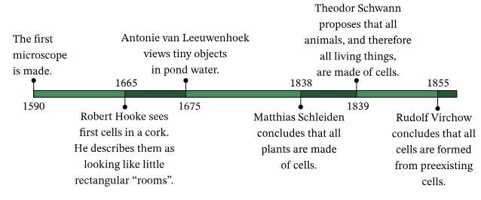
I. Cell Basics
A. What is a cell?
- Cells are the fundamental units of life.
- All living organisms are made up of one or more cells.
B. Types of cells
- Prokaryotic cells (e.g., bacteria)
- Eukaryotic cells (e.g., plant and animal cells)
C. Biological functions of cells
- Get rid of waste
- Bring in water and nutrients
- Obtain energy
II. Cell Structure
A. Cell Membrane
- Functions: Protection, control of what enters and exits the cell.
- Structure: Phospholipid bilayer.

B. Cytoplasm
- Function: Gel-like substance that holds organelles.
- Structure: Semi-fluid, contains water and various molecules.
C. Nucleus
- Function: Control center of the cell, houses DNA.
- Structure: Double membrane with a nuclear envelope.
A. Endoplasmic Reticulum (ER)
- Rough ER vs. Smooth ER
- Functions: Protein synthesis, lipid metabolism.
B. Golgi Apparatus
- Function: Modifies, sorts, and packages proteins for transport.
- Structure: Stacks of flattened sacs.

C. Mitochondria
- Function: Powerhouse of the cell; produces ATP.
- Structure: Double membrane with inner folds
D. Chloroplasts (in plant cells)
- Function: Site of photosynthesis, converts sunlight to energy.
- Structure: Contains green pigment (chlorophyll).
E. Vacuoles
- Function: Storage of water, nutrients, and waste.
- Structure: Membrane-bound sacs.
F. Lysosomes
- Function: Contain enzymes for breaking down waste materials.
- Structure: Membrane-bound sacs containing digestive enzymes.
G. Ribosomes
- Function: Site of protein synthesis.
- Structure: Small particles made of RNA and proteins.

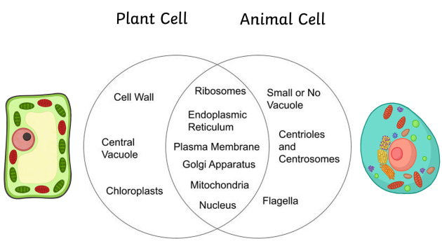
IV. What is Cell Theory?
Cell theory is a fundamental concept in biology that explains the properties of living organisms.
Cell Theory:
  - Living things are made of cells.
  - Cells are the smallest things that can be alive.
  - New cells come from existing cells.
V. Introduction to Microscopes
What is a microscope?
- A microscope is a scientific tool used to magnify and see tiny objects that are not visible to the naked eye.
Why are microscopes important?
Microscopes help scientists and researchers study small details in various fields like biology, chemistry, and materials science

Types of Microscopes
A. Light Microscope
- Uses visible light to magnify objects.
- Suitable for viewing living cells, tissues, and larger structures.
B. Electron Microscope
- Uses a beam of electrons to magnify objects.
- Provides extremely high magnification for very small structures, like viruses and nanoparticles.
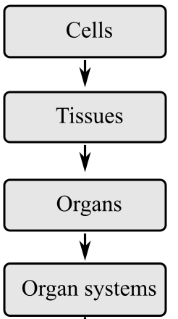
Levels of organization in living organisms from least complex (cells) to most complex (organ system)

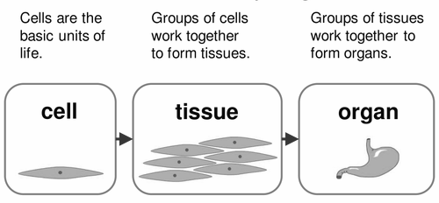

Passive transport is a way that small molecules or ions move across the cell membrane without input of energy by the cell. The three main kinds of passive transport are diffusion (or simple diffusion), osmosis, and facilitated diffusion. Simple diffusion and osmosis do not involve transport proteins. Facilitated diffusion requires the assistance of proteins.

Diffusion is the movement of molecules from an area of high concentration of the molecules to an area with a lower concentration. For cell transport, diffusion is the movement of small molecules across the cell membrane. The difference in the concentrations of the molecules in the two areas is called the concentration gradient.
Osmosis is the movement of water molecules from a solution with a high concentration of water molecules to a solution with a lower concentration of water molecules, through a cell's partially permeable membrane.
Facilitated diffusion is a type of transport that uses specialized proteins, such as channel proteins and carrier proteins, to help molecules move across a cell membrane. In this process, molecules can move down their concentration gradient without requiring any energy input from the cell.

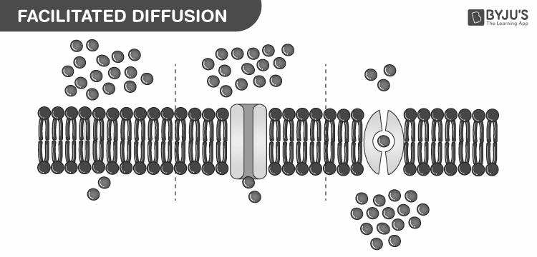

Active Transport is defined as a process that involves the movement of molecules from a region of lower concentration to a region of higher concentration against a gradient or an obstacle with the use of external energy.

