

Name_________________________ Date___________________

9th
Midterm Study Guide
First Semester

American History- Judith Cofer
- Conflict
- Conflict is a struggle between a character and an opposing force. Characters may find themselves in an external conflict, or a conflict with the outside world, such as a battle, a force of nature, or other challenging circumstance.
- In an internal conflict, a character struggles with his or her beliefs, desires, or values. The resolution of the story occurs when the character is released from the tension presented by the conflict. Just because a conflict is resolved, it doesn’t mean that the story ends favorably for the character.
Conflicts in American History
- Elena vs. herself (internal)
- Elena vs. Eugene’s mother (external)
- Elena vs. school girls (internal)
2. General Summary
American History by Judith Cofer is a short story that explores themes of identity, culture, and how historical events impact personal lives. It follows a young Puerto Rican girl who feels out of place in her mostly white school.
As she navigates her experiences with classmates and family, the story highlights the differences between her cultural background and mainstream American society. The backdrop of President John F. Kennedy's assassination adds to her feelings of alienation.
Through rich imagery and emotion, Cofer addresses issues like racism and belonging, showing how historical events affect individuals. The story emphasizes the importance of understanding one’s identity amid societal challenges.
3. Themes:
The themes in American History by Judith Cofer include:
- Identity and Cultural Conflict: The story explores the struggle between the protagonist's Puerto Rican heritage and the dominant American culture, highlighting issues of belonging and self-acceptance.
- Alienation and Isolation: The protagonist feels disconnected from her classmates and community, illustrating the impact of cultural differences and societal expectations.
- Racism and Prejudice: The story addresses the discrimination the protagonist faces, revealing how racial and cultural biases shape her experiences.
- Family and Support: The importance of family is emphasized as the protagonist navigates her feelings of alienation and seeks comfort in her family’s understanding of her identity.
- Historical Context: The backdrop of Kennedy's assassination serves to connect personal experiences with broader historical events, showing how history influences individual lives.
Vocabulary
1- Anticipated: Expected or looked forward to; predicted or awaited with excitement.
2- Devoted: Committed or dedicated to a person, cause, or activity; showing strong loyalty or love.
3- Enthralled: Captivated or fascinated; held spellbound by something interesting or beautiful.
4- Elation: A feeling of great happiness or joy; a state of high spirits.
5- Infatuated: Possessed by an intense but short-lived passion or admiration for someone or something; often involves overwhelming attraction.
6- Impulse: A sudden strong urge or desire to act; a spontaneous reaction that may not be based on careful thought.

The Moral Logic of Survivor Guilt- Nancy Sherman
- Claims and Supporting Details
-To fully understand an editorial, you must analyze its claim or central idea and supporting details. To do this, note each main point the writer makes.
- Then, identify the specific details that explain or illustrate the main point. To help in your analysis of the text, ask questions as you read. For example, it can be helpful to identify the topic of the text, the central point of the text, and the details that support the central point of the text.

- Main idea:
- Survivor guilt arises from the psychological and moral dilemmas faced by individuals who survive traumatic events, highlighting the complexities of grief, responsibility, and the societal expectations that shape how survivors process their emotions and experiences.
- Sherman attempts to rationalize the concept of Survivor Guilt and make it logical.
- Survivor guilt, according to Sherman, is an indication of morality and ethics. It is an indication that one is a good person.

- Supporting details:
- Personal Narratives: She shares stories of individuals who have experienced survivor guilt, illustrating the emotional turmoil and psychological impact of surviving traumatic events.
Two main examples are the cases of Captain Bonenberger and Pulaski and Captain Prior and Private Joseph Mayek. (Refer back to the text to read them)
- The author discusses research and theories related to trauma and guilt, explaining how these emotions manifest in survivors and affect their mental health.

Types of Guilt:
- Subjective Guilt: The personal feelings of guilt an individual experiences based on their own beliefs, emotions, and conscience, regardless of whether their actions are deemed wrong by others. Usually not as a result of actions.
- Objective Guilt: Guilt that is based on the actual violation of a law, rule, or moral standard, regardless of the individual's feelings about their actions; it focuses on the external reality of wrongdoing.

- Agent Regret: The remorse or regret that an individual feels about their actions, particularly when they reflect on the consequences of their choices and wish they had acted differently. This can involve recognizing one's role in causing harm or negative outcome
Vocabulary:
- Burden: A heavy load or responsibility that causes stress or worry; something that weighs down emotionally or mentally.

- Conscience: The inner sense of right and wrong that guides a person's thoughts and actions; an awareness of moral or ethical considerations.

- Remorse: A deep feeling of regret or guilt for a wrong committed; a strong emotional response to one's actions that causes distress.

- Culpability: The degree of responsibility or blame for wrongdoing; the state of being guilty or deserving punishment.

- Entrusted: Given responsibility or confidence to manage or take care of something; placed in someone’s care or trust.

- Empathetic: Showing an ability to understand and share the feelings of another person; being sensitive to the emotions and experiences of others.

- Clauses vs. Phrases

Clauses:

A clause is also a part of a sentence that consists of a subject and a verb, unlike phrases. They can be divided into two main types depending on how they behave in a sentence.

There are two types of clauses:
- Dependent clause
- Independent clause
Here are the definitions:

- Dependent Clause: A group of words that contains a subject and a verb but cannot stand alone as a complete sentence. It often starts with a subordinating conjunction (like "because," "although," or "if") and relies on an independent clause to provide context.
For example: "Although it was raining."

- Independent Clause: A group of words that contains a subject and a verb and can stand alone as a complete sentence. It expresses a complete thought.
For example: "I took an umbrella."

Phrases:

A phrase is a part of a sentence which consists of a group of words that give more information about the subject, action or event in a sentence. A phrase cannot stand on its own and will not convey meaning if separated from the sentence.

- Anu and Teena ( phrase)
- Have been searching (phrase)
- Beside the trees (phrase)
- Extremely well (phrase)
- The house on 6th street ( phrase)
- As soon as I reach the office (dependent or subordinate clause)
- I did not bring my umbrella. (independent clause)
- When the little boy saw his mom (dependent or subordinate clause)
- Collect your parcel from the courier office. (independent clause)
- Though we left home early (dependent or subordinate clause)

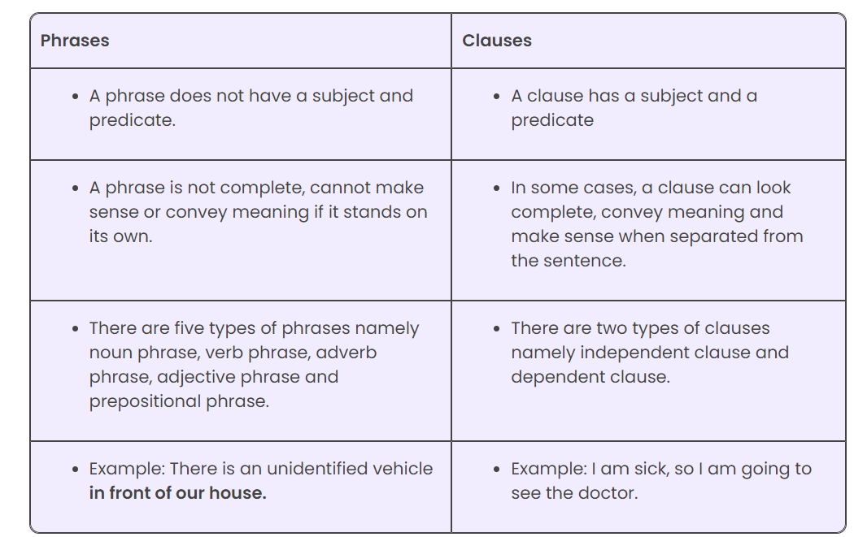

B. Sentence Structures:

- A simple sentence is one independent clause—a group of words that has a subject and a verb and can stand by itself as a complete thought.
Example: The dog chased the ball.
A simple sentence may have a compound subject or a compound verb or both.
- A compound sentence consists of two or more independent clauses linked by a word such as and, if, but, so, or or.
Example: Mr. Roberts was a teacher, but he also coached soccer.
- A complex sentence contains one independent clause and one or more dependent or subordinate clauses—a group of words that has a subject and a verb but is not a complete thought.
Example: Although he was a science teacher, Mr. Roberts also taught math.
- A compound-complex sentence has two or more independent clauses and one or more subordinate clauses.
Example: I can reach my father on the phone, or I will go to his office if I have enough time.

