Grade 8 Mathematics - Solving Equations and Inequalities

Unit 1: Solving Equations and Inequalities

Lesson 1: Solving Linear Equations
Linear equations are equations of the form ax + b = 0, where a and b are constants, and x is the variable. To solve a linear equation, isolate the variable using inverse operations.
Example 1: Solve 2x + 3 = 7.
Solution: Subtract 3 from both sides: 2x = 4. Then divide by 2: x = 2.
Example 2: Solve (3/4)x - 5 = 1.
Solution:
Add 5 to both sides:
(3/4)x = 6.
Multiply both sides by 4/3:
x = 8.
Example 3: Solve 3x - 2 = 4x + 1.
Solution:
Subtract 3x from both sides:
-2 = x + 1.
Subtract 1 from both sides:
x = -3.
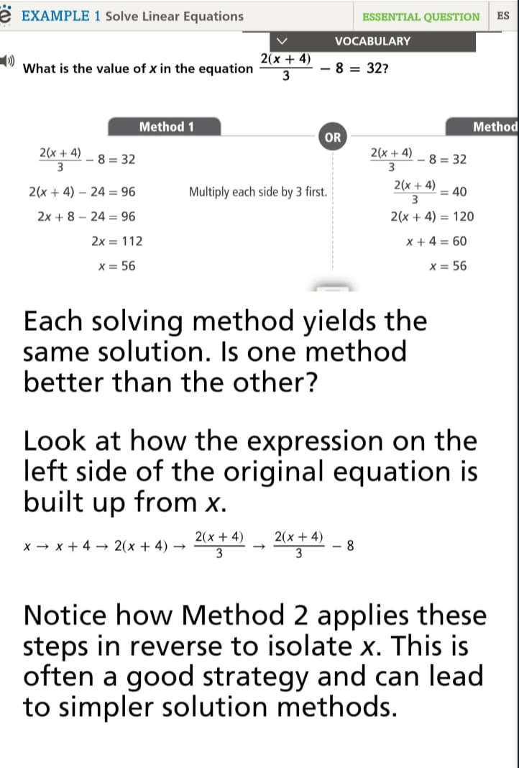

Lesson 2: Solving Equations with Variables on Both Sides
When solving equations with variables on both sides, you need to collect all variable terms on one side and constants on the other side.
Example 1: Solve 2x + 5 = 4x - 3.
Solution: Subtract 2x from both sides:
5 = 2x - 3.
Add 3 to both sides:
8 = 2x. Divide by 2:
x = 4.
Example 2: Solve (1/2)x + 3 = (3/4)x - 2.
Solution:
Multiply both sides by 4 to eliminate fractions, then solve for x.
Example 3: Solve 5x + 7 = 3x + 13.
Solution: Subtract 3x from both sides, then solve for x.
"For more examples, please refer to the book examples on Savvas."

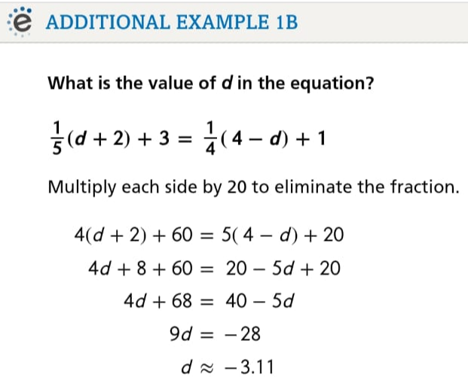

Lesson 3: Literal Equations and Formulas
Literal equations involve multiple variables, and you solve for one variable in terms of the others. These are often formulas used in real-world applications.
Example 1: Solve for y in the equation 3x + 2y = 12.
Solution:
Subtract 3x from both sides, then divide by 2:
y = (12 - 3x)/2.
Example 2: Solve A = lw for l.
Solution: Divide both sides by w:
l = A/w.
Example 3: Solve d = rt for t.
Solution: Divide both sides by r: t = d/r.

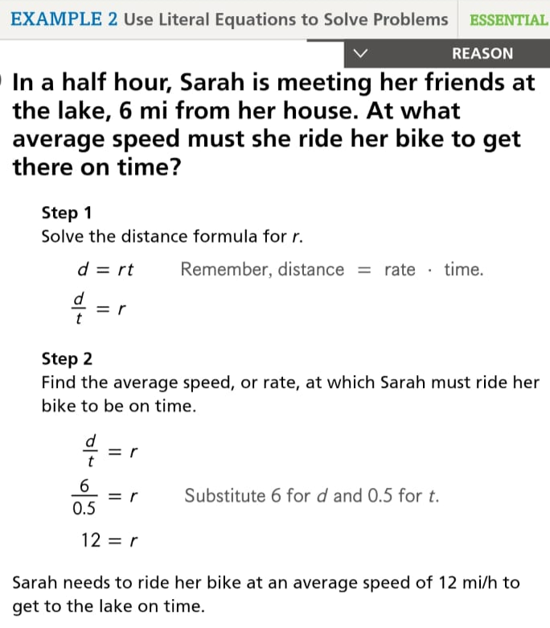
"For more examples, please refer to the book examples on Savvas."

Lesson 4: Solving Inequalities in One Variable
Solving inequalities is similar to solving equations, but you must reverse the inequality sign when multiplying or dividing by a negative number.
Example 1: Solve 2x - 3 > 7.
Solution: Add 3 to both sides: 2x > 10. Divide by 2: x > 5.
Example 2: Solve -4x ≤ 12.
Solution: Divide both sides by -4 and reverse the inequality sign: x ≥ -3.
Example 3: Solve and graph x - 2 < 4. Solution: x < 6, so the solution is all values of x less than 6.
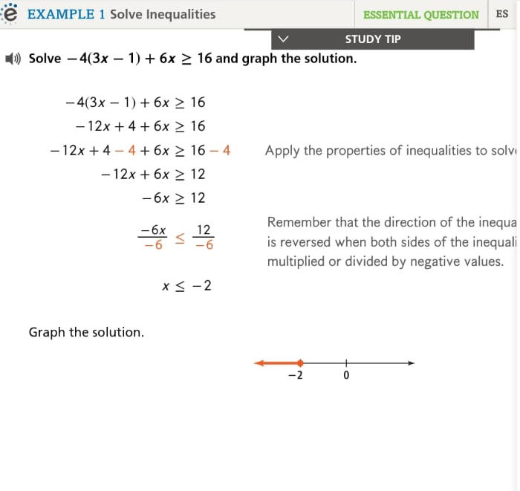
"For more examples, please refer to the book examples on Savvas."

Lesson 5: Compound Inequalities
Compound inequalities involve two inequalities joined by 'and' or 'or'. You solve each inequality separately and then find the intersection (for 'and') or union (for 'or').
Example 1: Solve 1 < x + 2 ≤ 5.
Solution: Subtract 2 from each part: -1 < x ≤ 3.
Example 2: Solve x - 1 < -2 or x + 3 > 7.
Solution: x < -1 or x > 4. The solution is all x less than -1 or greater than 4.
Example 3: Solve and graph -3 ≤ x < 2. Solution: The solution is all values of x between -3 and 2, including -3 but not 2.
"For more examples, please refer to the book examples on Savvas."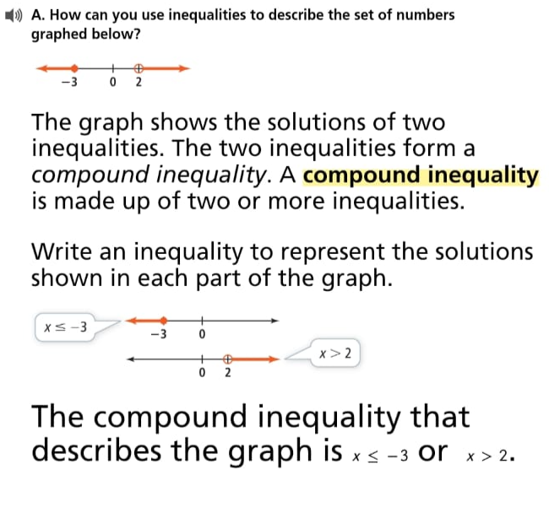

Lesson 6: Absolute Value Equations and Inequalities
Absolute value equations involve solving for the variable inside the absolute value. For inequalities, you consider both the positive and negative cases.
Example 1: Solve |x - 3| = 7.
Solution: Set up two cases: x - 3 = 7 and x - 3 = -7. Solve both: x = 10 or x = -4.
Example 2: Solve |2x + 1| < 5.
Solution: Set up two inequalities: -5 < 2x + 1 < 5. Subtract 1 from each part: -6 < 2x < 4. Divide by 2: -3 < x < 2.
Example 3: Solve and graph |x - 2| ≤ 4. Solution: -4 ≤ x - 2 ≤ 4, so -2 ≤ x ≤ 6.
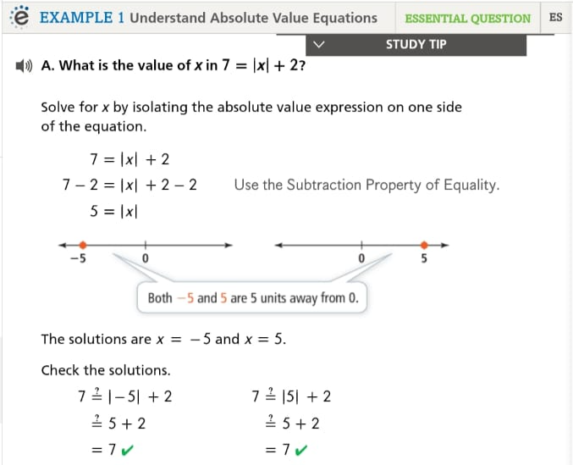
"For more examples, please refer to the book examples on Savvas."

