Grade 9 Mathematic summary

Unit 1: Exponents and Roots

Lesson 1: Operations on Real Numbers
Real numbers include rational and irrational numbers. Operations on real numbers include addition, subtraction, multiplication, a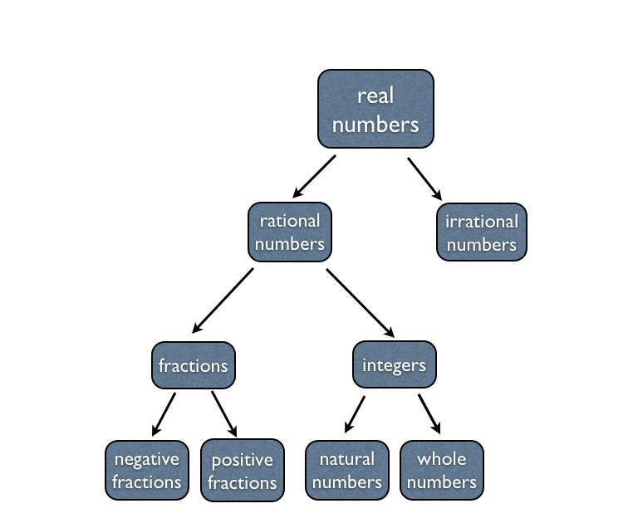
nd division. These follow key properties:
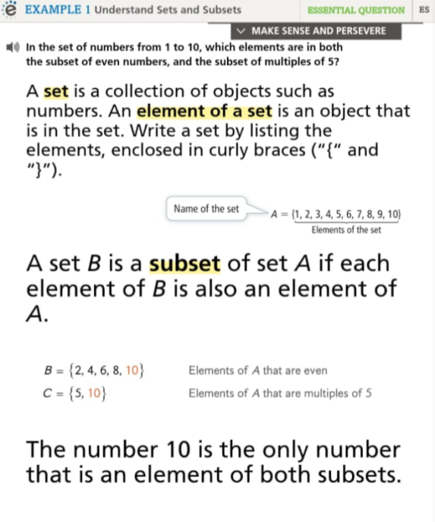

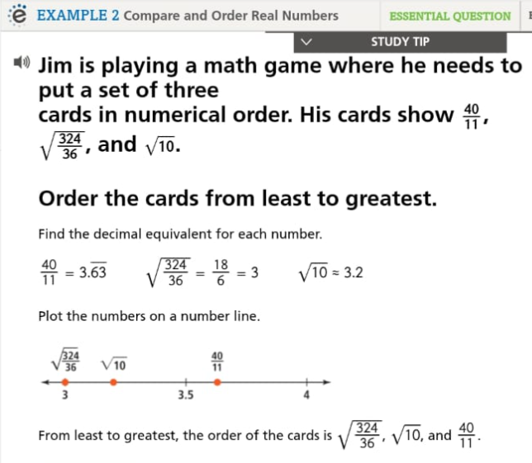
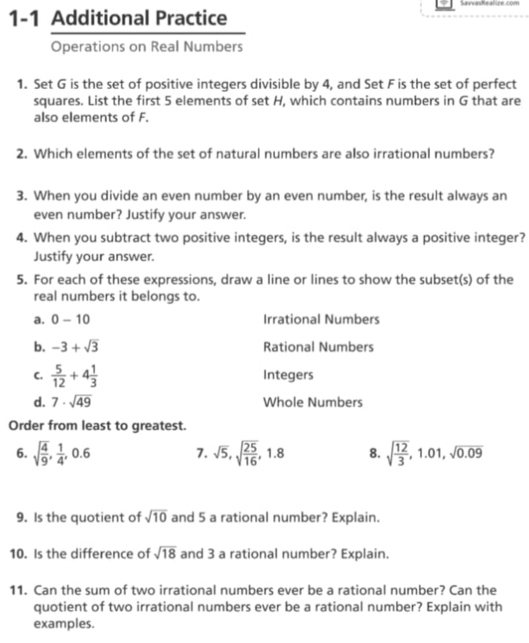

Lesson 2: Rational Exponents and Properties of Exponents
Rational exponents are a way to express roots and powers. Important properties of exponents include the product of powers, quotient of powers, and power of a power.
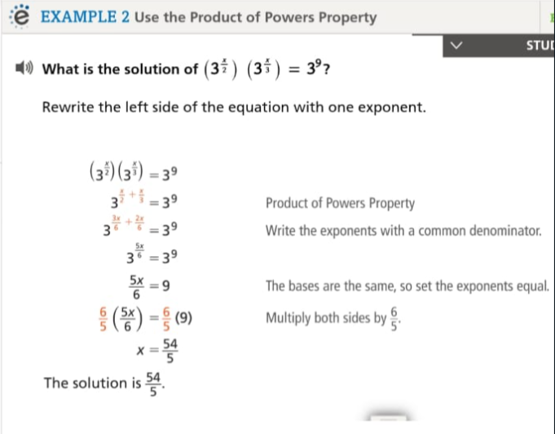

Lesson 3: The Square Root Function
The square root function is denoted as f(x) = √x. It is the inverse of the squaring function. The domain is [0, ∞), as the square root of negative numbers is not defined in real numbers.

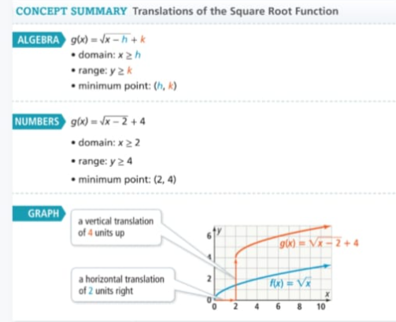

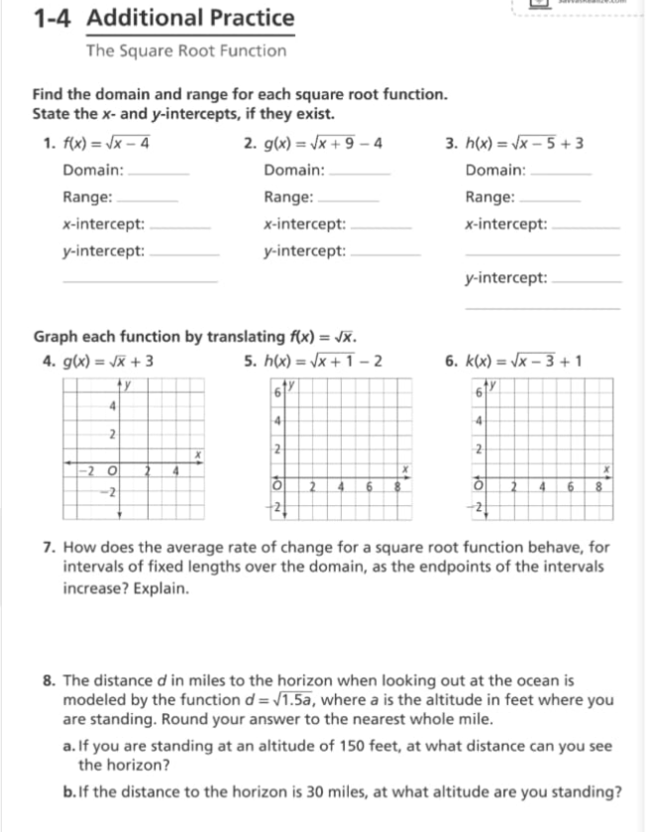

Lesson 4: The Cube Root Function
The cube root function is denoted as f(x) = ∛x. It is the inverse of cubing a number. Unlike the square root, the cube root is defined for both positive and negative numbers.

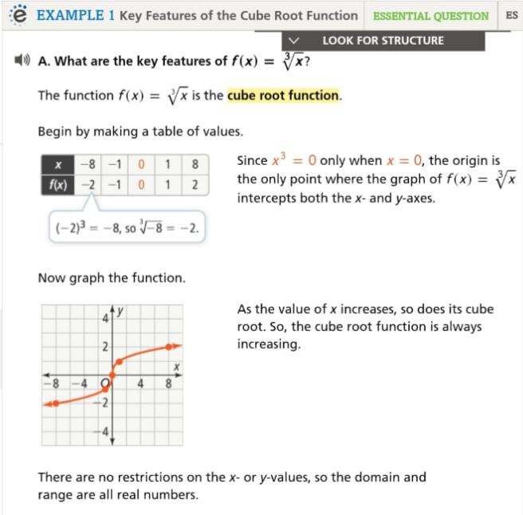

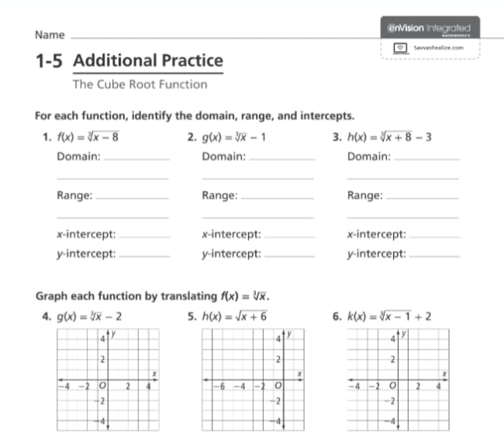

Unit 2: Polynomials and Factoring

Lesson 1: Adding and Subtracting Polynomials
Polynomials are expressions that consist of terms involving variables raised to powers. When adding or subtracting polynomials, combine like terms (terms with the same variables raised to the same powers).

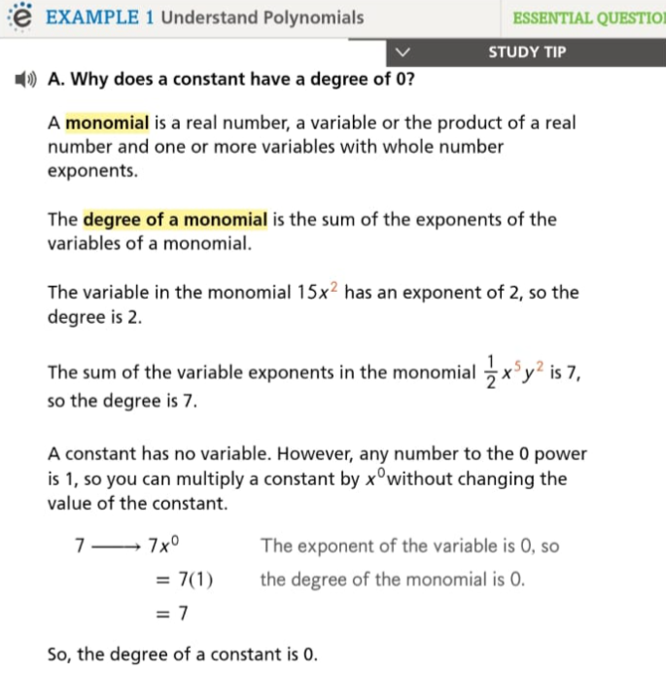
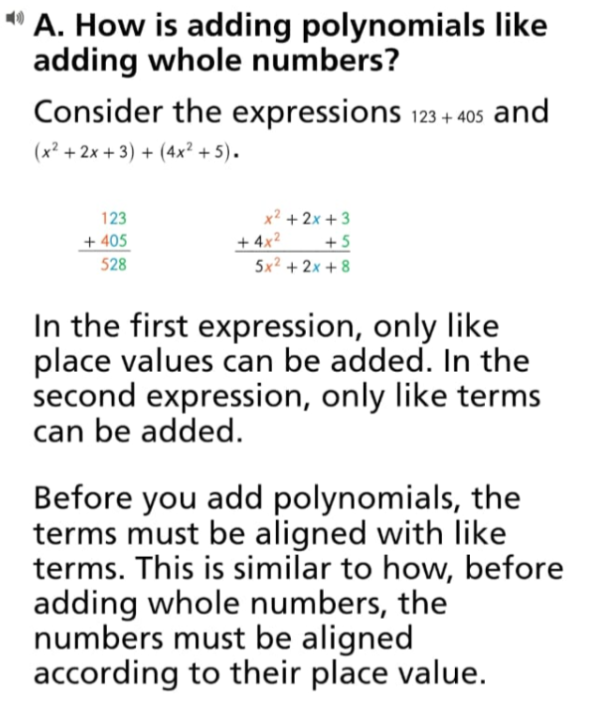

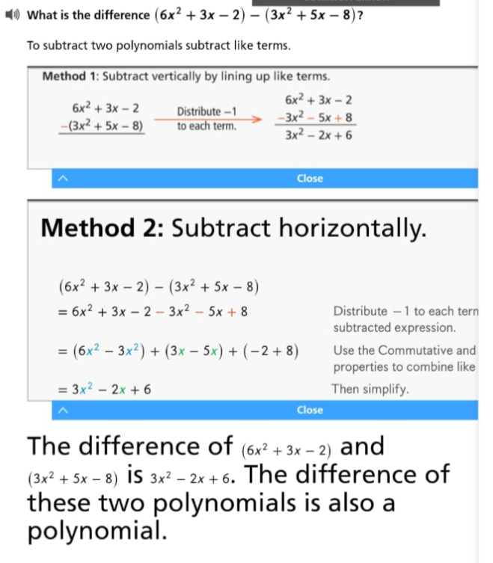

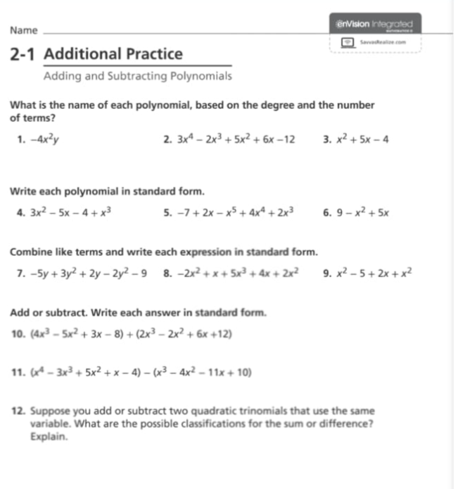
.

Lesson 2: Multiplying Polynomials
When multiplying polynomials, use the distributive property or the FOIL method (for binomials). Multiply each term in one polynomial by every term in the other polynomial, then combine like terms.
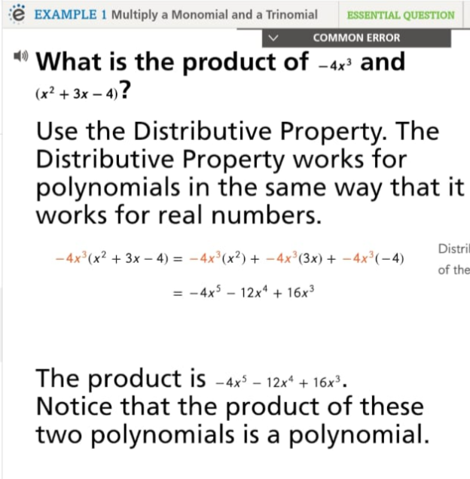

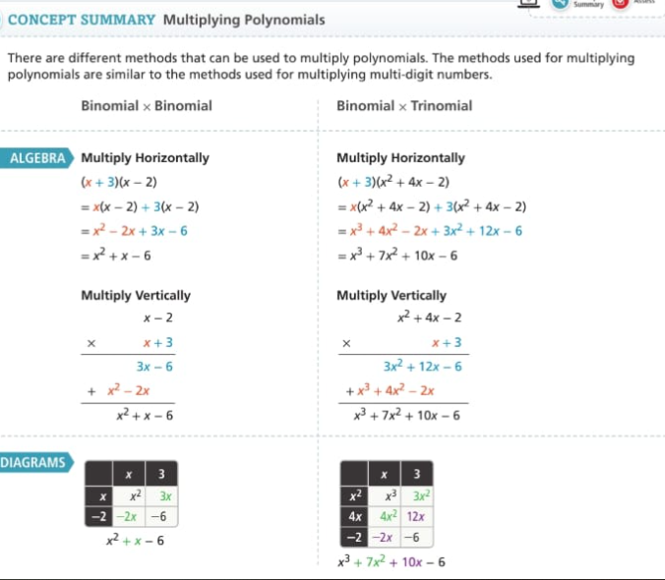
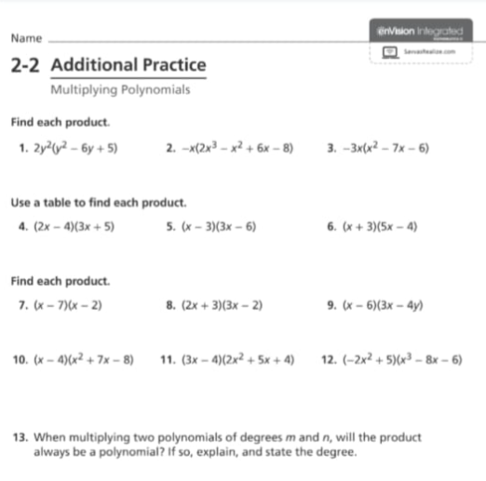
For more examples and excurses , please refer to the book on Savvas.
Good luck

