
8th Grade English
Unit 1 Literature
Mid Term Study Sheet

Literature
1. The Medicine Bag
Genre: Short Story
Read lesson from PDF handout, will be assigned on Savvas.
(Comprehension Check Questions)

BACKGROUND
The Lakota Indians are part of the Sioux Nation, an indigenous people of the Great Plains region of
North America. Today there are about 170,000 Sioux Indians living in the United States. About one-
fifth of the American Indian population live on reservations, which are designated pieces of land ruled
by tribal law.

- Analyze the Text
1. Evaluate - Do you think Grandpa made the right decision to travel and visit his family?
2. Interpret - Summarize the story Grandpa tells about his father
3. Draw Conclusions - What happens to Grandpa and to Martin at the end of the story?
4. Essential Question: What are some milestones on the path to growing up?

- Analyze Craft and Structure
Figurative Meaning: Symbolism A symbol is anything that stands for or represents something else.
Symbolism is the use of symbols.
• Symbols are common in everyday life as well as in literature. For example, a dove with an olive branch in its beak is a symbol of peace.
• In literature, symbolism can highlight certain ideas the author wishes to emphasize.
• Symbolism can also add levels of meaning to a text.
Most Native American cultures show deep respect for nature, and the natural world is considered to
have profound spiritual qualities. Symbols of nature play an important role in Native American
traditions, especially religious ones. In “The Medicine Bag,” the medicine bag is an important symbol.
Think about other symbols connected with Grandpa in the story.

Practice

1. (a) What details in the story suggest that the medicine bag is a symbol and is important to Grandpa?
(b) Why do you think the author wants readers to understand Grandpa’s connection to the medicine bag?

Answer (a) Grandpa wears the medicine bag on his neck. He never opens it. Before Grandpa had it, his
father had it, and it has been passed down among the generations of the family. (b) The author wants
readers to understand why Grandpa thinks it is important for the narrator to have the medicine bag, and
why Martin finally puts it on at the end of the story.

2. (a) How does Martin’s view of the medicine bag change? What changes his mind? (b) How do Martin’s
changing feelings about the medicine bag help show what it represents?

Answer (a) At first, Martin is embarrassed by the medicine bag. He can’t imagine wearing it. After he
hears Grandpa’s story, Martin feels a connection to the history of the bag. (b) Martin’s feelings about
the medicine bag change when he learns about its role in his family history and in Lakota customs.
This helps shows that the bag represents family and Lakota tradition.

3. (a) The medicine bag is not the only symbol in the story. Record in the chart two other details from the
story that serve as symbols and what each one represents. (b) What is the purpose of each symbol?
The answers are in the chart.
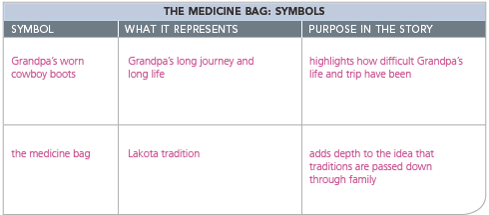

2. Apache Girl’s Rite of Passage – Media Video will be assigned on Savvas
(Comprehension Check Questions)

BACKGROUND
For hundreds of years, the Mescalero Apaches were nomadic hunters and warriors who roamed
throughout the American Southwest and northern Mexico. Today, this Native American tribe lives on
a major reservation in New Mexico, in what was once the center of their homelands. The ceremony in
this video is one of their most important and sacred traditions.

3. Hanging Fire and Translating Grandfather’s House - Read lesson from PDF handout
(Comprehension Check Questions)

BACKGROUND - Hanging Fire
Adolescence can be a challenging stage of life, with childhood left behind but adulthood not yet
achieved. In “Hanging Fire,” Audre Lorde explores the frustrating feelings that can arise from the
contradictions of being a “young adult.”

BACKGROUND - Translating Grandfather’s
In the poem, E.J. Vega mentions Zorro, a popular fictional character, originally created in 1919 by
writer Johnston McCulley. In McCulley’s novel, Zorro is a heroic outlaw and a skilled sword fighter
who wears a mask to hide his true identity—he is actually a wealthy noble named Diego de la Vega.

Analyze the Tex

1. Review and Clarify: Identify the lines that are repeated throughout the poem. What does this repetition
suggest about the relationship between the speaker and the mother?
-Answer: The repeated line is “Momma’s in the bedroom with the door closed.” This suggests that the
speaker does not have an open relationship with her mother.
2. Essential Question: What are some milestones on the path to growing up? What have you learned about
growing up by reading these poems?
-Answer: Growing up often involves a longing for the past. Memories of family homes and moments
shared can shape our identity and understanding of who we are.

Analyze Craft and Structure

Forms of Poetry Two major forms of poetry are lyric poetry and narrative poetry. Understanding a poem’s structure and style will help you to analyze the meaning of a poem and identify a theme, or insight about
life that it conveys.
• The purpose of lyric poetry is to create a single, vivid impression of an object, person, or moment in time.
Lyric poems are generally short. They may be rhymed or unrhymed, but most lyric poems contain musical
qualities that help to convey meaning. These musical effects are created through the repetition of words
and sounds as well as the rhythm created by the strong and weak stresses a reader
naturally places on words.

• A narrative poem tells a story and includes the main elements of
a short story—characters, setting, conflict, and plot. A narrative
poem may also include musical effects, but generally not to the same
degree that a lyric poem does.
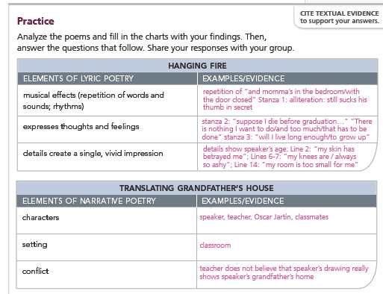

1. (a) What overall impression does “Hanging Fire” create? (b) What theme is conveyed by the poem?

Answer: (a) This leaves me with the impression that the fourteen-year-old is very anxious and unsure
about her future. She wishes she could go to her mother, who is shut away. (b) Life has many
challenges, and sometimes one has to wait for them to be resolved.

2. (a) How is the conflict resolved in “Translating Grandfather’s House”? (b) What theme does the poem
suggest?

Answer: (a) There is a conflict between the truth of the speaker’s experience and how it is seen in the
outside world. (b) One of the challenges of life is growing up and being different in a world where
everyone else is the same.
Concept Vocabulary:

Word Vocabulary #1 Wearily, Straggled, Fatigue, Frail, Sheepishly, Reservation, Glamorous,
Procession, Descendants, Reinforce

Word Vocabulary #2 synchronization, narration, pan, close-up, audio, contrast, nomadic, reservation

Word Vocabulary #3 awakenings, horizon, melodies, betrayed, beaming
- Analyze Craft and Structure
Figurative Meaning: Symbolism A symbol is anything that stands for or represents something else.
Symbolism is the use of symbols.
• Symbols are common in everyday life as well as in literature. For example, a dove with an olive branch in its beak is a symbol of peace.
• In literature, symbolism can highlight certain ideas the author wishes to emphasize.
• Symbolism can also add levels of meaning to a text.
Most Native American cultures show deep respect for nature, and the natural world is considered to
have profound spiritual qualities. Symbols of nature play an important role in Native American
traditions, especially religious ones. In “The Medicine Bag,” the medicine bag is an important symbol.
Think about other symbols connected with Grandpa in the story.

Analyze the Text

1. Evaluate - Do you think Grandpa made the right decision to travel and visit his family?
2. Interpret - Summarize the story Grandpa tells about his father
3. Draw Conclusions - What happens to Grandpa and to Martin at the end of the story?
4. Essential Question: What are some milestones on the path to growing up?

Grammar
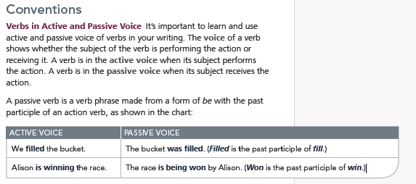

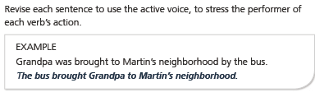

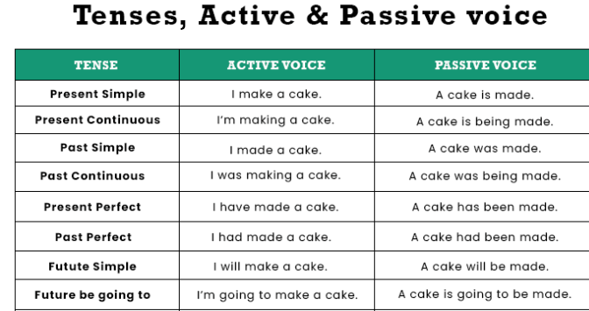
Active and Passive Voice
Practice the differences
1. Active Voice- Meeta sings a duet.
Passive Voice- A duet is sung by Meeta.

2. Active Voice- Seema reads a novel.
Passive Voice- A novel is read by Seema.

3. Active Voice- He composes a song.
Passive Voice- A song is composed by him.
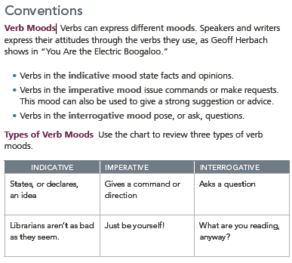

Example Questions
1. Victor [enjoys] skating; however, he [doesn't skate] very often.
a. indicative b. imperative c. subjunctive
2. Please [don't forget] to water the plants.
a. indicative b. imperative c. subjunctive
3. Today, I [am meeting] my friends for a coffee at the Corner Café.
a. indicative b. imperative c. subjunctive
4. I suggest that you [dress] warmly because the temperature is dropping.
a. indicative b. imperative c. subjunctive

