Science Study Guide – Unit 1
This study guide covers key concepts, definitions, and important points from each lesson to help you prepare for the exam. By studying all sections carefully, you can achieve a full mark.

Exam Topics Covered
1. Energy, Speed, and Moving Objects
2. Collisions
3. Energy Transfer
4. Electric Circuits

Vocabulary Words
- Kinetic Energy: the energy of a moving object.
- Potential Energy: stored energy in an object.
- Transform: to change from one type of energy to another.
- Collision: the action of one object bumping into another.
- Simulate: to demonstrate or copy something to make it easier to understand.
- Radiation: energy that travels as a wave.
- Wave: a disturbance that travels in a pattern and carries energy.
- Electric current: the flow of charged particles in the same direction.
- Insulator: a material that stops the flow of electric current.
- Resistor: a device used to control the flow of electricity.

Thermal Energy and Particles of Matter
Thermal energy affects particles by making them move faster when they gain heat and slower when they lose heat. For example, heating up water makes its particles move faster, causing it to boil.

Newton’s Cradle and Energy Transfer
In Newton’s cradle, the spheres in the center barely move because they pass energy from one side to the other without moving themselves. This demonstrates energy transfer through objects.

Four Methods of Energy Transfer
Energy can be transferred through Heat, Sound, Light and Electricity.

Diagrams and Drawing Tips
Electric Charges
- Particles with opposite charges attract each other.
- Particles with similar charges (both positive or both negative) repel each other.
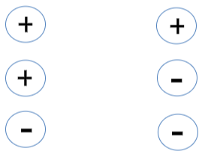

Study Tips
1. Review definitions and examples for each vocabulary word.
2. Practice explaining each energy transfer method with examples.
3. Use drawings to show energy transfer in Newton’s cradle.

