Reading test - Monday , Nov 18

Group A
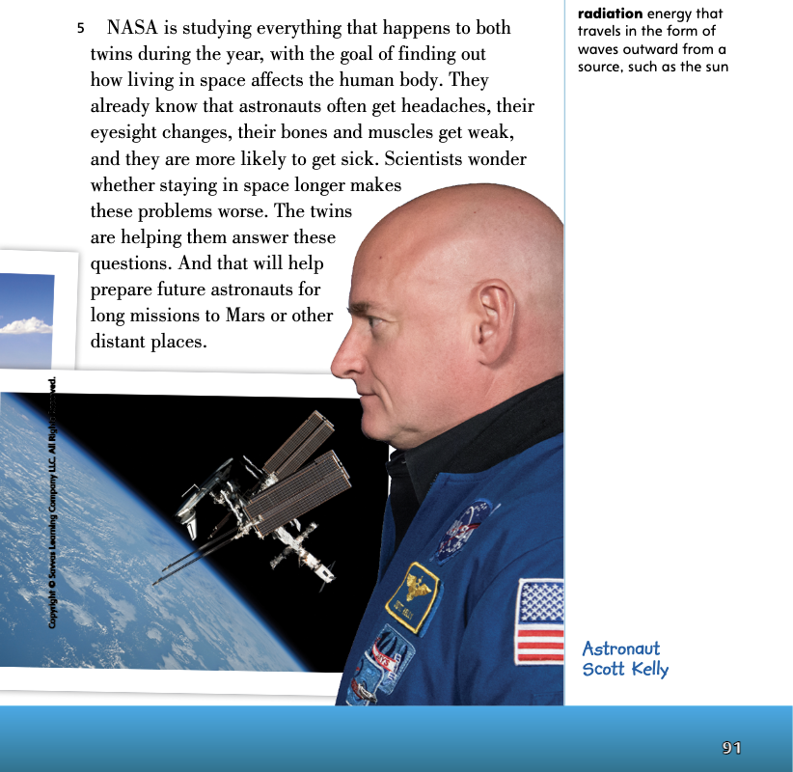
Page 91 Paragraph 5

Group B
Page 90 Paragraph 3

