Dictation test - Wednesday , Nov 20

Group A
Page 91 Paragraph 4
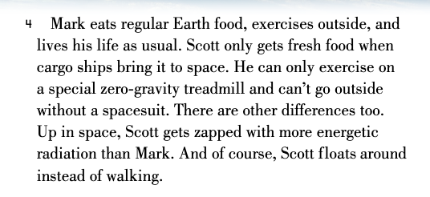

Group B
Page 90 Paragraph 1

