Assignment for grade7 Mr. Kamel
Name :______________________ date :____________
Q1.
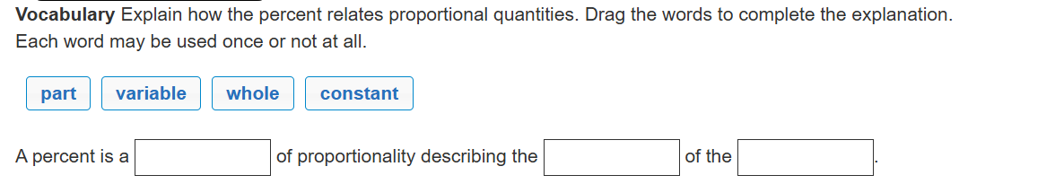
Q2 .
Lou and Jacob each sold 200 pieces of jewelry. If 20% of Lou's sales were rings, and Jacob sold 35 rings, who sold more rings?
- Jacob sold 5 more rings than Lou.
- Lou sold 5% more rings than Jacob.
- Jacob sold 5% more rings than Lou.
- Lou sold 5 more rings than Jacob.
Q3 .
