Second Exam
$7^{th}grade$ Mr. Kamel
Name :________________________ Date :______________________
Q1. Find the percentage of the following
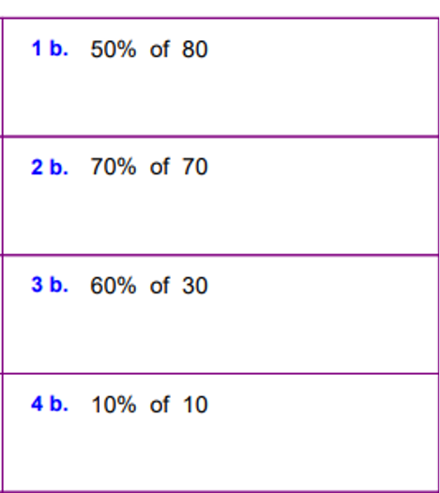
Q2. Find the value of x in following equation of percentage
- $\frac{10}{100}=\frac{x}{25}$
- $\frac{x}{12.5}= \frac{64}{100}$
- $\frac{x}{50}= \frac{70}{100}$
Q3. Evaluate the following expression
$a. 3x-4y+2x-9$ , when $x=9 , y=-3$
b. $\frac{-2a}{3b}+\frac{9}{2a}$ , when $a=9 , b-9$

Q4.
- Simplify the following expression and what is the property used.

$$3x - \frac{1}{2}y + 7x +\frac{3}{4}y -9$$

- Connect the steps with the right property .

- $3x+2y-2x$ |  | $$\left(-9x-2x\right)+3y$$ |  | Commutative property
- $-9x-(2x+3y)$ |  | $$3x-2x+2y$$ |  | Associative Property
c.$3x-6x -9$ |  | $$(3-6)x-9$$ |  | Distributive property

