Second Exam
Name :______________ grade 8 date :__________________ Ms. Kamel
Q1. (6 mark)
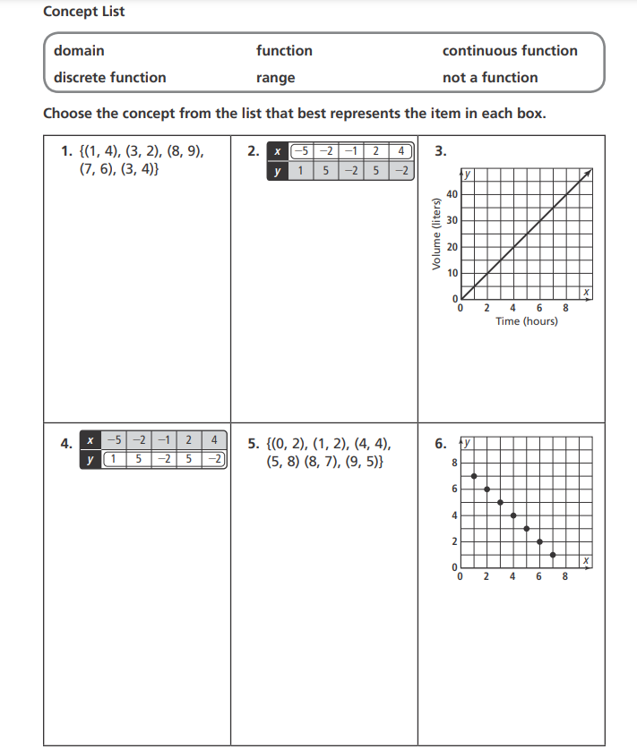

Q2 . write the key features of the following tables , sets of order pairs and linear functions . (8 mark)
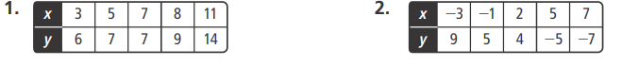
4. $\left\{\left(1,3\right),\left(3,6\right),\left(6,9\right),\left(9,12\right),\left(12,15\right),(15,18)\right\}$

Q3. ( 6 mark)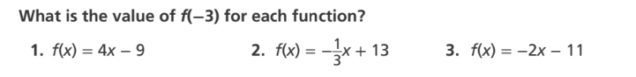

Q4. (6 mark)