Exam for 8th grade
Name :__________________ Ms. Kamel
date :_________________ ( mark 15)

Q 1. Write the equation in slope-intercept form of the line that passes through the given points. (4 mark )
$$a. (-3, 2) and (4, -2)$$
$$b. (6,- 3) and ( 2 , 4 )$$
Q 2. (3 mark ) 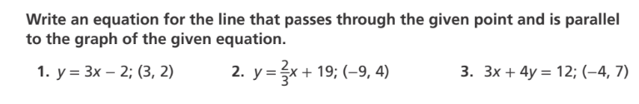

Q 3. Graph the line that represents each linear equation. (2 mark)
a.
b.
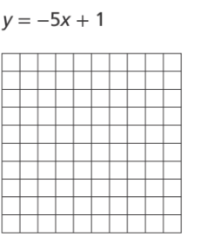 . 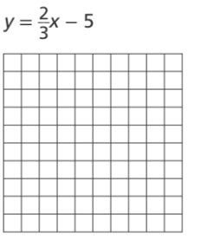

Q 4. (3 mark) 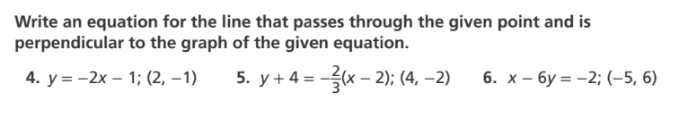

Q 5. (mark 3)