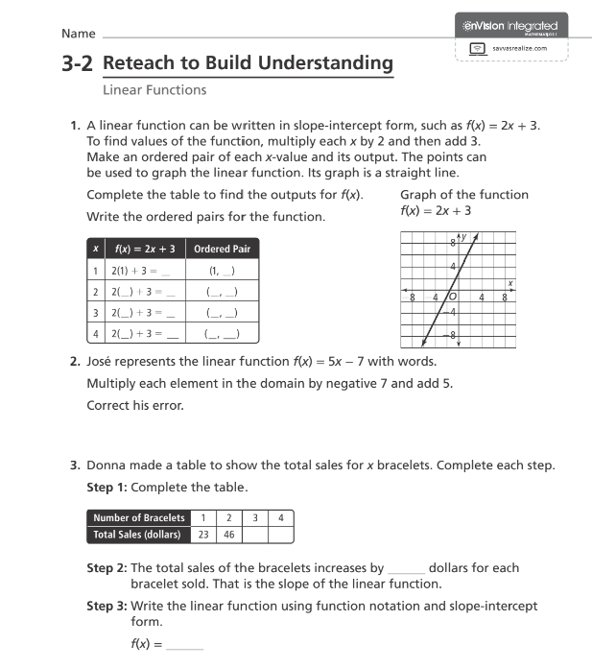

Q2 . find the intercept point s of the following function
- $f\left(x\right)=7-7x$

- $F(x)= 9x-18$

- $f\left(x\right)=2\left(x-2\right)+x-1$

