Assignment Grade8 mark 15
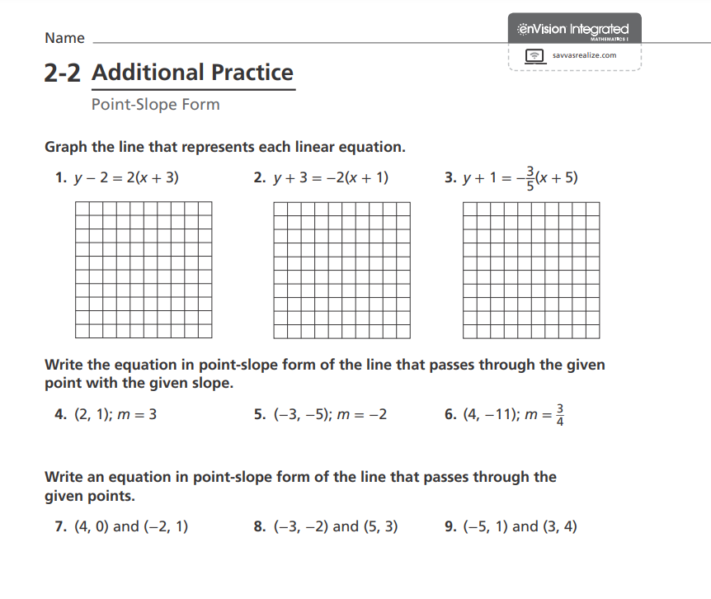Q10. Find x, a line has slope = -1 and passes through the given points
( 2 , x ) and ( 4 , -6 ) .

Q11. Find the equation of a line passes through the point ( 1 , 2) and the slope of the perpendicular line on it $-\frac{3}{2}$ .

