7th Grade English Levels
Final Exam-
Study Guide

Dear Students,
This guide will help you prepare for your final exam. Please use your notebooks and worksheets to review all notes, activities, and exercises we’ve completed in class. Pay special attention to the examples and explanations provided during our discussions.
Unit 2: A Starry Home
Essential question: Should we make a home in space?

“Dark They Were, and Golden-Eyed” by Ray Bradbury

Summary
The Bittering family settles on Mars, where Harry, the father, worries about their new life. His son David believes unseen Martians may punish Earth people for taking over their planet. Harry dismisses David’s fears but grows uneasy when strange changes occur: their cow grows a third horn, the lawn turns purple, and people’s eyes, including his own, begin turning yellow.
As time passes, the Bitterings and other settlers undergo physical and mental changes, adapting to Mars. Harry works on building a rocket to escape but gradually loses interest. The family eventually moves to a deserted summer home in the hills, fully embracing their transformation.
Five years later, a rocket from Earth arrives, but the settlers are gone. The newcomers plan to rename the Martian landscape, unaware the settlers have become Martians.

Key Points:
- A science fiction (not a real story) short story about a family adapting to life on Mars.
- Themes: Change, identity, human connection to place, and the inevitability of transformation.
- Main Characters: Harry Bittering, his family, and the settlers on Mars.
- Setting: Mars, a place of isolation and transformation.

- Concept Vocabulary
Make sure to study the vocabulary words and their definition
Submerged | completely covered with a liquid
Forlorn | abandoned or deserted
Canals | artificial waterways for transportation or irrigation
Immense | very large
Atmosphere | the gas surrounding the earth; the air
Mosaic | made of many small pieces of colored glass or stone

- Figurative Language:

Key Types of Figurative Language

1. Simile
- Definition: A simile is a figure of speech that compares two seemingly unrelated things using the words like or as.
- Purpose: To highlight similarities between two things, making abstract or unfamiliar concepts more relatable.
- Example:
Her smile was as bright as the sun.
(Her smile is being compared to the sun because both are bright.)

2. Metaphor
- Definition: A metaphor directly compares two unrelated things by saying that one is the other.
- Purpose: To create a strong, direct comparison that suggests deeper symbolic meaning.

- Example:
Time is a thief.
(Time is being compared to a thief because it "steals" moments from us.)

3. Personification
- Definition: Personification gives human qualities to things that aren’t human.
- Example:
The wind whispered through the trees.
(The wind is described as if it can "whisper" like a person.)

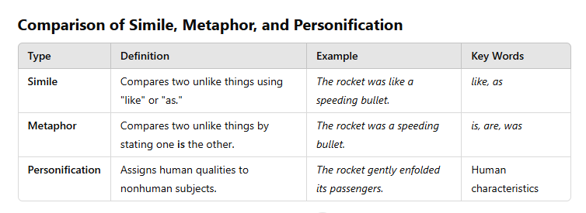

Quick Practice
- The car moved as slow as a turtle. (Simile)
- The clouds are cotton candy in the sky. (Metaphor)
- The stars smiled at us. (Personification)

- Grammar:

Sentence Structure
Understanding sentence structure is essential for creating clear and meaningful sentences. A well-constructed sentence includes three main parts:
Subject: The person, thing, or idea that the sentence is about.
Example: The sun (subject) is shining.
Verb: The action the subject performs or the state the subject is in.
Example: The cat (subject) sleeps (verb) on the couch.
Object: The entity that is affected by the action of the verb.
Example: She (subject) baked (verb) a cake (object).

Expanded Examples
- John (subject) kicked (verb) the ball (object).
- The students (subject) are reading (verb) their books (object).
- Lisa (subject) feels (verb) tired (adjective).

Types of Sentences Based on Structure
- Simple Sentence: Contains one independent clause.
Example: The bird sang.
- Compound Sentence: Contains two independent clauses joined by a conjunction.
Example: The bird sang, and the sun rose.
- Complex Sentence: Contains one independent clause and one or more dependent clauses.
Example: When the bird sang, the sun rose.
- Compound-Complex Sentence: Contains two or more independent clauses and at least one dependent clause.
Example: The bird sang, and the sun rose after the rain stopped.

Comparisons Using Adjectives and Adverbs
When comparing people, things, or actions, we use comparative and superlative forms of adjectives and adverbs.

What Are Adjectives and Adverbs?
- Adjectives: Words that describe or modify nouns and pronouns. They answer questions like what kind?, which one?, or how many?
Example: The tall tree. (tall describes the tree.)
- Adverbs: Words that describe or modify verbs, adjectives, or other adverbs. They answer questions like how?, when?, where?, or to what extent?
Example: She runs quickly. (quickly describes how she runs.)

Degrees of Comparison
Both adjectives and adverbs can express comparisons. There are three degrees of comparison: positive, comparative, and superlative.

1. Positive Degree
- Definition: Used when no comparison is made. It simply describes one thing.
- Examples:
  - Adjective: My toy is an old one. (old describes my toy without comparison.)
  - Adverb: We arrived quickly. (quickly describes how we arrived without comparing to anyone else.)

2. Comparative Degree
- Definition: Used to compare two things.
- How to Form:
  - For one- or two-syllable adjectives or adverbs, add -er to the word.
Example: long → longer; fast → faster
  - For longer words or adverbs that end in -ly, use the word more before the modifier.
Example: beautiful → more beautiful; quickly → more quickly
- Examples:
  - Adjective: Talia is taller than Jinan. (taller compares two girls.)
  - Adverb: We progressed more quickly than they did. (more quickly compares how two groups progressed.)

3. Superlative Degree
- Definition: Used to compare three or more things.
- How to Form:
  - For one- or two-syllable adjectives or adverbs, add -est to the word.
Example: long → longest; fast → fastest
  - For longer words or adverbs that end in -ly, use the word most before the modifier.
Example: beautiful → most beautiful; quickly → most quickly
- Examples:
  - Adjective: Ameena is the tallest girl in the class. (tallest compares more than two girls.)
  - Adverb: We progressed the most quickly of all the teams. (most quickly compares how multiple groups progressed.)
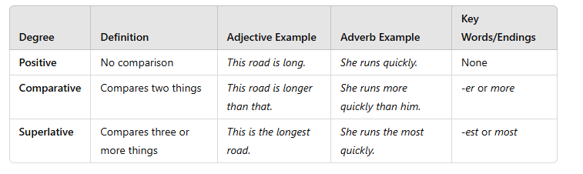

Quick Practice
- Positive: The book is interesting.
- Comparative: This book is more interesting than the other one.
- Superlative: This is the most interesting book I’ve ever read.

Important Notes:
- Some irregular modifiers don’t follow these rules:
  - Good → better → best (adjective)
  - Well → better → best (adverb)
  - Bad → worse → worst
- Avoid double comparisons:
  - Incorrect: more better, most fastest
  - Correct: better, fastest

2. “Future of Space Exploration Could See Humans on Mars, Alien Planets”
By: Nola Taylor Redd

a. Key Themes
- Inclusivity in Space Exploration
  - The 100-Year Starship program emphasizes the involvement of diverse people, not just scientists and engineers.
  - Mae Jemison’s vision includes artists, writers, and public engagement to foster enthusiasm.
- Challenges of Space Travel
  - Proxima Centauri, the nearest star, would take 70,000 years to reach with current technology.

- Public Enthusiasm and Commitment
• lack of public will and commitment slows down space exploration.
When people aren’t interested or don’t support space programs, it’s harder to make progress.
• Jemison says getting the public involved can bring back interest and money for space programs.
If more people care about space, it will help raise the funds and enthusiasm needed to continue exploring.
- Earth Benefits from Space Exploration
  - Advances from space exploration often contribute to solving problems on Earth.
  - Jemison believes investing in the future of space creates a better present for humanity.

b. Key Figures and Contributions
- Mae Jemison
  - Former NASA astronaut and head of the 100-Year Starship project.
  - Advocates for an inclusive approach to space exploration.
- Adam Steltzner
  - NASA engineer who discussed the challenges of long-term space travel, including societal stability over thousands of years.
c. Important Facts
100-Year Starship Program
- It’s funded by NASA and DARPA.
- The goal is to create the technology to travel to other stars in 100 years.
Technological Challenges
- The current spacecraft, like Voyager 1, would take 70,000 years to reach the nearest star, Proxima Centauri.
- The focus is on improving rocket systems and finding ways to travel through space faster.

- Concept Vocabulary
Make sure to study the vocabulary words and their definition
Colonize(v) | to settle and establish control over
Planetary (adj) | having to do with plants
Interstellar (adj) | among or between stars

- Questions and Answers
- What is the goal of the 100-Year Starship project?
  - To create the technology to travel to other stars in the next 100 years.
- Why does Mae Jemison emphasize public involvement in space exploration?
  - She thinks people lost interest because they weren’t included. Involving everyone makes it a shared goal.
- What does Jemison mean by saying, “The public was left out of space”?
People were not included in space programs, so they lost interest.

- Grammar:
The Principal Parts of Verbs
A verb has four principal parts:
- Present: This shows the action happening now.
For example: walk (I walk to school every day.)
- Present Participle: This shows an ongoing action. It's formed by adding "-ing" to the base verb and is used with helping verbs like am, is, are.
For example: walking (I am walking to school right now.)
- Past: This shows an action that already happened. For regular verbs, you add "-ed" to the base verb. For irregular verbs, the form may change completely.
For example:
walked (I walked to school yesterday.)
- Past Participle: This is used with helping verbs like has, have, had to describe an action that has been completed. For regular verbs, it's the same as the past form, but for irregular verbs, it can be different.
For example: walked (I have walked to school before.)
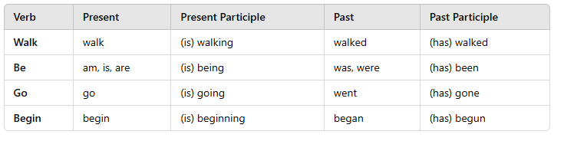

Identifying Verbs and Verb Phrases
In each sentence, you will identify the verb or verb phrase (which includes a main verb and a helping verb) and label it as present, present participle, past, or past participle.
- Jemison is an astronaut.
  - Verb: is (present)
  - Helping verb: is
- People have imagined trips to other planets.
  - Verb phrase: have imagined (present participle)
  - Helping verb: have
  - Main verb: imagined (past participle)
- Hillary planned the construction of a spaceship.
  - Verb: planned (past)
- Scientists are working constantly on the problem.
  - Verb phrase: are working (present participle)
  - Helping verb: are
  - Main verb: working (present participle)

Unit 3: Turning Points
Essential Question: What can cause a sudden change in someone’s life?

3. “Thank You, M’am” by Langston Hughes
"Thank You, M'am" is a short story written by Langston Hughes, first published in 1958. The story revolves around a young boy, Roger, who attempts to steal a woman's purse but ends up learning a lesson about kindness and trust.

a. Key Points:
• Introduction of Characters:
- The protagonist, Roger, is a boy who desires a pair of blue suede shoes.
- Mrs. Luella Bates Washington Jones is a large woman who catches Roger attempting to steal her purse.
• The Attempted Theft:
- Roger tries to snatch Mrs. Jones’s purse but loses his balance, causing him to fall.
- Mrs. Jones turns around and kicks him, then pulls him up by his shirt and demands he return the purse.
• Mrs. Jones’s Response:
- Rather than turning Roger over to the police, Mrs. Jones decides to teach him a lesson.
- She asks him why he tried to steal, and Roger admits he wanted the shoes.
• The Interaction:
- Mrs. Jones takes Roger to her home, where she talks to him like a mother figure, offering him food.
- She shows him kindness and shares a bit of her own life, asking him to wash his face and be presentable.
• The Lesson:
- Mrs. Jones does not accuse Roger but instead uses her experience to advise him.
- She tells him that shoes obtained through dishonest means will bring trouble, but she gives him $10 to buy the shoes.
• The Ending:
- Roger is left speechless, deeply moved by her kindness and teaching.
- He wants to say more, but can only say "Thank you, ma'am" before leaving.

  - Concept Vocabulary
Make sure to study the vocabulary words and their definition
Permit | to allow
release | to let go
contact | to be in touch, connect

C. Question and answers
1. What does Roger want at the start of the story?
Roger wants to buy blue suede shoes, but he tries to steal them from Mrs. Jones.
2. How does Mrs. Jones respond when Roger tries to steal her purse?
Mrs. Jones is strong but decides to teach Roger a lesson instead of getting angry or calling the police.
3. What lesson does Mrs. Jones teach Roger?
She teaches Roger that stealing is wrong and that he should get things honestly. She also talks to him about kindness and responsibility.

d. Elements of the Short Story:
Plot
What is Plot?
The plot is the sequence of events in a story. It shows how characters handle a problem or conflict. Stories often have five stages of plot:
- Exposition: Introduces the characters, setting, and situation.
- Rising Action: Events build up to the main problem or climax.
- Climax: The most exciting or intense moment of the story.
- Falling Action: Events happen after the climax, calming things down.
- Resolution: The conflict is solved, and the story ends.
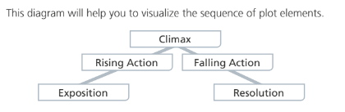

Thank You, M'am Plot:
Exposition: Roger tries to steal Mrs. Jones' purse.
Rising Action: She takes him home, feeds him, and talks to him about choices.
Climax: She gives him money for shoes.
Falling Action: Roger is left in awe of her kindness.
Resolution: Mrs. Jones is caring but firm; Roger is vulnerable yet redeemable.

4. Grammar :
Prepositions and Prepositional Phrases:

A preposition is a word that links a noun or pronoun following it to another word in the sentence. It shows the relationship between these words. Common prepositions include at, after, between, for, in, of, on, to, through, and with.

Example of a Preposition:
- The book is on the table.
In this example, on is the preposition. It shows the relationship between the noun table (the object of the preposition) and the noun book.
A prepositional phrase is a group of words that starts with a preposition and ends with a noun or pronoun, which is called the object of the preposition. The object of the preposition is the noun or pronoun that the preposition refers to.

Example of a Prepositional Phrase:
- The book is on the table.
Here, on the table is the prepositional phrase. On is the preposition, and the table is the object of the preposition.

Identifying Prepositional Phrases in "Thank You, M'am"

Example:
- She was a large woman with a large purse that had everything in it but hammer and nails.
Here, "with a large purse" and "in it" are prepositional phrases.
- With is the preposition, and a large purse is the object of the preposition.
- In is the preposition, and it is the object of the preposition.

Prepositional Phrases Example:
- My grandmother has always been there for me. She taught me many valuable lessons about kindness and patience. I remember sitting in her cozy living room while she told me stories.
In this example:
- For me: "For" is the preposition, and me is the object.
- About kindness: "About" is the preposition, and kindness is the object.
- In her cozy living room: "In" is the preposition, and her cozy living room is the object.
Practice:
• The boy ran through the park.
• She placed the flowers on the table.
• The cat hid under the bed.

Symbolism
- Definition: Symbolism is a literary device where an object, person, place, or event represents an idea or concept beyond its literal meaning.
Example: A heart symbolizes love, while a dove symbolizes peace.

Why Symbolism is Important in Literature
- Adds depth to stories by conveying complex ideas through simple symbols.
- Engages readers to interpret meanings, enhancing the reading experience.
- Helps express themes, emotions, or messages in an indirect but powerful way.

How to Identify Symbolism
- Look for objects, actions, or phrases that are repeated or seem important in the story.
- Ask yourself if the item has a meaning beyond its literal use in the text.
- Consider cultural, historical, or personal associations with the symbol

Symbolism in Thank You, M'am
Langston Hughes' short story Thank You, M'am uses symbolism to convey themes of kindness, trust, and the impact of compassion on personal growth. Below are some key examples of symbolism in the story:

Mrs. Luella Bates Washington Jones’ Purse
Literal Meaning: A large, heavy purse carried by Mrs. Jones.
Symbolic Meaning:
Responsibility and Trust: The purse symbolizes the weight of Mrs. Jones' life experiences and the trust she places in Roger when she doesn’t guard it after bringing him home.

Roger’s Attempt to Steal the Purse
Literal Meaning: Roger tries to snatch Mrs. Jones’ purse at the beginning of the story.
Symbolic Meaning:
Desperation and Misdirection: This act symbolizes Roger’s initial lack of moral guidance and his desperate attempt to fulfill a material desire in the wrong way.

Tips for Studying:
- Review Texts Side-by-Side: Analyze how themes in fictional and nonfictional texts connect.
- Practice Grammar in Context: Create sentences with prepositions and principle parts of verbs.
- Analyze Figurative Language: Identify metaphors and similes in different texts.
- Plot Elements Practice: Break down short stories into the plot structure.

General Study Tips:
- Use Your Notebook and Worksheets:
Highlight important notes, examples, and definitions.
Complete any unfinished exercises or revisit past worksheets.
- Practice Writing and Grammar:
Write sentences using the grammar concepts we studied.
Use the vocabulary from the texts in your own sentences.
- Ask Questions:
Bring any questions or doubts to our next class.

Good Luck

