
7th Grade English
1st Semester Final
Study Sheet

Literature
1. Future of Space Exploration Could See Humans on Mars, Alien Planets (pg.
Genre: News Article
Author: Nola Taylor Redd
What will it take to make interstellar travel a reality?

BACKGROUND
In 1969, Neil Armstrong became the first astronaut to walk on Earth’s moon. The next big step in space exploration is to put a person on another planet, such as Mars. In this article, former astronaut Mae Jemison and NASA engineer Adam Steltzner discuss the future of space
exploration and what is needed to make it possible. Comprehension Questions (Found on page 167)

*Comprehension Check Questions in notebook. (Questions found on page 175)
1. What is the goal of the 100-Year Starship project?
2. What does Jemison mean when she says that the project must be inclusive?
3. What is one of the challenges faced by the project?

Text Questions:
1. What can you infer the author’s purpose is in writing the news article? ________________________
__________________________________________________________________________________

2. What does Mae Jemison mean when she says “‘The public was left out of space.’”?
__________________________________________________________________________________

3. What does Mae Jemison mean when she says “‘I believe that pursuing an extraordinary tomorrow
will create a better world today’”? ______________________________________________________
__________________________________________________________________________________

Vocabulary
Future of Space Exploration: colonize, planetary, interstellar

Word Study
latin Suffix: -ary
The Latin suffix -ary means “belonging to or relating to.” For example, the word customary means “belonging to or relating to a custom.” In some cultures, it is a custom for people to shake hands with one another when meeting for the first time, so one could say that shaking hands is a customary gesture. *(See Worksheet )

Analyze Craft and Structure
Development of ideas: Text Structure
In order to communicate effectively, authors of nonfiction think about the best way to present
information.
1. In what part of the article does Redd explain what the 100-Year Starship project is? Why does
she describe it in this part of the article? ___________________________________________
_______________________________________________________________________________

2. Where in the article does Redd first quote Mae Jemison? Why does she quote her in this part
of the article? __________________________________________________________________
______________________________________________________________________________

Grammar
A verb has four principal parts: present, present participle, past, and past participle
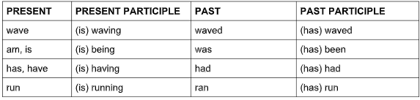
Identify the principal part of the verb: present, past, present participle, or past participle.
1. Neil Armstrong walked on the moon.
2. _________ Mae Jemison is talking to people about space travel.
3. _________ Mae Jemison has traveled to outer space.
4. _________ Space exploration leads to knowledge and innovation.
5. _________ Many people object to the space program.

Study from worksheets and quizzes

2. Thank You, M’am
Genre: Short Story
Author: Langston Hughes
A chance encounter has a powerful impact.

BACKGROUND
In this story, published in 1958, Roger, the protagonist, really wants a pair of blue suede shoes. This
particular fashion item became popular after Carl Perkins released his hit song “Blue Suede Shoes” in
1956. Elvis Presley also famously covered the song in the same year.

*Comprehension Check Questions in notebook. (Questions found on page 199)
1. How do Mrs. Jones and Roger meet?
2. What does Roger expect Mrs. Jones to do?
3. What does Mrs. Jones do instead?

Vocabulary:
Thank You, M’am: permit, release, contact, snatch, jerk, pocketbook, kitchenette, rattled,
forbids, precisely

Word Study
Multiple-Meaning Words Many words have more than one meaning. If you are not sure of the meaning of a multiple-meaning word, use context clues to make an educated guess.

Choose the definition that best matches the use of the underlined word. Write the letter on the line.

1. ____ Vince was really excited for summer to begin so he could restart his lemonade stand.
A. rise to one’s feet B. a small booth where goods are sold
2. ____ The warriors pushed with all their might, but the stone still wouldn’t budge.
A. impressive strength B. expressing possibility

Analyze Craft and Structure: Plot
Plot is the related sequence of events in a story. Each event in the plot moves the story forward. A plot has the following elements:
• Exposition: introduction of the characters, the setting, and the basic situation
• Rising Action: events that introduce a conflict, or struggle, and create tension
• Climax: the story’s high point, or moment of greatest intensity; often a turning point in the story
• Falling Action: events that follow the climax
• Resolution: the story’s final outcome and tying up of loose ends • the story’s title
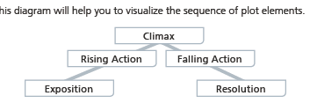

Analyze Craft and Structure
Author’s Point of View: The attitudes and approach that an author takes in an informational text
show the author’s point of view. In some informational texts, authors take an objective approach,
avoiding opinions and other biases. These texts are based almost entirely on factual information.

Grammar
Prepositions and Prepositional Phrases: A preposition relates a noun or a pronoun that follows it to another word in the sentence. Some commonly used prepositions include at, after, between, for, in, of, on, to, though, and with.

Underline the preposition(s) in each sentence.

1. In one corner of the room, there was an icebox.
2. There were lima beans and ham in the icebox.
3. He asked if she needed anyone to go to the store.
4. Mrs. Jones gave Roger some of her cake.
5. She sent him off into the evening, and he never saw her again.

3. Urban Farming Is Growing a Greener Future
Genre: Media Photo Gallery
Author: Hillary Schwei
How can changes in our surroundings produce changes in ourselves?

BACKGROUND
The year 2008 marked the first time that more people on Earth lived in cities than in rural areas. One significant consequence of this turning point is that most people no longer live in the agricultural areas that provide them with food.

*Comprehension Check Questions (Questions found on page 337)

Vocabulary:
Urban Farming Is Growing a Greener Future: rural, agricultural, localizing

Grammar
Action Verbs and Linking Verbs A verb is a word that expresses an action or a state of being. A complete sentence must have at least one verb.

• An action verb tells what action someone or something is doing.

• A linking verb joins the subject of a sentence with a word or phrase that describes or renames the subject. The most common linking verbs are forms of be, such as am, is, are, was, were, has been, and will be. Other linking verbs include seem, become, stay, and feel.
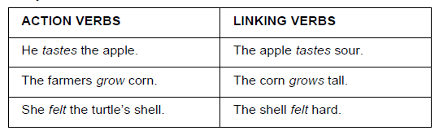

DIRECTIONS: Identify each underlined verb by writing action or linking.
1. The astronauts eat freeze-dried food. ______________________________________
2. They wear space suits when they leave the ship. ______________________________
3. Sometimes, the astronauts are bored. ______________________________________
4. Applicants compete with one another to win a spot in the space program. _________
5. Astronauts can stay busy with work. ________________________________________

