Study work sheet
Second Grade
(Earth environment + Global Neighbors)

Name: _______________________
Date: ________________________

The Environment
- The environment includes living things (plants and animals) and nonliving things (air, water, land).
- Living things need nonliving things to survive.
- People change the environment by building shelters and roads; some changes hurt the environment and some changes help it.

Urban areas

- Urban areas are places with lots of people and buildings.
- People build cities and create urban areas, clearing land of most plants.
- They build roads, homes, and other structures, which can destroy animal habitats.

Rural Area

- Rural areas are lands outside of cities.
- Buildings and homes are often far apart in rural areas.
- People in rural areas also change the environment by clearing land for farming.

Helping the Environment
- Clean air and water are good for people and animals.
- Planting trees cleans the air and keeps carbon dioxide.
- Trees also produce oxygen for living things to breathe.

Keeping Earth Clean

- Clean air and water keep people and animals healthy.
- Pollution makes the environment dirty.
- To keep air clean, people can reduce pollution from factories and cars.
- To keep water clean, people should not put chemicals and trash into rivers, lakes, and oceans.

Weather

- Weather includes temperature, sunshine, rain, snow, and wind.
- If it is sunny and warm, it is a good day for swimming.
- Rain is water that falls from clouds.
Snow is frozen rain that forms flakes.
Climate
- Climate and weather are not the same.
- Climate is weather in a place over a long time.
- Temperature measures how hot or cold it is.

Seasons

- A season is a part of the year with different weather.
- The four seasons are (winter, spring, summer, and autumn). Each lasts about three months.
- Each year, the seasons repeat.

Winter

- Winter is the coldest season.
- Some trees and plants stop growing during winter.

Spring

- In spring, the days grow warmer.
- Plants begin to grow again.

Summer

- Summer is the warmest season of the year.
- Many families take a vacation in summer.
Autumn

- Autumn comes after summer. It is also called fall.
- It becomes cooler.
- The leaves on many trees slowly die and fall to the ground.
Reading a Weather Map

- Weather maps help us know what the weather will be.
- Some maps show temperatures and whether it's cloudy or sunny.
- They also show where it will rain, snow, or be windy.

Question and Answers

Second Grade

Name: ___________________

Date: ____________________

Question #1: What are the two types of things in the environment?

1. Living things (plants and animals) .

2. Nonliving things (air, water, land).

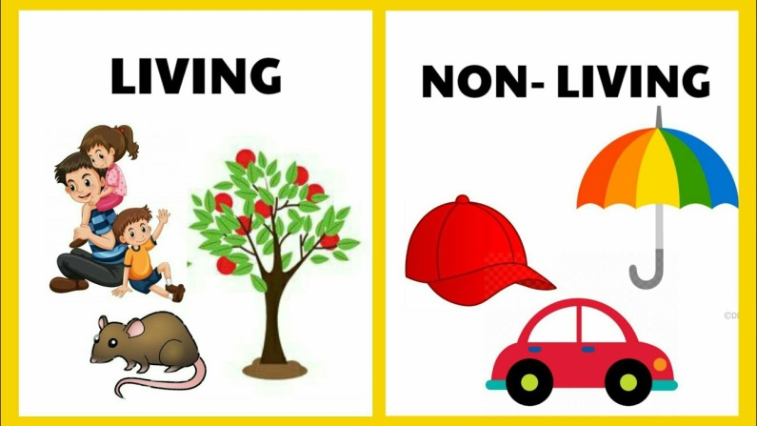

Question#2: How do people change the environment? Can it be good or bad?

People change the environment by building shelters and roads. Some changes help the environment, and some hurt it.

Question#3: What is the difference between urban and rural areas?
Urban area | Rural area
Have lots of people | Fewer people
Have lots of buildings | Fewer building

Question#4: Name one thing people do in urban areas that change the environment.

People build roads, homes, and other structures, which can destroy animal habitats.

Question #5: Why is clean air and water important?

To keep people and animals healthy.

Question#6: How can we keep rivers, lakes, and oceans clean?

By not putting chemicals and trash in them

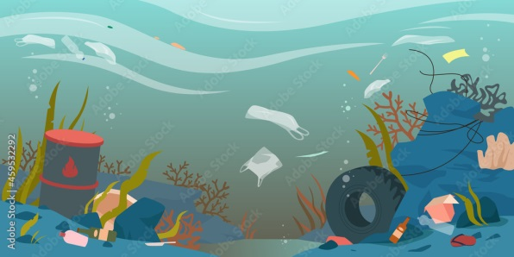

Question#7: What is weather? Can you name one type of weather?

(Temperature, Sunshine, Rain, snow, and wind). One type of weather is

rain.

Question#8: How is climate different from weather?

Climate is the weather in a place over a long time, while weather is what happens daily.
Climate | Weather
Is the weather in a place over a long time | Is what happens daily

Question#9: How many seasons are there in a year? Can you name them?

There are four seasons: winter, spring, summer, and autumn.

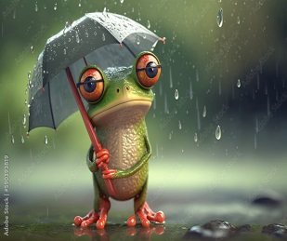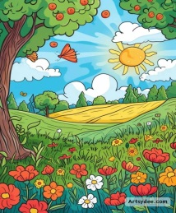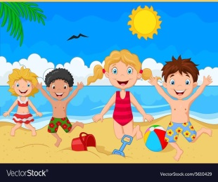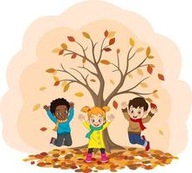

Question#10: What happens to plants in winter?

Some trees and plants stop growing.

Question #11: What do weather maps show us?

It shows temperatures and whether it will be rainy, snowy, or sunny.

