Grade 7 Mathematics – Final Exam Study Guide

Unit 3: Analyze and Solve Percent Problems

3-1: Analyze Percents of Numbers

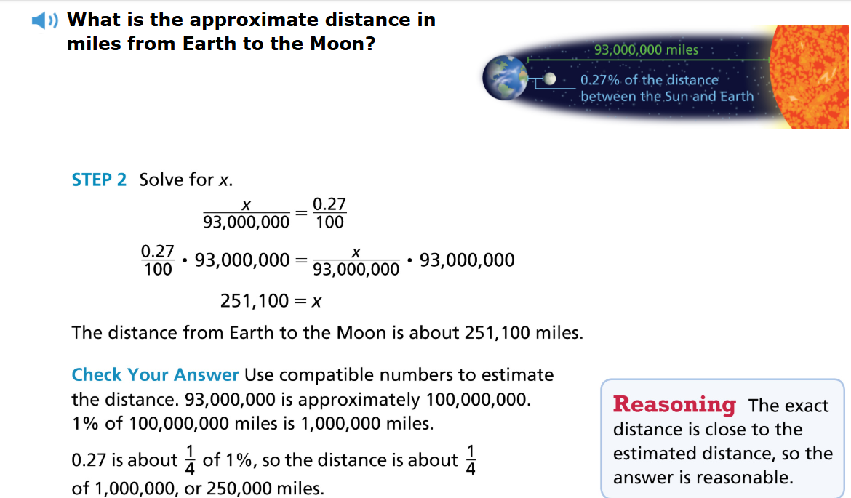

3-2: Connect Percent and Proportion

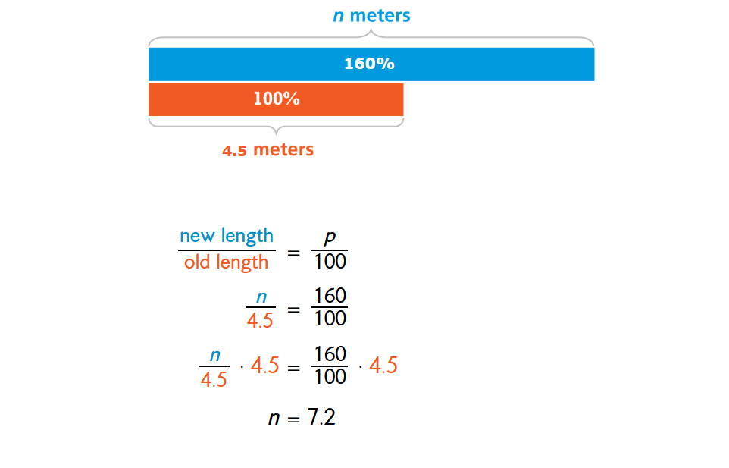

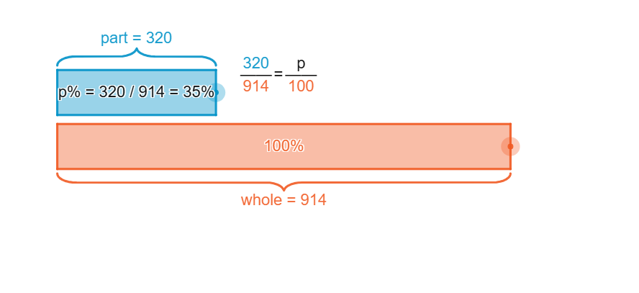

3-3: Represent and Use the Percent Equation
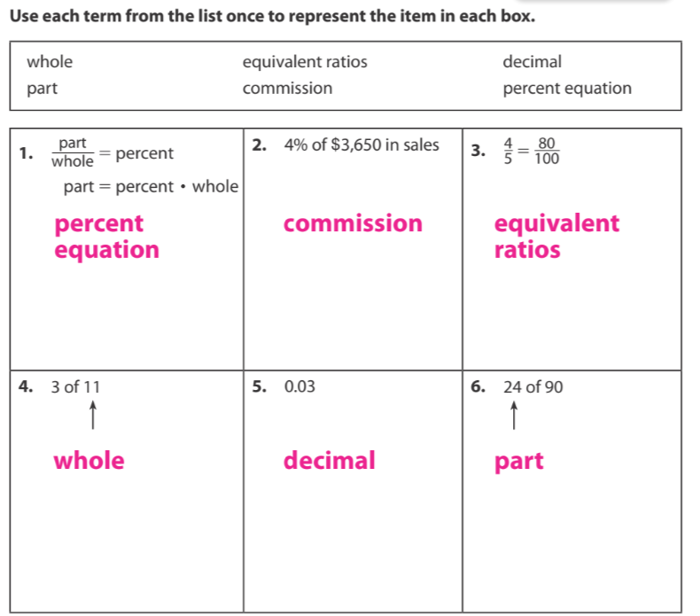.

Unit 4: Generate Equivalent Expressions

4-1: Write and Evaluate Algebraic Expressions

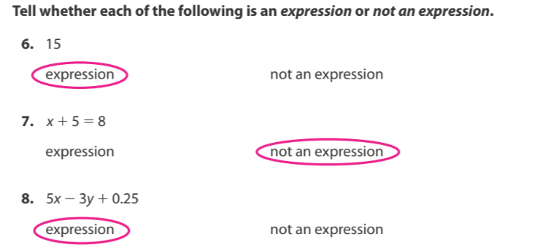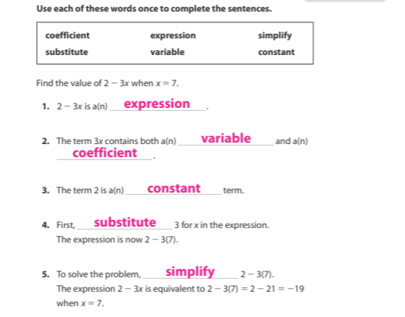

4-2: Generate Equivalent Expressions

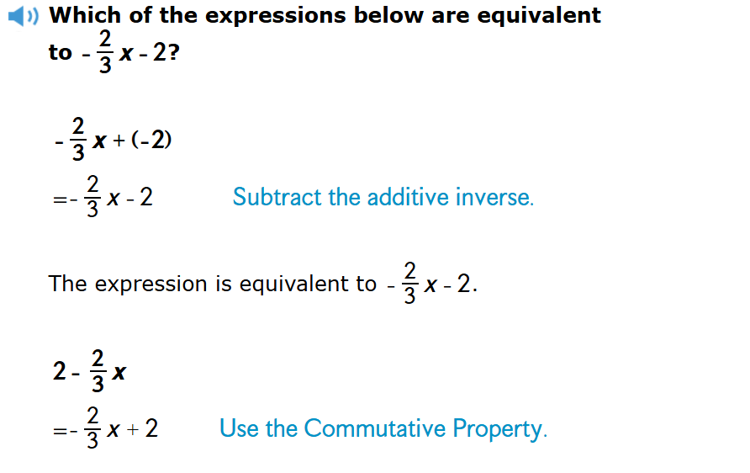4-3: Simplify Expressions

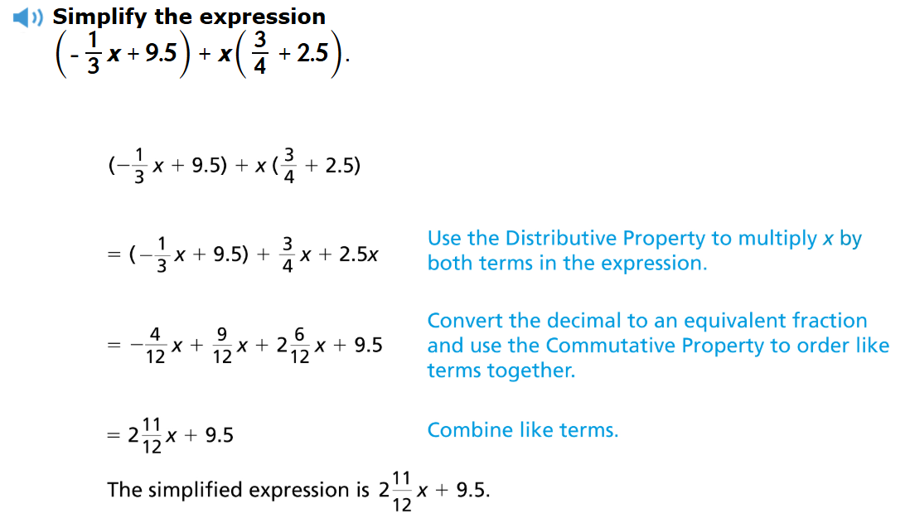

4-4: Expand Expressions

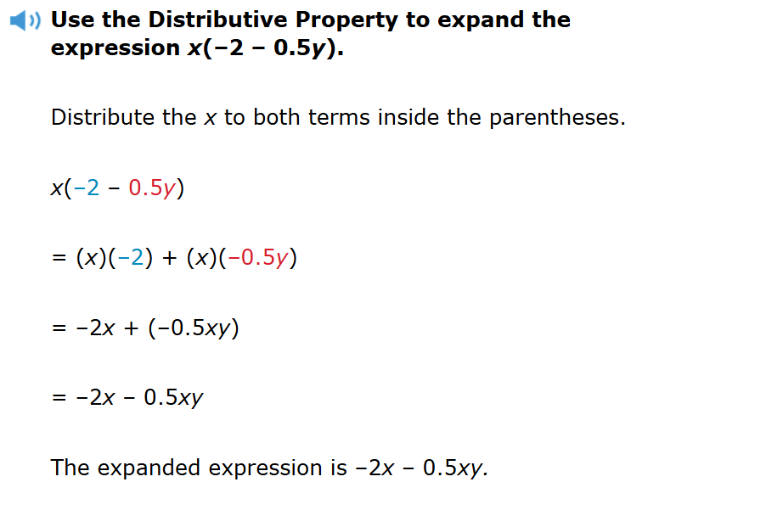4-5: Factor Expressions
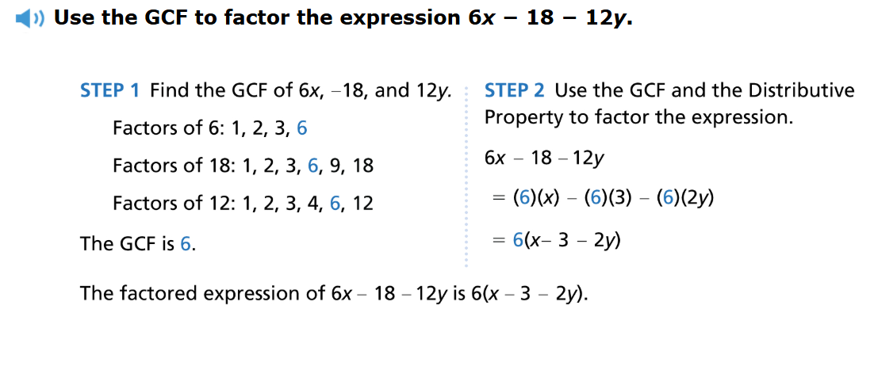

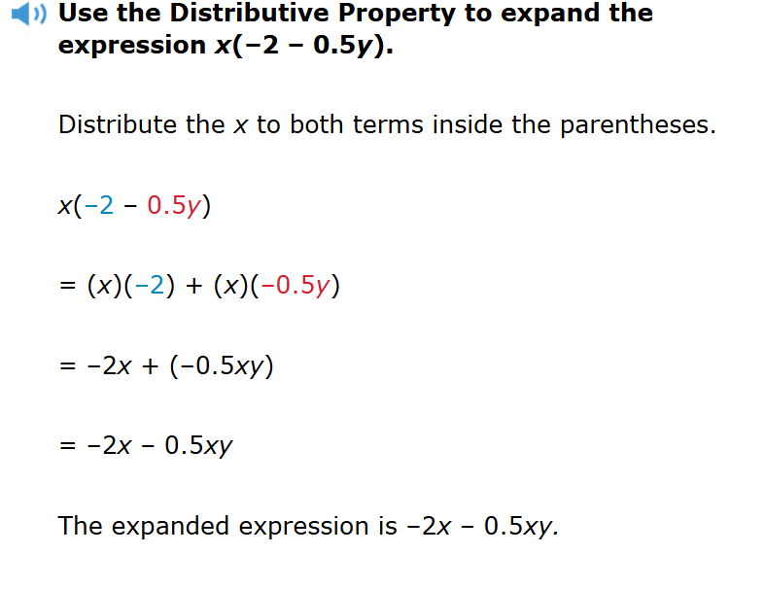 4-6: Add Expressions

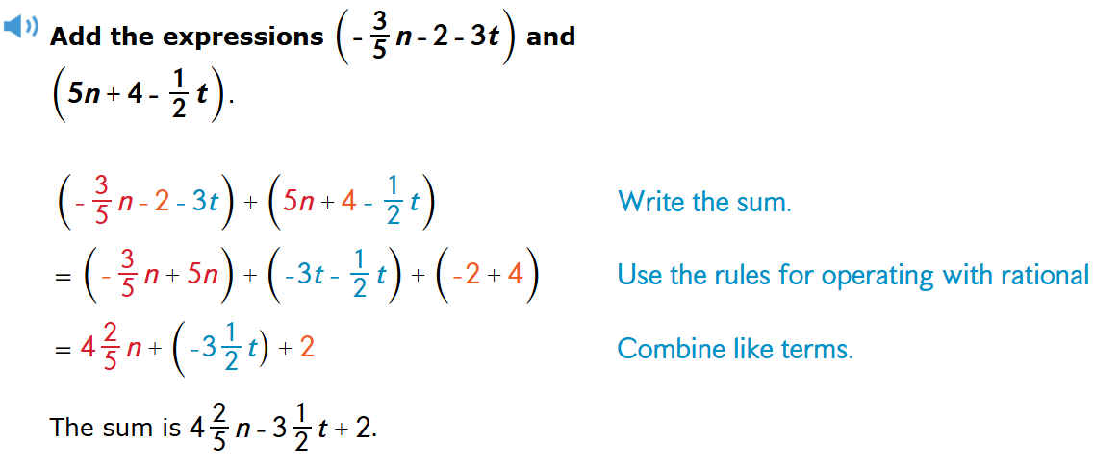

4-7: Subtract Expressions
. 