Name: worksheet (2) mark:
6th Grade (Ch2-number line) date:
__________________________________________________________________________

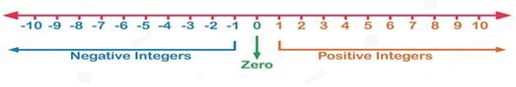
A)

B) Use the number line (X-axis) that helps you to solve the following expressions.

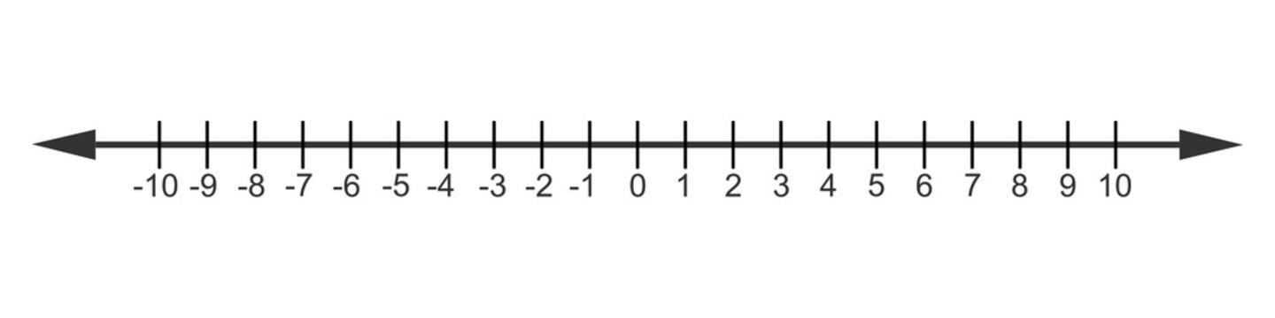

1) 3-5=

2) -7+3=

3) -4+2-6=

4) 8-5-3=

5) +4 -2+6=

C) Use the number line (X-axis) that helps you to solve the following expressions.

1) 4-8 2) -5+6-1= 3) -4-3+7 4) -3-2-1=

