Name: worksheet (1) mark:
7th Grade (Ch1-integers) date:
_______________________________________________________________________
1) The information’s in the following table are describes the speed of a car during
Three cases.
Kilo m | 2 | 4 | 6
min | 6 | 12 | 24

A) Write the ratio for each case.

B) Prove if all ratios have the same unit (constant unit)

C) Write the equation that describe the unit rates.

E) Graph the point at coordinate axis, then find the slope.
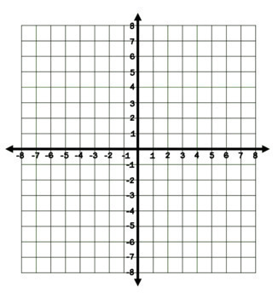


3) Find the missing variable (N) in the following proportions.

A) $\frac{6}{5}$ = $\frac{N}{10}$ B) $\frac{8}{64}$ = $\frac{1}{N}$

C) A) $\frac{3}{N}$ = $\frac{27}{81}$ D) $\frac{N}{18}$ = $\frac{3}{14}$

___________________________________________________________

4) Which of the following is Unit Rate for $\frac{12}{21}$ ?
A) $\frac{4}{7}$ B) $\frac{7}{4}$ C) 3 D) 4

5) One of the following is an equivalent ratio for $\frac{5}{4}$ ?
A) $\frac{3}{24}$ B) $\frac{30}{24}$ C) $\frac{1}{4}$ D) $5$

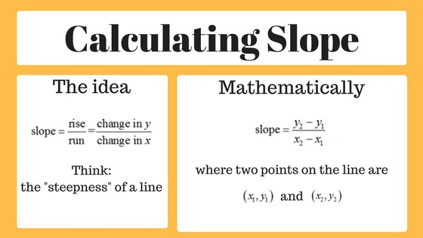

Find the slope for each line.
