1) Define the following word. (2pts)
A)Physics:........................................................................................................................................................................................................................................................
b)Measurement:.......................................................................................................................................................................................................................................
__________________________________________________________
2) Write the elements of measuring process (3pts)
1-
2-
3-
__________________________________________________________
3) Choose the correct answer. (5pts)
A) It is defined as the amount of matter contained in a body.
1) Gravity 2) Mass 3) Wight
B) It is defined as the interval between two events
1) Length 2) Time 3) Wight
C) Field of physics that deals with the structure and building.
1) Geology 2) Engineering 3) Chemistry
D) Branch of physics which deal with properties of sounds.
1) Acoustics physics 2) nuclear physics 3) Optics physics
E) A number which is written by power of 10.
1) Scientific notation 2) Magnitude 3) Prefixes

(1)
1) Use the fundamental physical quantities to derive the following.
A) Force
(5pts)
B) Area

B) Pressure

C) Work

D) Density

_____________________________________________________________________________________
2) Use the prefixes table to convert the Units. (4pts)

A) 45000 millimeter to meter C) 12 kilometer to centimeter

B) 4 km/h to m/s D) g/cm³ to kg/m³

(2)
3) Find the distance and the displacement for the bath of person traveled from home to school as shown in the following graph. (3pts)

School
600
800
Home 300
400 m

_____________________________________________________________________________________
4) Two forces, F1 and F2 .Find the resultant force (net force) in each case of the following.
1) When the angle between them =0º (4pts)

2) When the angle between them = 180º

3) When the angle between them =90º

(3)
5) Use the graph to describe the motion in each case. (6 pts)
Distance d
1) From point (a – b) 24
22
20 b c
16
9
4
1
Time
a 1 2 3 4 5 6 7 8 9 10 11 12 13 14
2) From point (b – c)

3) From point (c – d)

(4)

6) Find the velocity for the motion that described on graph.
Acceleration (2pts)

6
Time
4 5

_____________________________________________________________________________________
7) An object traveled 300m during 5 second; it started motion with initial velocity 12 m/s. Find
1) Acceleration (6pts)
2) Displacement at 3s
3) Final velocity at 5s

(5)

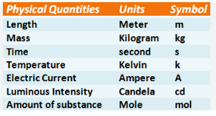
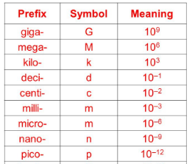

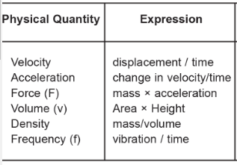

(6)

