Unit 1 Physics and Human Society
_____________________________________________________________________________________
1.1 Definition and Nature of Physics.
Physics: is a branch of natural science aimed at describing the fundamental aspects of our universe.

Physics attempts to describe the basic mechanisms that make our universe behave the way it does. For example,
• Physics enables you to understand the working principles of cars, airplanes, space-rockets, refrigerators, radios, televisions, etc
• Physics explains physical phenomena such as the difficulty of walking on a smooth plane, and why an electric fan rotates etc.
• Physics helps you discover some of the unknown parts of nature and makes you familiar with the modern world.

• Physics helps you to understand some concepts in other subjects like: Biology, Chemistry, Geology, Astronomy, etc.

Studying physics helps you understand concepts, relationships, principles and laws of nature.

A person who studies physics is called a physicist

(1)
Unit 1 Physics and Human Society
_____________________________________________________________________________________
1.2 Branches of Physics.
In addition to understanding the concepts, relationships, principles and laws of nature, studying physics has various career opportunities. Some of the fields in which physics is applicable include:


• The field of transportation.


• The field of aviation and space science.


• The field of medicine.


• The field of forensic and military science.

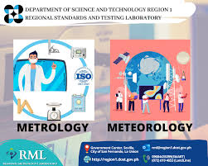
• The field of meteorology and metrology etc.

(2)
Unit 1 Physics and Human Society
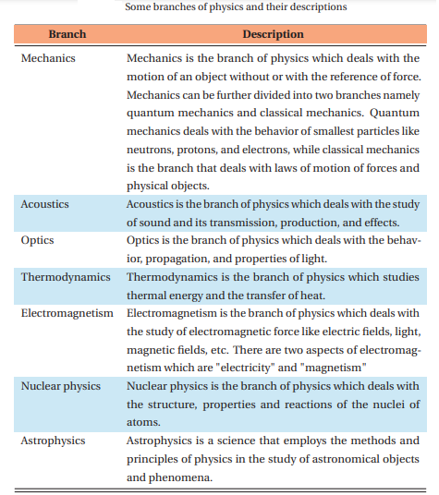
The branches of physics include: Mechanics, Acoustics, Optics, Thermodynamics, Electromagnetism, Nuclear Physics, etc

(3)
Unit 1 Physics and Human Society
_____________________________________________________________________________________
1.3 Related Fields to Physics.
Physics is the foundation of many important scientific disciplines. Some of them are discussed below.
• Chemistry: Chemistry deals with the interactions of atoms and molecules. However, it is rooted in atomic and molecular physics.
• Engineering: Most branches of engineering also apply physics. For example, in architecture, physics is at the heart of determining structural stability, acoustics, heating, lighting, and cooling for buildings.
• Geology: Parts of geology, the study of nonliving parts of Earth, rely heavily on physics; including radioactive dating, earthquake analysis, and heat transfer across Earth’s surface.
• Biophysics: Biophysics applies principles and methods used in physics to study biological phenomena. Physics uses mathematical laws to explain the natural world, and it can be applied to biological organisms and systems to gain insight into their workings.
• Geophysics: Geophysics applies the principles and methods of physics to the study of the Earth
• Medical Physics: Diagnostics and medical therapy, such as x-rays, magnetic resonance imaging (MRI), and ultrasonic blood flow measurements involves principles of physics.
(4)
Name: Worksheet (1)
Date: Physics and Human Society ........ Grade
_____________________________________________________________________________________

Unit 2 Physical Quantities
_____________________________________________________________________________________
Introduction: Physics begins with observations of phenomena, events, matter or energy. Through demanding and controlled experimentation and logical thought process, the physical phenomena are described quantitatively using mathematical tools. Any quantitative description of a property requires comparison with a scale of different measuring devises. For example, length needs a meter-stick, time needs a watch, and mass needs a beam balance. In this process, we recognize a very obvious fact that properties of different kinds cannot be compared. You cannot compare the time of travel from point A to B with the distance between the two points, although the two quantities may be related. The time of travel (time) is a physical quantity and the distance (length) is also a physical quantity. They are completely different types of physical quantities measured by different measuring devices and units. In this unit you will learn different types of scales, measurement, classification of physical quantities, and conversion from one system of units to another.
2.1 Scales, Standards, Units (prefixes (.
A scale: on a measuring device contains the markings that show a certain amount of whatever is being measured. The number of marks on a measurement device depends on how accurate a measurement can be. As the number of marks in the measuring device increases the precision of the device also increases. Figure 2.1 shows that there is a difference of 1 between the successively numbered values and there are ten spaces between them. As the result each space is one-tenth
(6)
Unit 2 Physical Quantities
_____________________________________________________________________________________
and each smaller mark represents one-tenth (0.1) of the distance to the next larger number. Measurements with this device can be precise to two decimal places. So, we can add a last digit which is estimated.
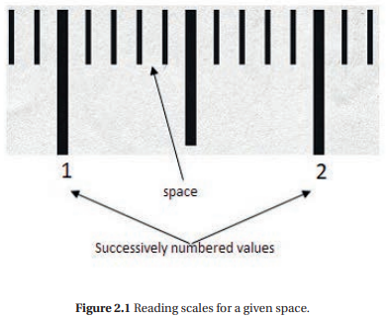

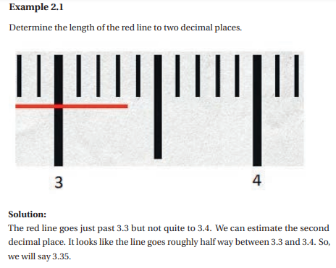

(7)
Unit 2 Physical Quantities

Standard: in the previous section you have learned different types of scales. Now, you are going to learn about measures used in your local area and the standard units of basic quantities. The laws of physics are expressed in terms of basic quantities that require a clear definition. In physics, the seven basic quantities are length (l), mass (m), time (t), temperature (T), current (I), amount of substance (n), and luminous intensity (IV).
Length: Meter is the standard or international system (SI) unit for length. There are also other non-SI units of length. These are centimeter (cm), millimeter (mm), and kilometer (km). The meter (m) is defined as a distance traveled by light in vacuum during a time of 1 299792458 s.
Time: It is defined as the interval between two events. It is a fundamental quantity. The unit of time in SI system is second (s). The non-SI units of time are minute (min), hour (hr), day, month and year. The second (s) is defined as 9 192 631 770 times the period of vibration of radiation from the caesium-133 atom.
Mass: The kilogram (kg) is the standard or international system (SI) unit of mass. The non-SI units of mass are gram (g), milligram (mg), and tone. The kilogram (kg) is defined by taking the fixed numerical value of the Plank constant h = 6.62607015×10−34 when expressed in the units of J s (which is equal to kg m2 s).
Standard Units are conventional units which are used to measure physical quantity scientifically
(8)
Unit 2 Physical Quantities

Scientific Notation: a system in which numbers are expressed as products consisting of a number between 1 and 10 multiplied by an appropriate power of 10.
In physics, scientific notation is a way of writing measured values that are too large or too small to be conveniently written as a decimal. This can be written more easily in scientific notation, in the general form:
d ×10^{n}
Prefixes: is a letter or a syllable which is written directly before a unit name with no space.
In the previous section you have learned different basic units. When a numerical unit is either very small or very large, the units used to define its size may be modified by using a prefix. A prefix is an important aspect of dealing with units. Prefixes are words or letters written in front that change the meaning. Table 2.2 lists a large set of these prefixes. The kilogram (kg) is a simple example. 1 kg is 1000 g, or 1×103 g. We can replace the 103 with the prefix k (kilo).
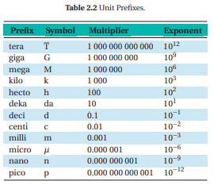

(9)
Unit 2 Physical Quantities

2.2 Measurement
Measurement is the process of comparing an unknown quantity with another quantity of its kind (called the unit of measurement). The measurement process has three key elements:
• The physical quantity to be measured.
• The necessary measuring tools.
• Units of measurements used (standard units)

Measuring Length When you are measuring the length of objects, you are comparing it with the standard length. The SI unit of length is meter (m) as we discussed before. There are also non SI units of length. These are millimeter (mm), centimeter (cm) and kilometer (km).

Length is one of the fundamental (basic) physical quantities which describes the distance between two points.
Measurement is the comparison of an unknown quantity with the known fixed unit quantity. It consists of two parts: the unit and the number indicating how many units are in the quantity being measured.

For example:
The length of a table is 3 meters. In this example, 3 is the magnitude, and meter is the standard (unit) of that quantity.
(10)
Unit 2 Physical Quantities

Measuring Mass
Definition: Mass is a basic physical quantity. It is defined as the amount of matter contained in a body.
The SI unit of mass is a kilogram (kg). There are also non SI units used to measure the mass of an object. In scientific way mass is measured by an instrument called beam balance.
Measuring Time
Time is the basic physical quantity. It describes the duration between the beginning and end of an event. The SI unit of time is second (s). The commonly used non SI units of time are: minute, hour, day, week, month and year.
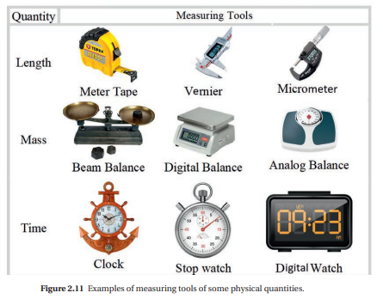

(11)
Unit 2 Physical Quantities

2.3 Classification of Physical Quantities.
Physical quantities
Definition: A physical quantity is anything that you can measure. For example, length, temperature, distance and time are physical quantities.
Quantities that can be measured directly or indirectly are known as physical quantities. The measured values of physical quantities are described in terms of number and unit. Each physical quantity and its unit have a symbol.
You can observe that some physical quantities are directly measured while other physical quantities are measured by combining two or more measurable quantities. For example you measured the width and length of your blackboard directly. However, the area is measured by multiplying the length and width of the blackboard - A = l ×w. Physical quantities can be classified into two.
• Fundamental or basic physical quantities.
• Derived physical quantities.
Fundamental or basic physical quantities: are physical quantities which can be measured directly. They cannot be described in terms of other physical quantities. The units used to measure fundamental quantities are called fundamental units. i.e., the unit of fundamental quantity is called fundamental unit. It does not depend on any other unit.
(12)
There are seven fundamental physical quantities as shown in Table 2.3
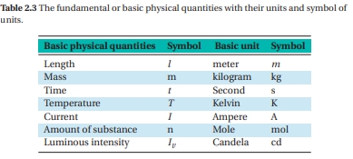

Derived physical quantities: Physical quantities which depend on one or more fundamental quantities for their measurements are called derived physical quantities. The units of derived quantities which depend on fundamental units for their measurement are called derived units. Area, volume, density, and speed are some examples of derived physical quantities. Table 2.4 shows some derived quantities with their units and symbol of units.

(13)
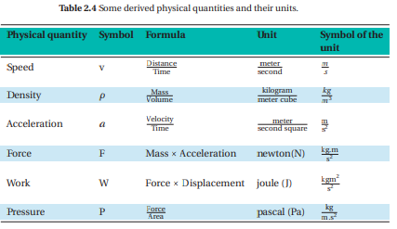

Physical quantities can also be classified as scalar and vector quantities. Some physical quantities are described completely by a number and a unit. A number with a unit is called a magnitude. However, other quantities have a direction attached to the magnitude. They cannot be described by a number and unit only. Thus, physical quantities are grouped into two. These are:
• Scalar quantities.
• Vector quantities.

(14)

A scalar quantity is a physical quantity which has only magnitude but no direction.
Examples are: distance, mass, time, temperature, energy etc.
A vector quantity is a physical quantity which has both magnitude and direction. When expressing that the car moves 50 km/h to east, this gives full information about the velocity of the car that includes magnitude and direction (50 km/h is the magnitude, and east is the direction). Because of this, velocity is a vector quantity. Examples are: displacement, acceleration, force, etc. A vector can be represented either by a single letter in bold face or by a single letter with arrow head on it. For example: displacement can be represented as ~S or S.
2.4 Unit Conversion
In the previous section you have learned different physical quantities. These physical quantities have SI and non SI units. It is possible to convert units from SI unit to non SI unit and vice versa. Conversion of units is the conversion between different units of measurement for the same physical quantity, typically through multiplicative conversion factors.

(15)

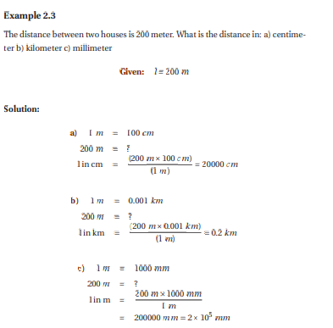
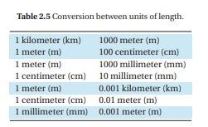
(16)

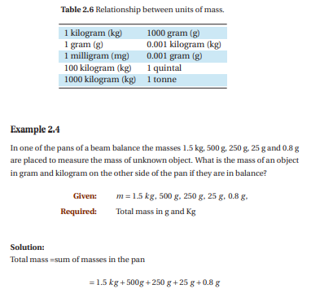
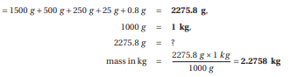

(17)

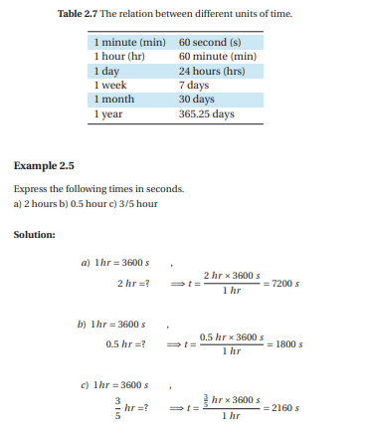

(18)
Name: Worksheet (2)
Date: Physical Quantities ...... Grade
_____________________________________________________________________________________

1) Physics and Human Society
1.1 Definition and Nature of Physics . . . . . . . . . . . . . . . . . . . 1
1.2 Branches of Physics . . . . . . . . . . . . . . . . . . . . . . . . . . . 2
1.3 Related Fields to Physics . . . . . . . . . . . . . . . . . . . . . . . . 4

2) Physical Quantities
2.1 Scales, Standards, Units (prefixes) . . . . . . . . . . . . . . . . . . . 6
2.2 Measurement and Safety . . . . . . . . . . . . . . . . . . . . . . . . 10
2.3 Classification of Physical Quantities . . . . . . . . . . . . . . . . . 12
2.4 Unit conversion . . . . . . . . . . . . . . . . . . . . . . . . . . . . . 15
2.5 Vectors . . . . . . . . . . . . . . . . . . . . . . . . . . . 19
3) Motion in a Straight Line
3.1 Position, Distance and Displacement . . . . . . . . . . . . . . . . .
3.2 Average Speed and Instantaneous Speed . . . . . . . . . . . . . . .
3.3 Average Velocity and Instantaneous Velocity . . . . . . . . . . . .
3.4 Acceleration . . . . . . . . . . . . . . . . . . . . . . . . . . . . . . .
3.5 Uniform Motion . . . . . . . . . . . . . . . . . . . . . . . . . . . . .
3.6 Graphical Representation of Motion . . . . . . . . . . . . . . . . .
4) Force, Work, Energy and Power
4.1 The Concept of Force . . . . . . . . . . . . . . . . . . . . . . . . . .
4.2 Newton’s Laws of Motion . . . . . . . . . . . . . . . . . . . . . . .
4.3 Forces of Friction . . . . . . . . . . . . . . . . . . . . . . . . . . . .
4.4 The Concept of Work . . . . . . . . . . . . . . . . . . . . . . . . . .
4.5 Kinetic and Potential Energies . . . . . . . . . . . . . . . . . . . . .
4.6 Power . . . . . . . . . . . . . . . . . . . . . . . . . . . . . . . . . . .

