Name:
Date:
Topic 2 Study Worksheet (First Grade)

1.) Carrie has 4 ribbons. Her sister gives her 5 ribbons.
How many ribbons does Carrie have now?
A 7
B 8
C 9
D 10
2.) Juan has 2 stickers.
His teacher gives him
6 stickers.
How many stickers does Juan have in all?
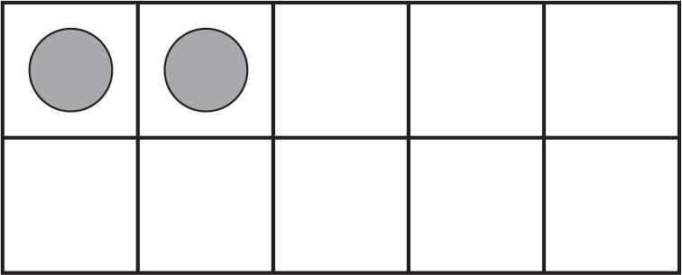
A 5
B 6
C 7
D 8

3.) James buys 8 red apples. He buys 2 green apples.
How many apples does James buy?
Explain how you know.

______ apples
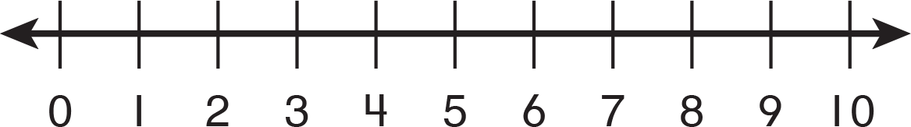
4.) Find 6 – 2.
Show your work.
6 - 2 = _____

5.) Write the doubles fact that will help you find 4 + 5. Find the sum.
____ + ____ = ____
4 + 5 = ____

6.) Maria is thinking of a number. Her number is 3 less than 6. Write an equation to find her number.

____ - ____ =

7.) 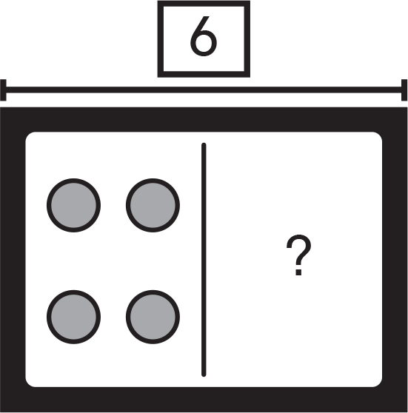
4 + ____ = 6
So, 6 – 4 = ____

8.) There are 3 basketballs and 2 soccer balls.
What two equations match this picture?
 ____ + ____ = ____
2 + 3 = 5
2 + 5 = 7
3 + 2 = 5
5 + 2 = 7

9.) What two addition equations can help you find
6 - 5 =
5 + 1 = 6
1 + 5 = 6
2 + 4 = 6

10.) Find 3 + 6. Use the
Number line. 3 + 6 = ____

- ) Julie has 2 cards.
How many more should Michael give her so she can have 10?
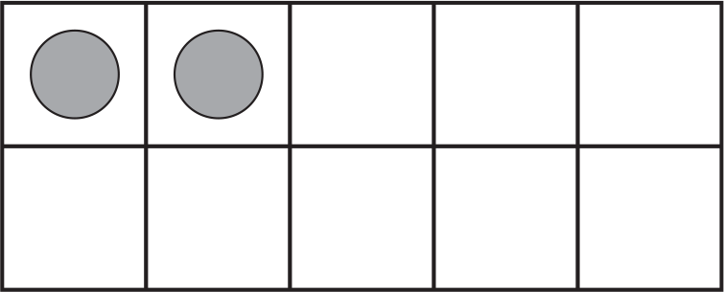 ______ + ______ = 10

12.) Which is a doubles fact?
A 2 + 3 = 5
B 3 + 3 = 6
C 6 + 1 = 7
D 3 – 3 = 0
13.) Erin wants to buy 5 balls of yarn. She can buy purple or green yarn. Complete the table to show all the ways Erin can buy the yarn.
Purple  | 0 |  | 2 | 3 |  | 5
Green |  | 4

