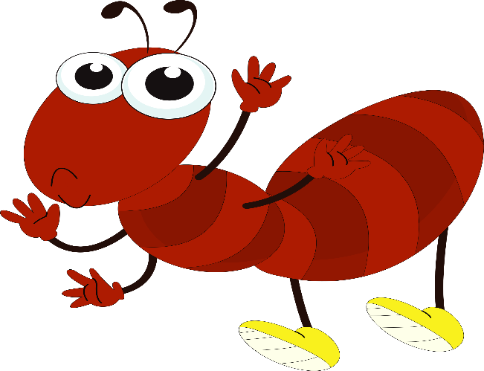
*Adverbs : حال
An adverb tells how
something happens .
For example :
1 The rabbit ran quickly .
Quickly : is an adverb .
2 Jack sang happily .
Happily : is an adverb .

An adverb tells when something happens .
For example :
- We will leave soon .
Soon : is an adverb .
- I will go to Icon mall tomorrow .
Tomorrow : is an adverb .

An adverb tells us where something happens .
For example :
1 The children are playing outside .
Outside : is an adverb .
- There is a fat rat inside .
Inside : is an adverb .

Conjunctive adverb :
Is a special tool that connects to simple sentences .* For example : The children played skillfully all year ; eventually , they were going to win a game .
Skillfully : is an adverb .
Eventually : is a conjunctive adverb .

It’s a special tool that can start a sentence , but after comes a comma . For example :
1 In fact , the chips tasted very salty .
In fact : is a conjunctive adverb .
Very salty : is an adverb .

It’s a special tool that connects a dependent clause with an independent clause , but you have to put a comma before and after the conjunctive adverb
For example :
1 Sally studied hard for the exam , however , she didn’t pass .
However : is an conjunctive adverb .

