
Third Grade
Name:


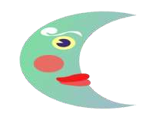
Assessment Sheet
Why Sun and Moon Live in the Sky

Vocabulary:
Choose the correct answer from the following:-
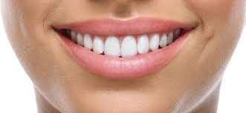
- She smiled …………..when she meet her friends.
a) broadly b)massive
c) scales d)sturdy
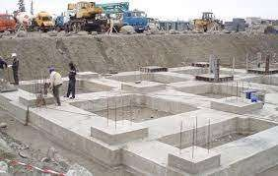
- This house has a solid ……………
  - foundation.
  - Broadly
  - Scales
  - Massive


- He had a …………., muscular, physique.
  - broadly
  - scales
  - fooundation
  - sturdy

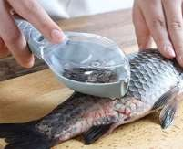
- There were tiny fish with glittering ………….
  - Massive
  - Foundation
  - Scales
  - Sturdy

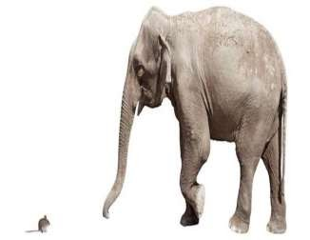
- The size of the ocean is ……………. a.sturdy
- massive
- foundation
- scales

- Words that name people ,places or things …………
  - adjectives
  - nouns
  - verbs
d. adverbs

- Words that tell what something or someone is or does
a) adjectives b)nouns
c) verbs d)adverbs

- Words describing what nouns name
a) adjectives b)nouns
c) verbs d)adverbs
- Words that tell how or when or where something happens
a) adjectives b)nouns
c) verbs d)adverbs

Word Study
Choose the correct spelling:-

- thousands –thuosands –thoosands – thousends.
- shawer –showar- shawor–shower.
- pawor–pawer– pewar – power .
- enjoy –enjay– enjiy –enjey .
- bounce – bounc – bawnce – baunce .
- avoed– avoid – avoyd – avoide.
- appoynt – appoint– appaint –appuint.
- annoiy –annouy – annowy – annoy.
- proud – prowd –proid –prawd.
- fowntain – fountain - fawntain –fontain.

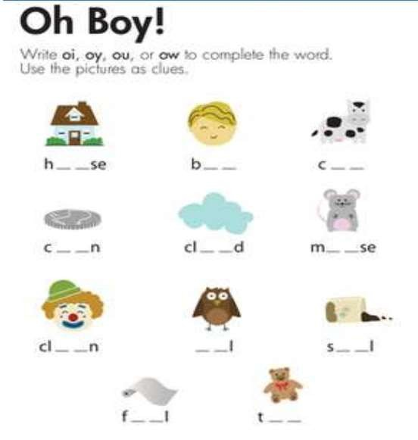

Fill in the spaces with one of these H.F.W. words:
(Unit - Figure)
1. A centimeter is a …………………… of length.
- A family is the smallest ………………………… of society.
- Suddenly, a ………………. jumps out of a bush dressed head-to-toe in Arm
- The program helps students ………………….. out how they can read fluently.

Choose the correct answer (author’s purpose):
  - When a book gives facts ( inform – entertain – persuad).
  - When a book is just for fun ( inform – entertain – persuad).
  - When the author tries to get you to do something ( inform – entertain – persuad).
  - A book of knock-knock jokes ( inform – entertain – persuad).
  - A cookbook with recipes for cookies ( inform – entertain – persuad).
  - A girl's note to her mom about why she should get a pet ( inform – entertain – persuad).

  - A commercial for mcdonald's ( inform – entertain – persuad).

  - A booklet about why you should not watch too much tv ( inform – entertain – persuad).

Essay Questions:
Answer the following questions:
  - What is the genre of our story?
………………………………………………….
  - Who are the main characters in our story?
………………………………………………….
  - What was the Sun’s problem?
………………………………………………….
  - What did his wife – Moon- suggest?
………………………………………………….
  - How did they manage to build their house?
………………………………………………….
  - Who did the Sea invite along?
………………………………………………….
  - What happened at the end of our story?
………………………………………………….
  - Was water a good guest?
…………………………………………………

Grammar:
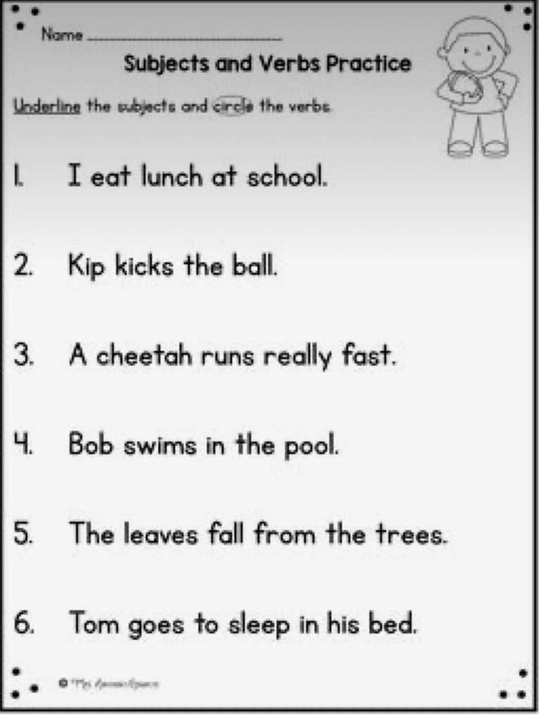

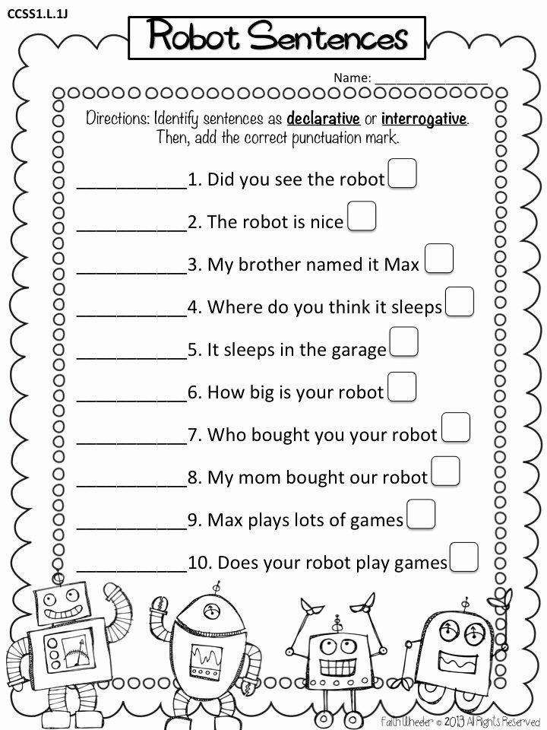

Directions: Read the selection and answer the questions that follow.

Looking to the Stars
What is the Very Large Array?
The Very Large Array (VLA) is a group of special telescopes. They do not use lenses to look into space. These telescopes are shaped like bowls. This shape allows them to capture radio waves.
How does it work?
Objects in space, such as stars, make energy. This energy can be sent into space. One type of energy sent into space is radio waves. Radio telescopes can find this energy.
Where is the Very Large Array?
The VLA is located in the desert in New Mexico. Large telescopes work best away from light. Radio telescopes like the VLA need quiet places to collect radio signals from space. The desert is the perfect place for a telescope because it is dark and quiet.
How many telescopes are in the Very Large Array?
The VLA is made up of 27 dishes that are lined up in a large Y. Each dish is 82 feet wide and weighs over 200 tons. That’s almost as long as two buses and as heavy as 2,000 elephants! Scientists use the VLA to study the galaxy and neighboring planets. It helped them discover ice on Mercury!
