Science Topic 5 Study Guide (Worksheet)

- Parts of the Plant
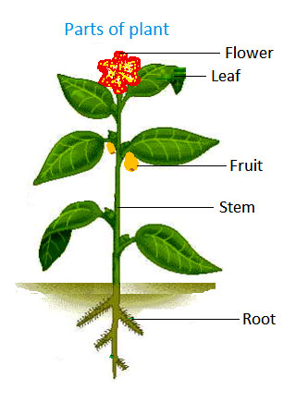
What do the roots help the plant do?
The roots of plants take in water from the soil and they keep the plant stuck in the ground.

What do the stems do?
The stem helps move water to all the parts of the plant. It also holds the plant up.

What do the leaves do?
The leaves make the food for the plant using sunlight.

What do flowers and fruits do?
Flowers and fruits help make new plants. Flowers help make seeds. Fruits hold and keep seeds safe.

- How animals move
-Animals move to find food and water
 Bears have legs to move. They are protected with fur. Bears use their nose and lungs to breathe.

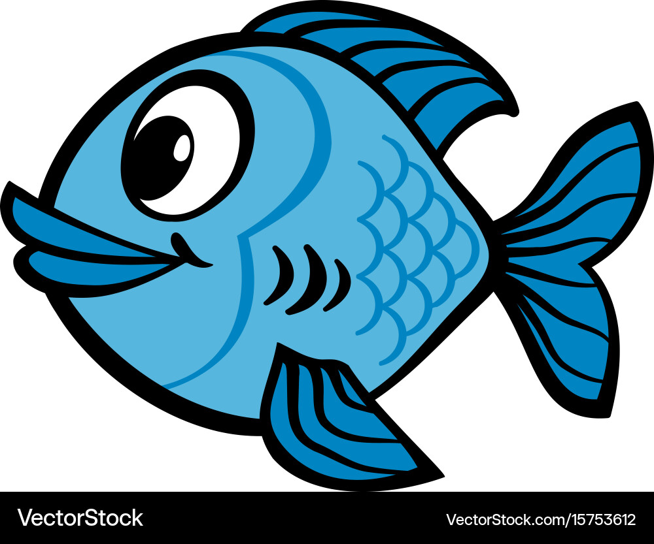 Fish have fins to move and swim. They are protected with hard scales. Fish use gills to breathe underwater.

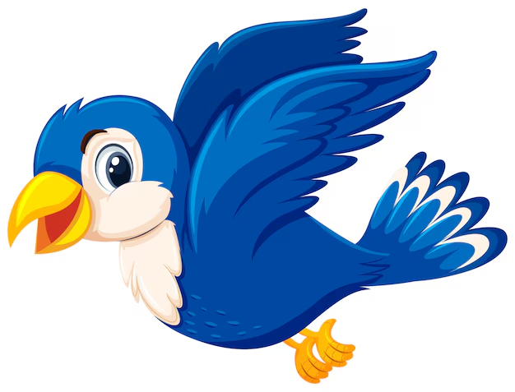Birds have wings to help them fly. They are protected with feathers. They have sharp beaks to help them eat seeds.

- Animals Senses
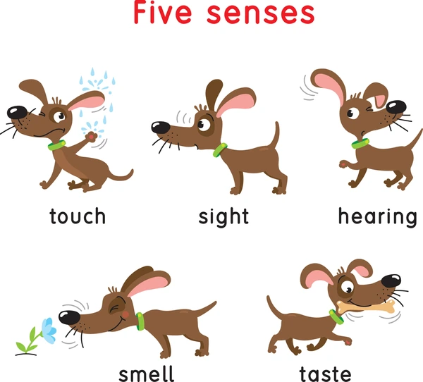
Animals use their five senses to get information around them and to keep them safe from danger.

- People Mimic Nature
How do we get ideas from animals and plants to help us live?
People copy or mimic some things plants and animals do.
Example: Bears have sharp claws on their legs that help them dig in the dirt. We copied this idea and made a tool that looks like this: 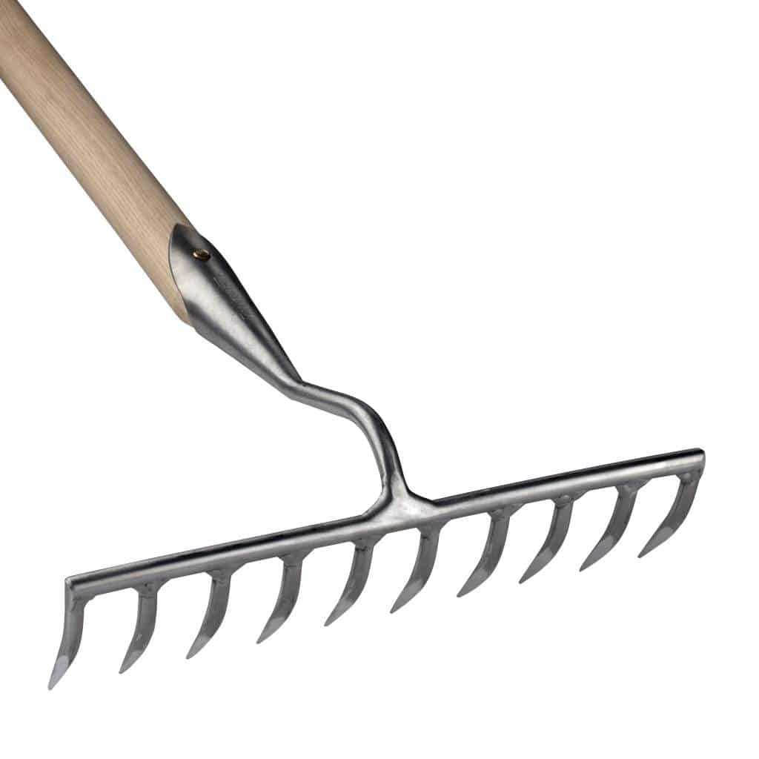

- Environments
-Plants and animals live in environments.
What is an environment?
An environment is everything that is around you.
-There are living things and nonliving things in an environment.
-Living things need food, air and water to live and grow. Like animals, plants and people.
-Nonliving things do not need food, water or air to stay alive and they do not grow or change. Like rocks and water.
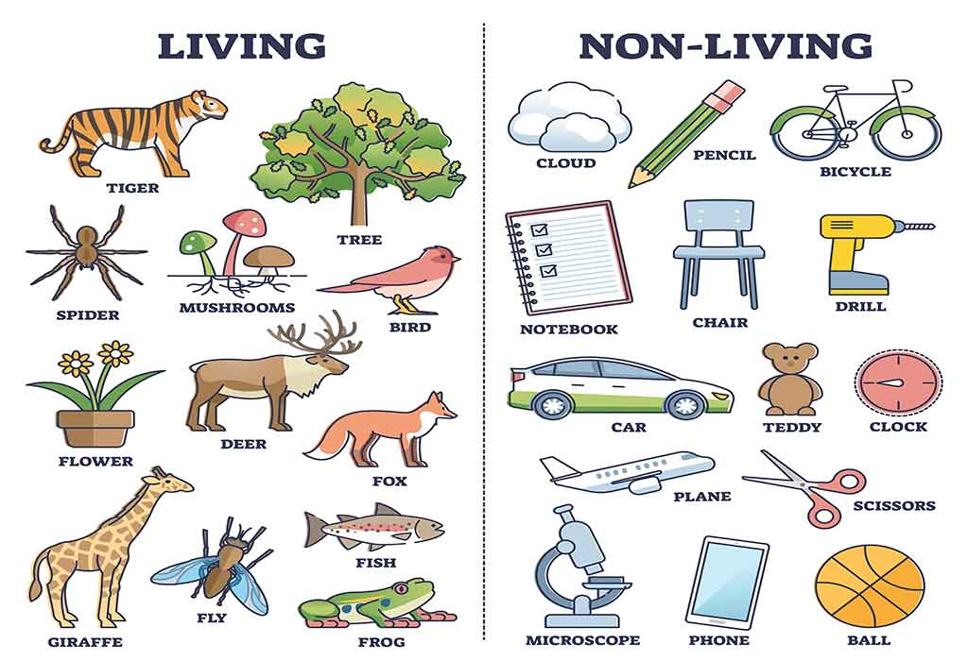
- Land and Water Environments
- Ocean: The water in oceans is salty and deep. Fish live there.
- Grasslands: Land environment that has trees and grass. Birds and small animals live there.
- Desert: The land is very dry and hot. Few plants and animals live there.
- Wetland: Water covers the soil and is not deep. Birds can live here.

