Religion :

Religion
Religious beliefs and values help shape cultures. Religion :is a system of worship and belief, including belief about the nature of a God or Gods. Religion can help people answer questions about the meaning of life. It can also guide people in matters of ethics, or standards of acceptable behavior.
The world has many religions. Jews, Christians, and Muslims believe in one God. Members of other religions may believe in several Gods.
All religions have special buildings where religious rituals and worship take place. For Christianity, it is a church. In Judaism, that place is a synagogue. In Islam, it is a mosque. In Hinduism and Buddhism, it is a temple. Most religions have an institutional clergy, the body of people trained to carry out religious duties and lead ritual worship. Each religion also has its own prayers and rituals. Followers also observe special religious holidays.
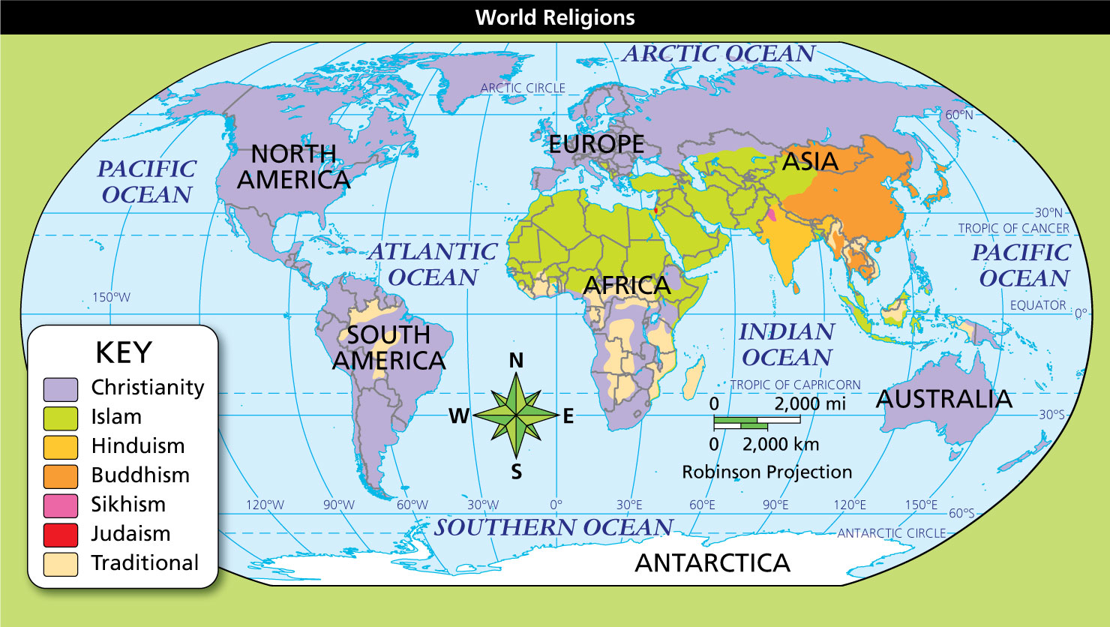

Geography Skills
The map shows the most widely followed religions around the world. While the map shows the religions with the largest number of followers in each region, many regions have important religious minorities, and every major religion has followers worldwide.
- Region Where is Islam the dominant religion?
Notebook
- Draw Conclusions Why do you think traditional religions are generally found in small areas?
Notebook
Image long description
The world's principal religions, and the areas where they have the most followers, are as follows:
- Christianity: North America, Central America, South America, parts of southern Africa, Europe, Russia, Australia, and some of the Pacific Islands.
- Islam: northern Africa, West Asia, Central Asia, Indonesia, and parts of South Asia.
- Hinduism: India
- Buddhism: China, as well as parts of Japan and other East Asian countries.
- Sikhism: a region of northwestern India.
- Judaism: Israel in West Asia.
- Traditional religions have large numbers of followers in parts of South America, large swaths of sub-Saharan Africa, parts of Southeast Asia, and some of the islands of the Pacific.

Judaism
Judaism is based on a belief in one God, with spiritual and ethical teachings recorded in the Hebrew Bible. It began in the Middle East more than 3,000 years ago. By 100 ce, Jews lived in Europe, Southwest Asia, and North Africa. The Jewish State of Israel was established in 1948. There are about 14 million Jews worldwide.

Christianity
Christianity is based on the teachings of Jesus, who Christians believe was the son of God. The Christian Bible is their sacred text. Christianity began in Southwest Asia around 30 ce and spread first to Europe and Africa and later to the rest of the world. There are more than 2 billion Christians.

Islam
Islam is based on the Quran, a sacred text. The Quran contains what Muslims believe is the word of God as revealed to Muhammad beginning in 610 ce. Islam spread across Southwest Asia and North Africa, then to the rest of the world. There are almost 2 billion Muslims.

Hinduism
Hinduism evolved gradually over thousands of years in South Asia. It has several sacred texts. Hindus believe that everyone in the universe is part of a continuing cycle of birth, death, and rebirth. There are more than 1 billion Hindus.

Buddhism
Buddhism is based on the teachings of Siddhartha Gautama, known as the Buddha, who was born in India in the 500s bce. The Buddha’s teachings include the search for enlightenment, or a true understanding of the nature of reality. There are about 500 million Buddhists.

Sikhism
Sikhism is based on the writings of several gurus, or prophets. Guru Nanak founded Sikhism about 1500 ce in South Asia. Sikhism’s teachings include the cycle of rebirth and the search for enlightenment. There are about 24 million Sikhs.

Traditional Religions
Traditional religions include thousands of distinct religions. These religions tend to be passed down by word of mouth instead of through sacred texts. Each has its own set of beliefs, some having to do with gods or spirits. Examples include many traditional African religions.
- Reading Check Identify Supporting Details How does religion help shape a culture?

