What Is Culture?
All people have the same basic needs and wants, such as food, clothing, and shelter. But different cultures respond to those needs and wants in different ways. A culture is the beliefs, customs, practices, and behaviors of a particular nation or group of people.
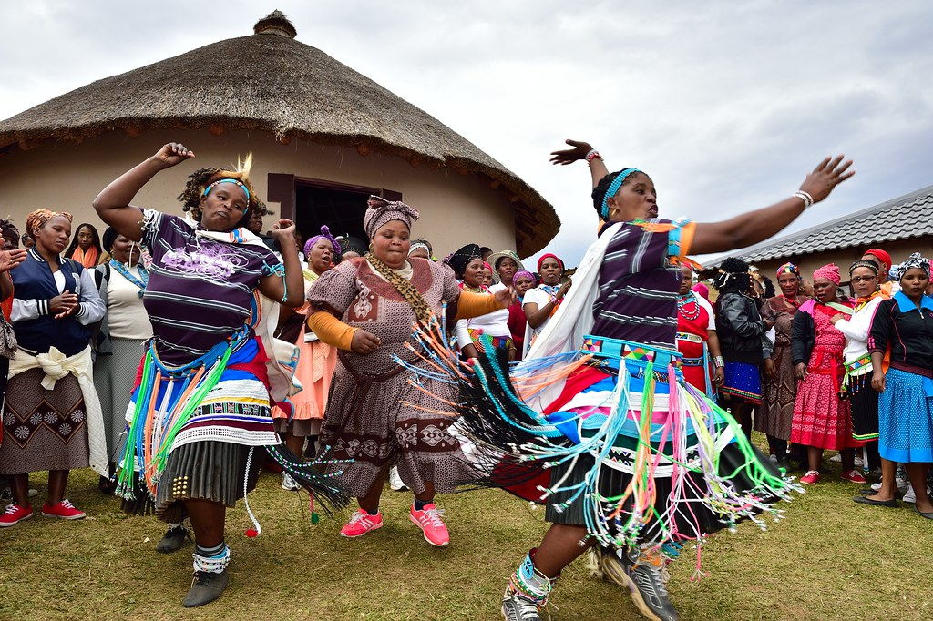

Features of Culture
Features that make up a culture are known as cultural traits. Cultural traits include language, laws, religion, values, food, clothing, and many other customs. Children learn cultural traits from their parents and other adults. People also learn cultural traits from the mass media and from organizations they belong to. Common cultural traits are called norms, which are behaviors that are considered normal in a particular society.
Some cultural traits remain constant over many years. But culture can change over time as people adopt new cultural traits. For example, Americans dress differently today than they did 100 years ago.
Culture and Geography
People can shape their environment by meeting their basic needs for food, clothing, and shelter. People of different cultures use the land in different ways. They build houses differently. They plant different crops and build settlements differently.
The environment can also shape culture. When people move from one place to another, their culture can change in response to new climates and land forms.
A single culture can dominate a region. A culture region is an area in which a single culture or cultural trait is dominant. Earth has thousands of different culture regions. Common traits that unify a culture region include shared religion or language. Culture regions are often different from political units. Occasionally, a culture region may cover an entire country. In Japan, for example, nearly everyone speaks the same language, eats the same foods, and follows the same customs. A country often includes more than one culture region.
Culture regions can also include several countries. For example, the Arab world forms a culture region in Southwest Asia and North Africa. Arab Muslims are the majority in many countries in these regions. They share the religion of Islam, the Arabic language, and other traits.

