Language
Cultures could not exist without language. The set of spoken sounds, written symbols, or hand gestures that is language makes it possible for people to communicate. Without language, people would not be able to share information or ideas. They could not pass on cultural traits to their children.
Languages often vary from one culture to another. Within a country, differences in language can keep people from distinct cultures apart and make it harder to unify the country. Language differences can also keep the people in different countries apart by preventing communication.
People who speak different languages sometimes turn to a third language in order to communicate with each other. In modern times, English has often served as a common language for people around the world.
Languages that are similar form language groups, such as those shown on the map. The languages in a language group share a common ancestor. This ancestor was a language spoken so long ago that it gradually developed to become several related languages.
Click a picture for more information
- 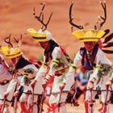
- 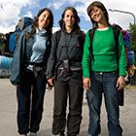
- 
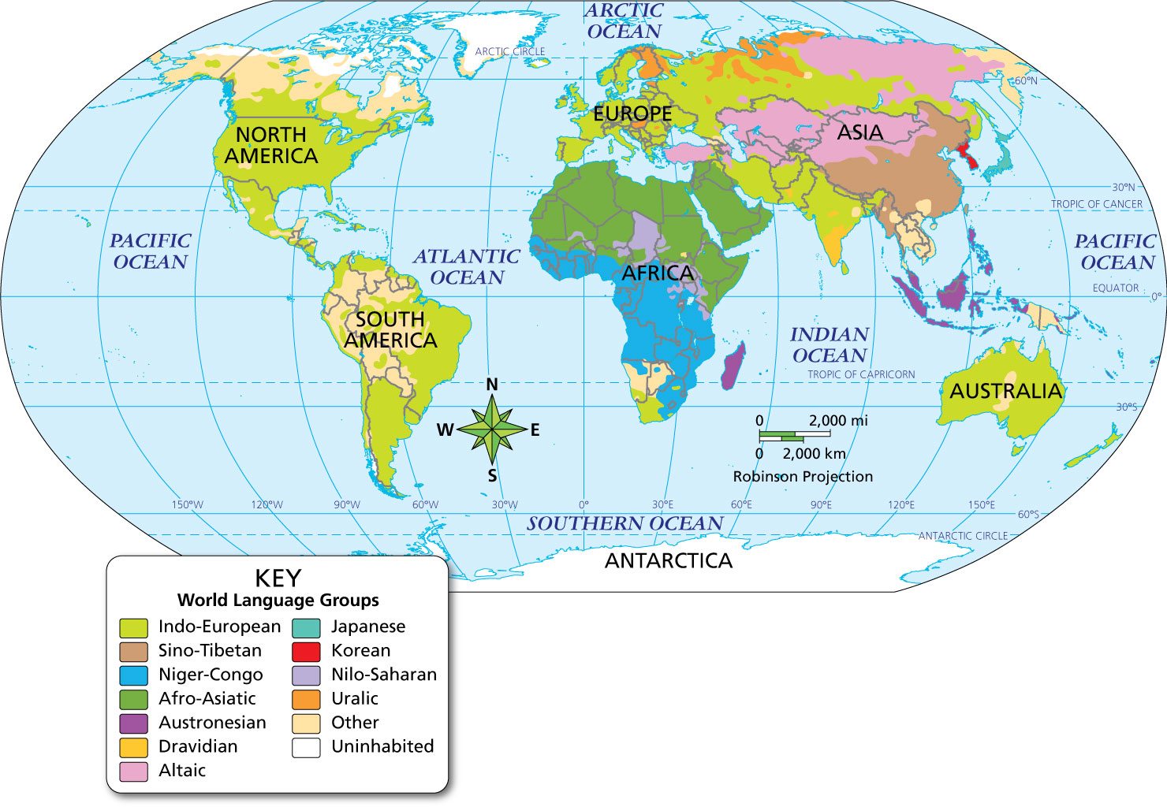
Geography Skills
This map shows the distribution of the major language groups spoken around the world.
- Place What language group dominates most of North and South America?
Notebook
- Synthesize Visual Information Which language group appears to have spread across the Indian Ocean?
Notebook
Image long description
The world language groups are distributed as follows:
- Indo-European: North America, Central America, South America, Europe, Russia, Central Asia, South Asia, and Australia.
- Sino-Tibetan: eastern China and surrounding regions.
- Niger-Congo: mid-to-southern Africa.
- Afro-Asiatic: northern Africa and West Asia.
- Austronesian: island nations of the South Pacific, including Indonesia, Malaysia, and the Philippines.
- Dravidian: the southernmost region of India, Sri Lanka, with small pockets in Pakistan, Afghanistan, and Bangladesh.
- Altaic: Central and the far north of Asia.
- Japanese: the Japanese islands.
- Korean: the Korean peninsula.
- Nilo-Saharan: scattered through central Africa.
- Uralic: northern and eastern Europe and Siberia in Russia.
- Other: This category includes languages spoken by indigenous peoples throughout the world, principally in North America, Central America, South America, southern Africa, Southeast Asia, and Australia.
- Uninhabited
- Reading Check Identify Main Ideas How are language and culture related?

