From Hatchet :
*Realistic fiction includes events and characters that seem real -but are not .

Purpose :
Why do writers write realistic fiction stories ?
To entertain or tell a story .

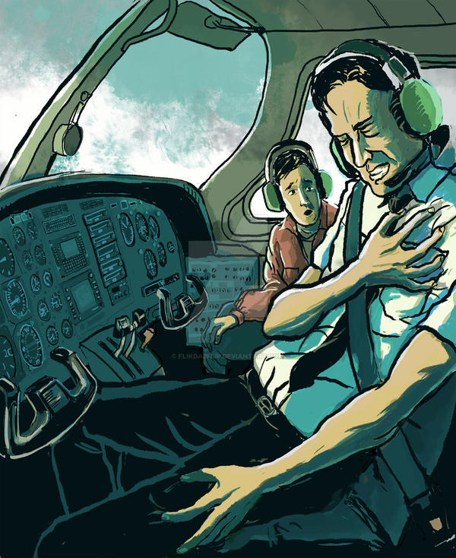
This Photo by Unknown Author is licensed under CC BY-NC-ND
Q1 : What is the genre of the story ?
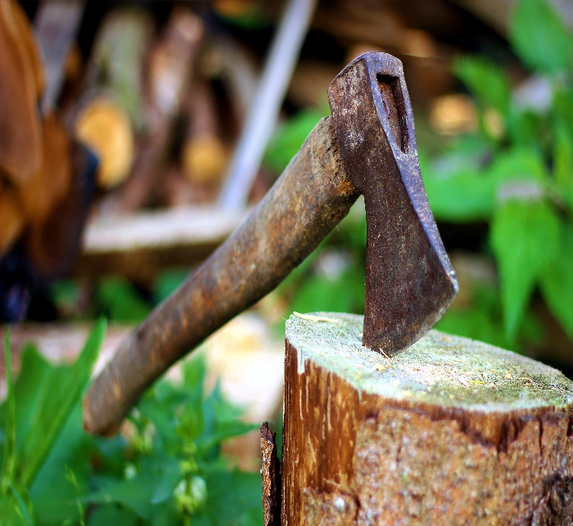
It’s a realistic fiction story .

Q2 : What are the elements of the story?
A setting : is the place that is real or could be real .
Characters act and change like real people .
The plot events could happen in real life

*Text structure :
It’s a chronological order . For example:
(First , second and third ). 1st ,2nd and 3rd.

Vocabularies :
1 Gingerly : cautiously ; with great care . بحذر
2 ignite : catch fire . يشتعل
3 Sputtered : gave out popping sounds . طقطق
4 Painstaking : done with great care and attention . /دقيق
5 Gratified : felt great satisfaction . الشعور بالسعادة
Who is the author ? What do you know about him ?
The author is Gary Paulsen . Gary is no stranger to adventure . He has lived in the woods , raced dogs in Alaska , and , like Brian in Hatchet , survived tough situations alone . He also says that he reads like a wolf eats -and wants you to read like that , too !

