Name: ___________________
Date: ____________________

Math Topic 6: Collecting and Representing Data Activity
Who has more pretzels and M&Ms?

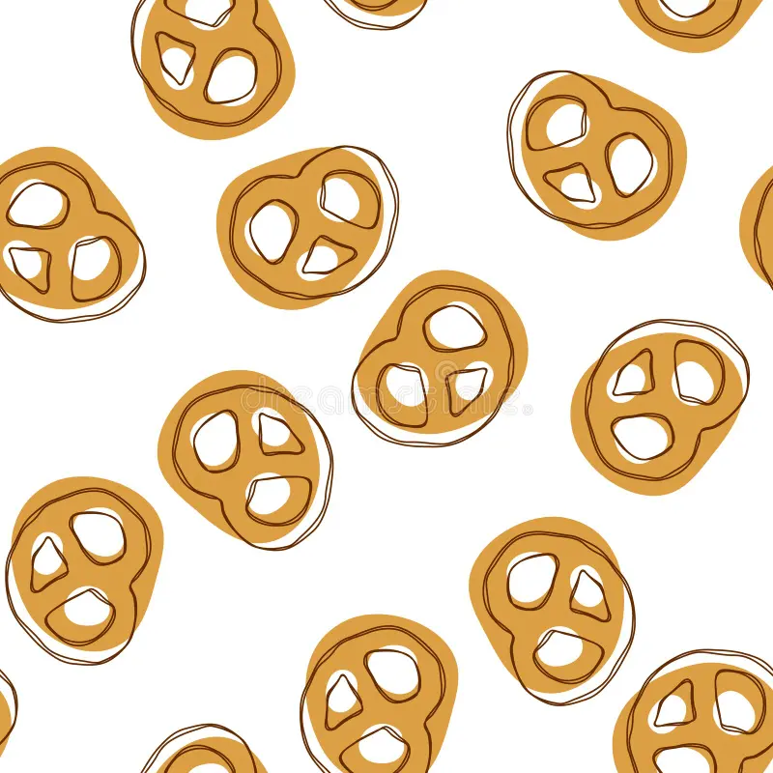 | Total Number of Pretzels ____________

Colors of the M&Ms

Color of the M&M | Tally Mark
Red
Blue
Orange
Brown
Yellow
Green
Which color is the most? _________ Which color is least?_________

