The Life Cycle of a Sunflower
Graded Worksheet
First Grade
Name:

Date:

Main Idea and Details
Main idea is the big most important idea in the story and details are small pieces of information.

Planting a Sunflower
Planting a sunflower takes steps and time. First, dig a small hole. Next, put the seed in the hole. Then, cover the seed with dirt. Last, water the seed.

Write the main idea of the text: ________________________________________________________

________________________________________________________

What is the title of the text?

________________________________________________________

Story Comprehension
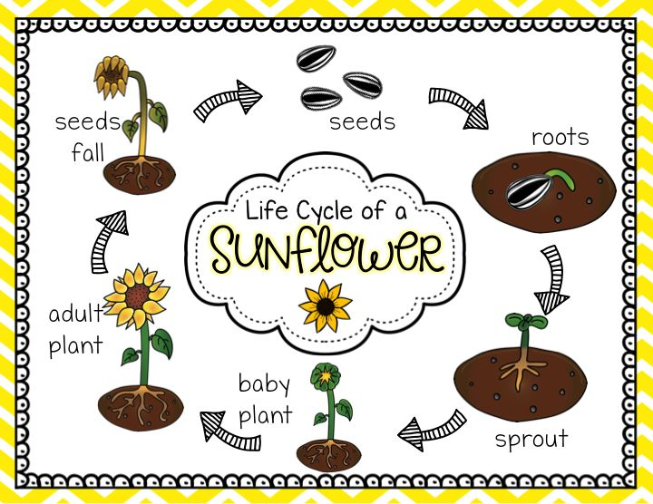

Let’s Grow a Sunflower! Fill in the blanks:

seeds | soil | sunlight | water | air | roots | sprout | leaves | buds | fall

Let’s grow a sunflower! First we need sunflower _____________.

We plant the seeds in the ______________. Flowers need __________ , ___________ and ___________ to grow.

Then they grow __________ and ___________. Small _____________ grow on the stems. Flower ___________ grow on the branches of the stems. Then the flower blooms!

Last, in the season of ___________, the flower dies and their seeds scatter.

Vocabulary Words
Lets use the glossary!:

Buds | ________________________________________
Stem | ________________________________________
Leaves | ________________________________________
Soil | ________________________________________

Phonics (k Spelled ck) page 52

Write the words with ck next to the picture:

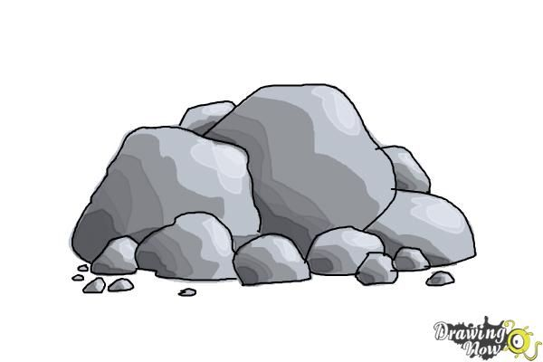 ___ ___ ___ ___

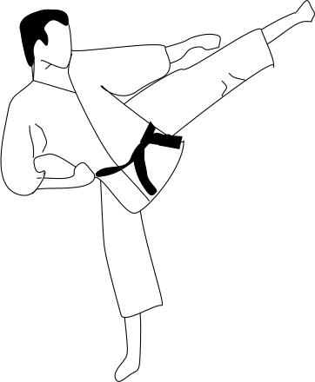 ___ ___ ____ ____
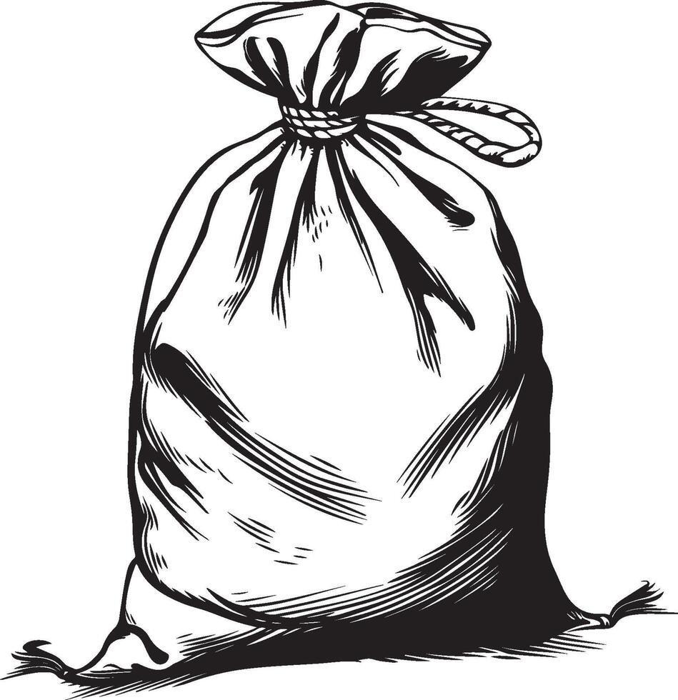 ___ ___ ___ ____
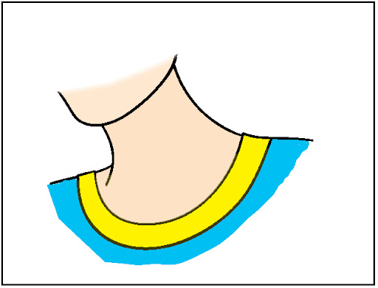 ____ ____ ____ ____

Phonics (s Sound and z Sound Spelled s) page 57
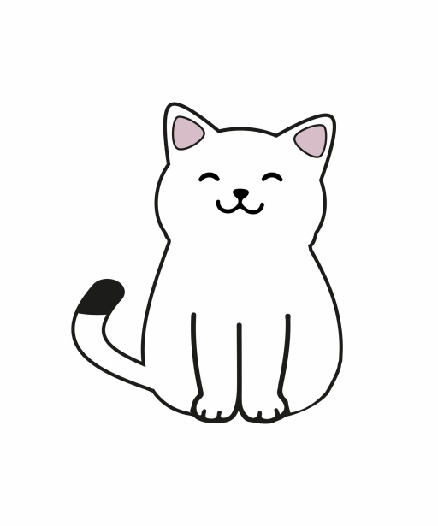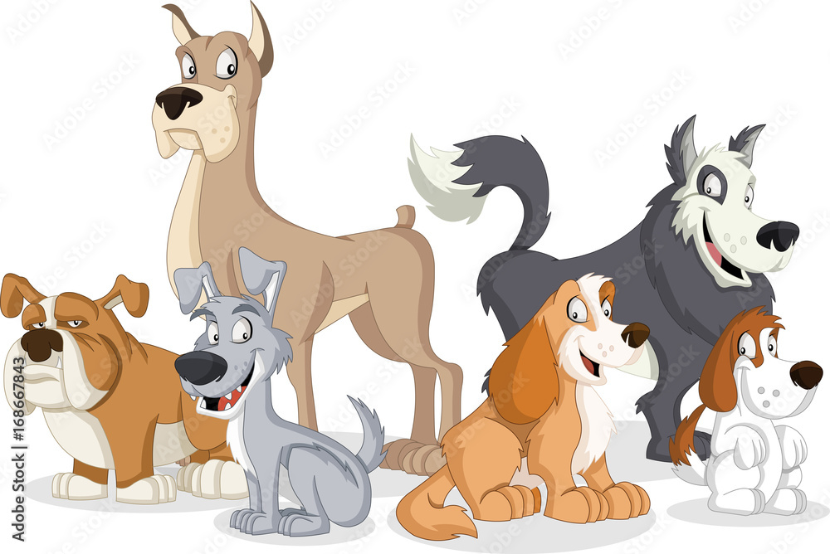
Cat Cats Dog Dogs

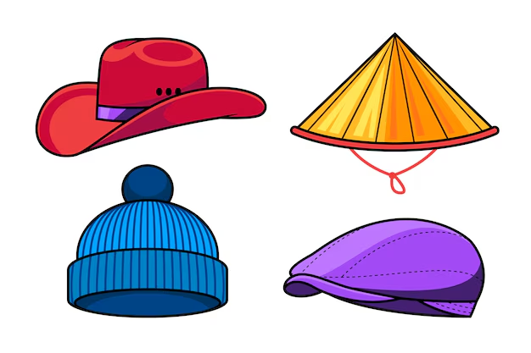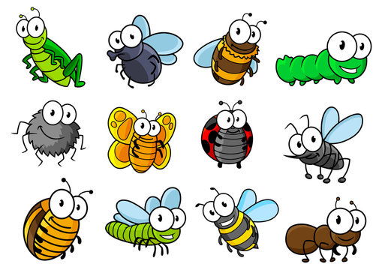
Hat Hats Bug Bugs

Write a sentence using one of the words above:

_________________________________________________________

_________________________________________________________

Grammar (Declarative Sentences) page 84
A declarative sentence is a telling sentence that makes a statement. It begins with a capital letter and ends with a period.

Fix the sentence and put the right punctuation mark:

is plant The green ! _____________________________________

tall will It grow ? _________________________________________

Write a declarative sentence about the picture below:

________________________________________________________

________________________________________________________

