Name: ________________
Date: _________________

Unit 2 - Lessons 1- 4 Graded Worksheet
Families, Culture and Traditions

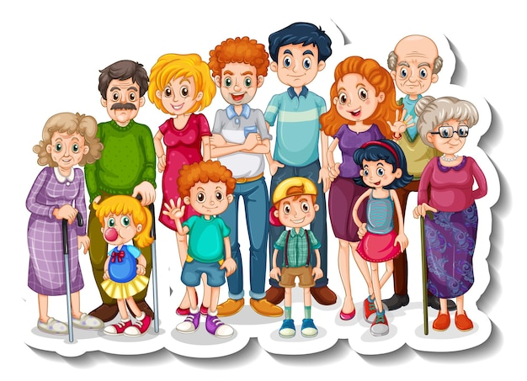

1.) What do we call a group of people who care for each other?
a. family
b. culture
c. history

2.) Who are members of your family?
a. a classmate
b. a neighbor
c. Aunts, uncles, cousins, and grandparents

- ) Which family is from the past and which is from the present?
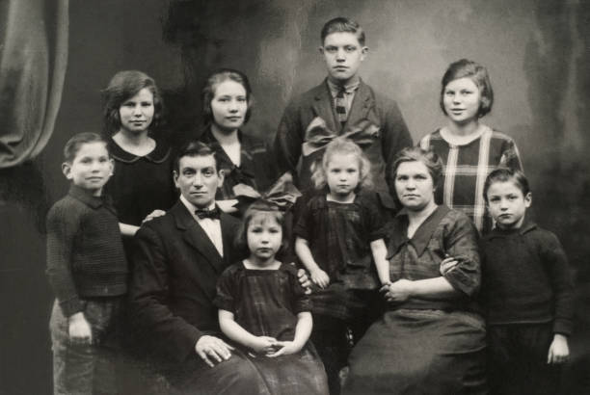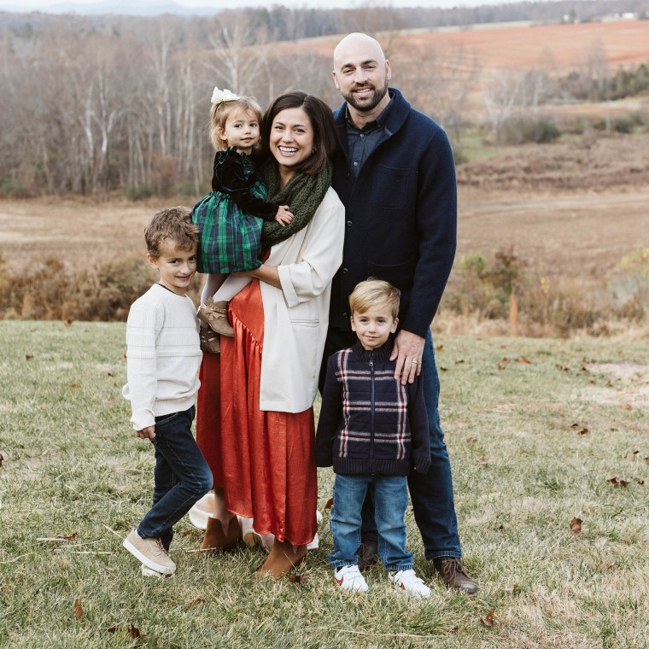

___________________________ ________________________

Match the description with the correct time.
1. Most families living close to each other ____________________________
2. People in families taking care of each other ________________________
3. Family members making phone calls to each other _________________
a. in the past
b. in the present
c. in the past and in the present

Match to make three sentences.
1. Some families in the past were ____________________________________
2. Family members love each other and ______________________________
a. keep each other safe.
b. larger than families today.

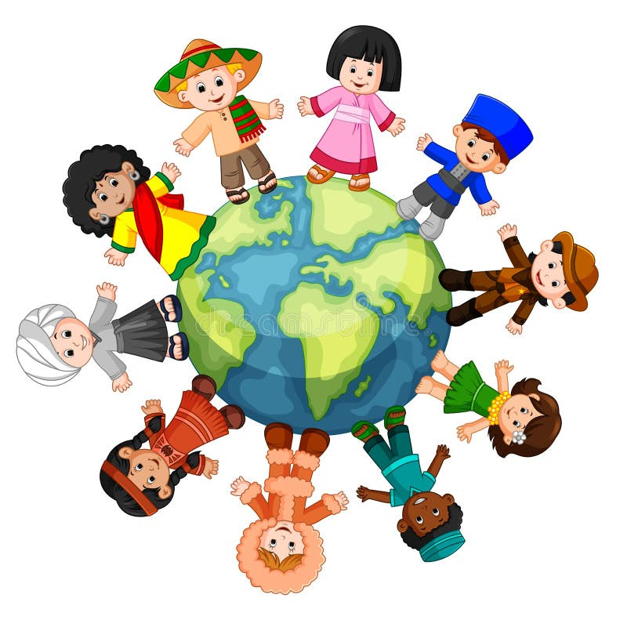 What does this picture show?
- Jobs people have
- People’s favorite subject
- People’s different cultures
What does culture mean?
- a job people do
- Special things a group of people do
- People’s favorite subject

How do people show their culture?
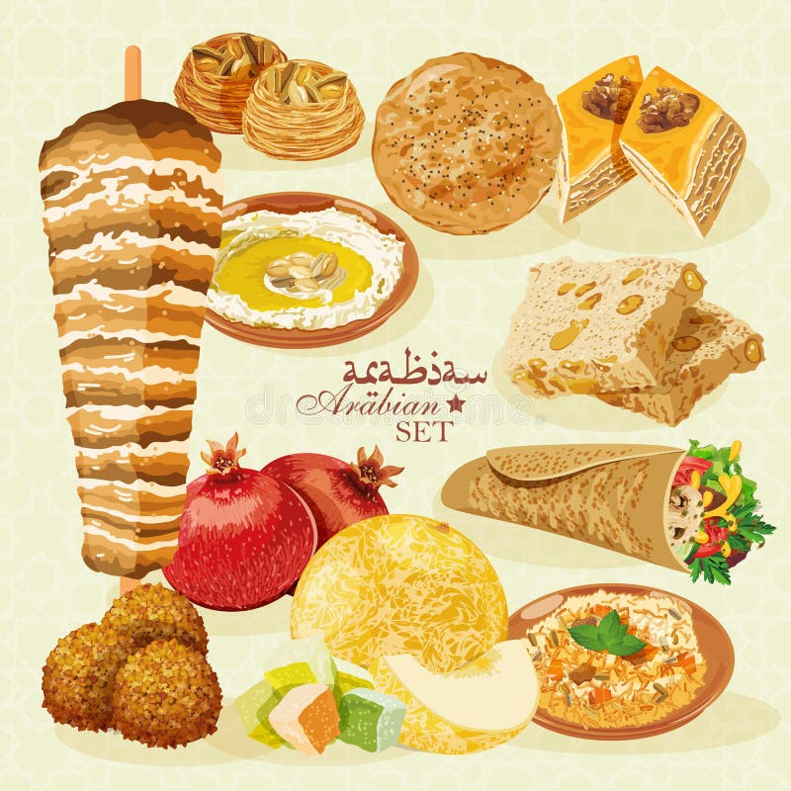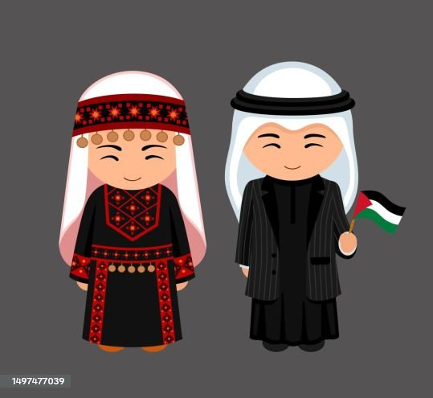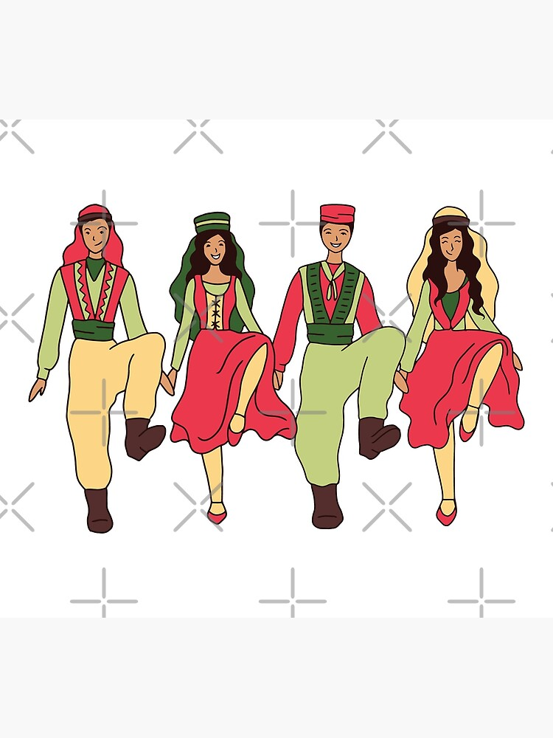

_________________ ___________________ __________________

What are traditions?
a. Traditions are trying new things.
b. Traditions are things that people do the same each time
c. Traditions are fireworks.

Fill in the blanks with the correct words:
tradition | festival | feast | greeting | Ritual

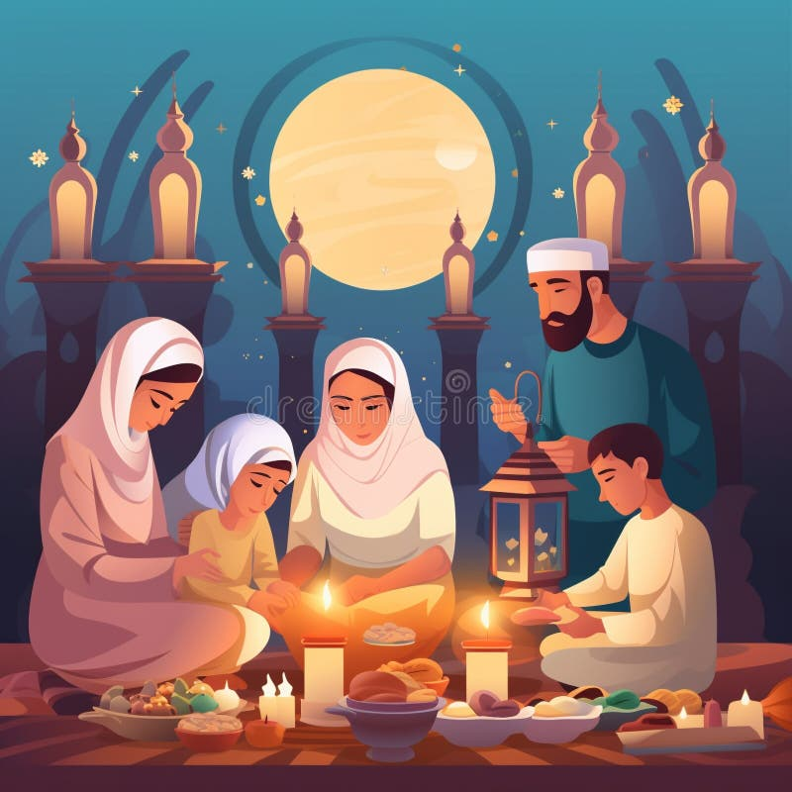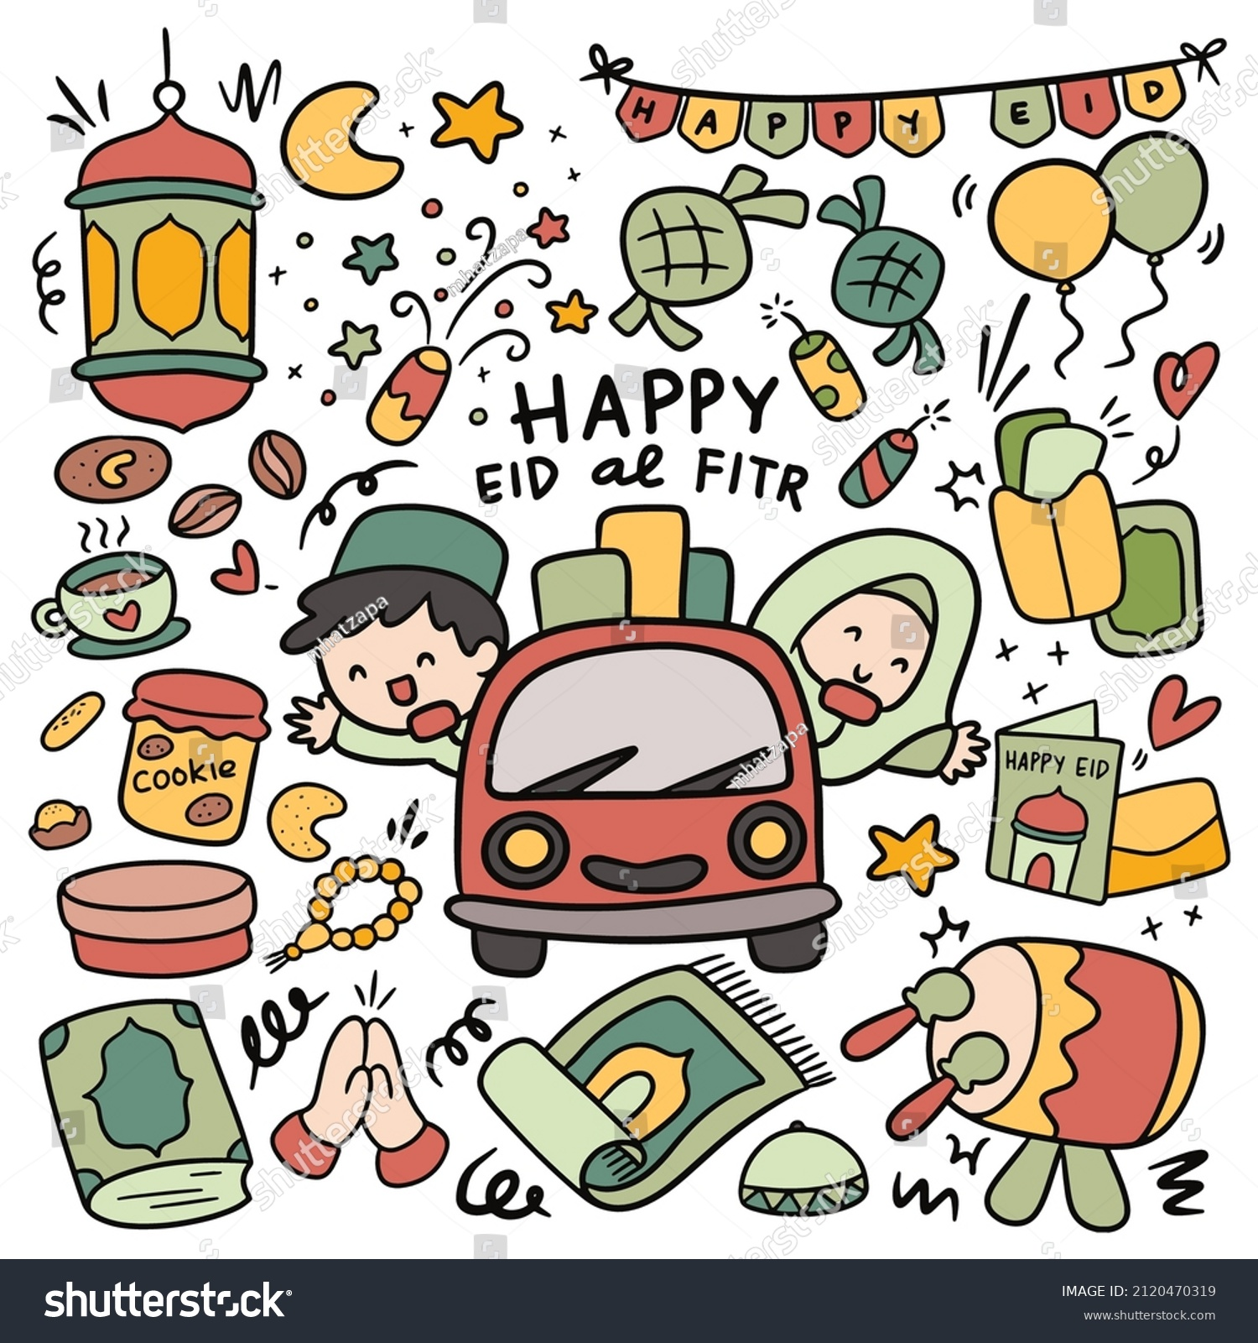

Ramadan is a month of ______________ in the Middle East. During Ramadan, we make _____________ of food like maqlooba to bring our families together. We_____________ our guests by saying “Asalamu Alaikum!”. At the end of Ramadan, we have a ______________ to honor our fasts called Eid al Fitr. We have _____________ during Eid like getting money from our grandparents, wearing nice clothes, playing games and eating maamoul.

