Name: ____________________
Date: _____________________

Social Studies Graded Packet
Unit 2: Lessons 5-7: History and Learning from the Past

What is History?
- History is what happened in the past, including key events.
- A key event is when something important happens in the past. It can be like the birth or death of someone. It can also be a war starting or ending. It can also be a discovery.
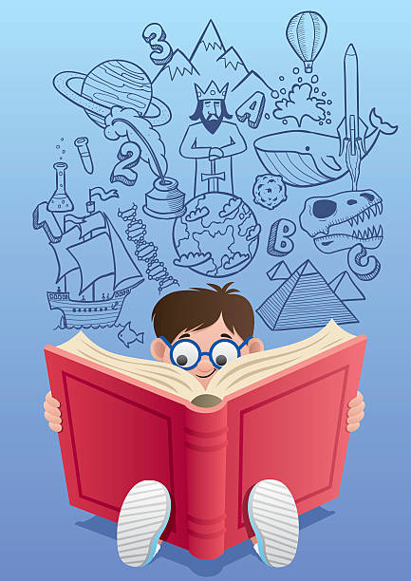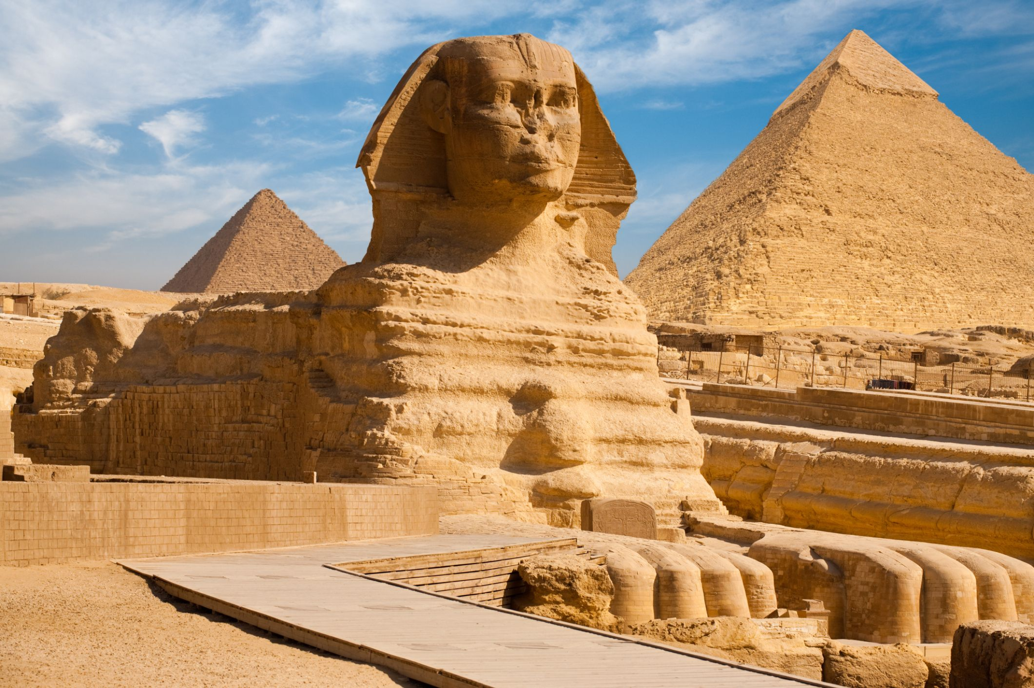
This is a building from the past in Egypt

- History can tell us how people lived in the past.
- History can show us how the world has changed from the past until today.
- History affects our world. Like discovering oil in the Middle East changed the way the Middle East looks and works today.

What is history?
- What happened in the present
- What happened in the past
- What happened in the future

What is an example of a key event?
- Discovery of oil in the Middle East
- A basketball team won a game

T/F: ___________ History tells us how people lived in the present.
___________ History does not affect our world.
___________ Learning about the past gives us a better understanding of our world.

How do we learn about history?
- Reading books can give us details about the past
- Internet
- Asking older family members
- Going to museums and looking at artifacts
- Art can teach us about our traditions and culture from the past.
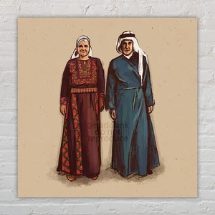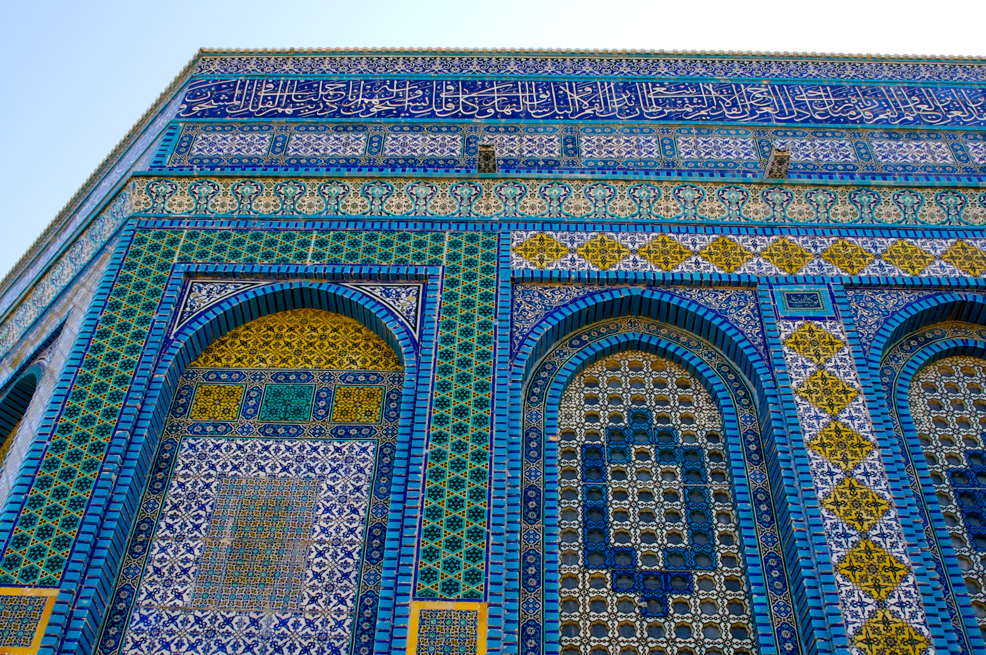
Circle the ways we can learn about the past.
- Reading a history book
- Playing a video game
- Studying art, and objects in museums
- Listening to your grandparents’ stories about the past
What is a timeline?
- A timeline records events that happened a long time ago in the past in order.
- Timelines help us study and learn about the past
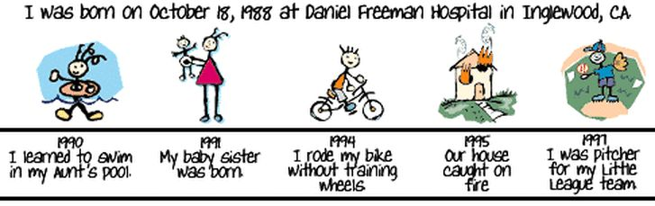
Travel and Schools
- In the past, people traveled using horses and camels.
- Today we use cars, buses, planes, trains and boats.
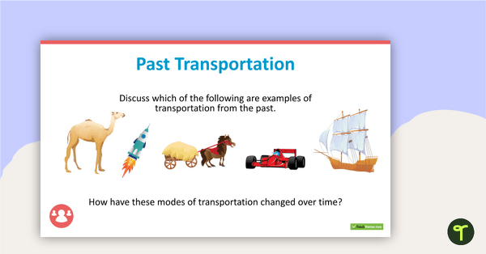
- Schools in the past used to be only one classroom. Children of different ages would learn together.
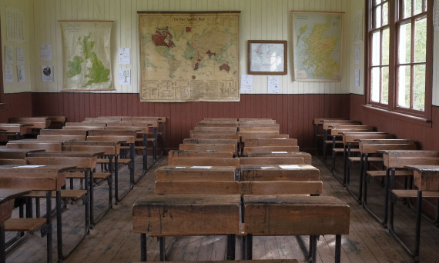
640 × 426
- How do we learn about the past?
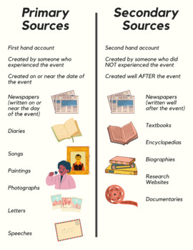
- A source is something we can study to learn about the past.
- An artifact is an object made by someone from the past.

- Letters, maps, and maps are _________________ sources.
- Textbooks, school projects and books are __________________ sources.
- Fact Versus Opinion
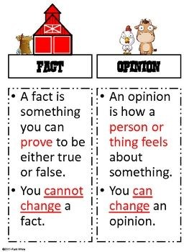
Which is a fact and which is an opinion?
- Palestine is in the Middle East. _______________
- I love Palestinian culture because it has yummy food and beautiful art. _________________
- Oil being discovered in the Middle East was a key event. ______________
- I think that Eid al Fitr is the best holiday. _________________
- My History
Draw a picture of something important from your life
________________________________________________________________________________________________________________________________________________________________________________________________________________________________________________________________________________________________________________________________________________________________________________________________________________________________________________________________________________________________________________________________________________________________________________________________________________________________________________________________

