Cultural Diffusion:
Cultural Diffusion and Change
All cultures change over time. That is, their cultural traits change. Traits from one culture can spread to nearby cultures and influence them. The spread of cultural traits from one culture to another is called cultural diffusion. It can involve the spread of material culture, or objects. It can also mean the spread of ideas and values. Cultural traits often have spread through trade, migration, and war.
As traders move among different cultures, they carry with them features of their own culture, such as food or religious beliefs. Traders expose people to these new traits. In a similar way, migrants bring cultural traditions with them to their new homelands. For example, immigrants to the United States have brought with them foods, languages, music, ideas, and other cultural traits. Some of these traits have become part of American culture. War spreads culture traits as well. Just like traders, soldiers take their culture with them to new lands.
There are many positive effects of cultural diffusion. Useful ideas, products, or ways of doing things can move from one culture to another. The changes can improve people’s lives. Exposure to ideas of equality and the chance to see women in nontraditional roles in entertainment media, for example, have helped improve the lives of women in some societies.
Yet there may also be negative effects of cultural diffusion. If customs change too quickly, people may feel that their culture is threatened. Some people today worry that rapid communication is creating a new global culture that threatens diversity. These people fear that the things that make people and cultures unique and interesting might disappear.
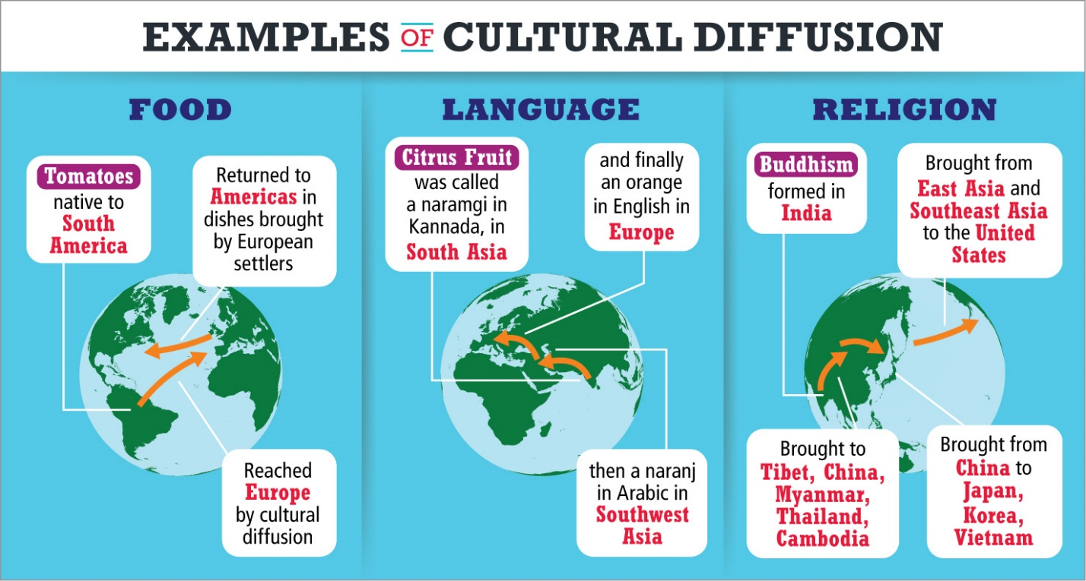
Analyze Diagrams The movements of foods, words, and religions are all examples of cultural diffusion.
- Apply Concepts What other example of cultural diffusion can you think of?
Notebook
Image long description
Three examples of cultural diffusion are given: food, language, and religion. For each example, a drawing of a globe shows a different part of the world, and arrows indicate movement.
- For food: Tomatoes, which are native to South America, reach Europe by cultural diffusion, then are returned to the Americas in dishes brought by European settlers.
- For language: Citrus fruit was called a naramgi in Kannada, in South Asia. Then it was called a naranji in Arabic in Southwest Asia. And finally it was called an orange in English in Europe.
- For religion: Buddhism formed in India. It was brought to Tibet, China, Myanmar, Thailand, and Cambodia. From China it was brought to Japan, Korea, and Vietnam. From East Asia and Southeast Asia it was brought to the United States.
- Reading Check Identify Main Ideas Why do cultures change?

