Science and Technology
Science and technology are important parts of culture. Science is the process of acquiring knowledge of the natural world through experiments. Technology is the way in which people use tools and machines. New technologies may rely on knowledge gained from science.
Technology can help spread culture, and improved communication has sped cultural change. The Internet, for example, has made instant communication common. Today, Americans can find out instantly what people in places such as Peru, India, or Japan are wearing, eating, or creating. If we like some of these traits, we may borrow them and make them a part of our culture. Traits of American culture have spread to other lands through American movies and television shows.
Many advances in science and technology have transformed people’s lives and raised their standard of living. Standard of living is the level of comfort enjoyed by a person or a society. Modern technology allows people to make more goods with less effort. Modern medicine can treat and prevent illnesses that were fatal in the past. More children attend school than in the past, and fewer people go hungry. Our homes are full of gadgets that make life easier. Our workplaces are safer. People live better and longer lives now than 100 years ago.
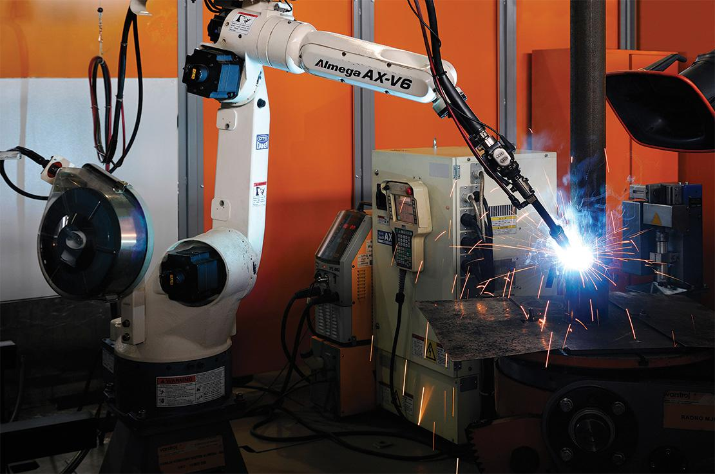
Analyze Images Robots like this one are now used in manufacturing.
- Draw Conclusions How might these machines affect standards of living?
Notebook
- Reading Check Draw Conclusions How do you think technology might change culture in the future?

