
7^{h} Grade English
2nd Semester 3rd Quarter Final
Study Guide Sheet

Literature
1. Urban Farming Is Growing a Greener Future (pg. 332)
Genre: Photo Gallery
Author: Hillary Schwei

BACKGROUND
The year 2008 marked the first time that more people on Earth lived in cities than in rural areas. One significant consequence of this turning point is that most people no longer live in the agricultural areas that provide them with food.

1. Comprehension Questions (Found on page 337)
WHAT THE PHOTO SHOWS and HOW THE PHOTO RELATES TO THE TEXT Graph

2. Concept Vocabulary and Word Study (Worksheet in Packet, Text Book pg. 368):
2a. Vocabulary: Rural Agriculture Localizing

3. Grammar: Sentence Structure

Sentence Structures In English, there are four types of sentence structure.

• A simple sentence consists of one independent clause—a group of words that has a subject and a
verb and that can stand by itself as a complete thought.
EXAMPLE: My cousin Tyrone and I are close friends.

• A compound sentence consists of two or more independent clauses linked by a conjunction such as
and, but, or or.
EXAMPLE: I like spending time with Tyrone, and we like doing the same things.

• A complex sentence contains one independent clause and one or more dependent clauses. A
dependent clause is a group of words that has a subject and verb but is not a complete thought.
EXAMPLE: Tyrone lives in my neighborhood, although his house is not very close to mine.

• A compound-complex sentence consists of two or more independent clauses and one or more
dependent clauses.
EXAMPLE: We often go to the park, and, if we have all afternoon, we might go to a movie.

2. from Silent Spring (pg. 363)
Genre: Descriptive Nonfiction
Author: Rachel Carson

BACKGROUND
Pesticides are chemical compounds designed to destroy crop-eating insects. Pesticides can be deadly to many species—including humans—in addition to the insects and other pests they are intended to kill. In 1962, Rachel Carson published Silent Spring, which revealed to the public the dangers of DDT, a pesticide in wide use at the time. The awareness raised by Silent Spring eventually led the United States to ban DDT entirely in 1972. This excerpt comes from the opening pages of the book.

1. Comprehension Check Questions in textbook. (Questions found on page 365)
1. What are two animals that attracted visitors to the town?
2. What happened to the animals and the people in the town?
3. What fell on the roofs, lawns, fields, and streams?

2. Concept Vocabulary and Word Study (Worksheets in Packet and Text Book pg. 368):

2a. Vocabulary: 1. blight 2. Puzzled 3. Stillness 4. Maladies 5. Stricken 6. Deserted
2b. Word Study: Anglo-Saxon Suffix: -ness
The Anglo-Saxon suffix -ness means “the condition or quality of being.” It usually indicates that the word in which it appears is a noun.

3. Analyze Craft and Structure: Author’s Word Choice: Imagery (pg. 367)

Imagery is language that includes images—words or phrases that appeal to one or more of the five
senses. A writer uses imagery to bring his or her writing to life with vivid descriptions of how the subjects look, sound, feel, taste, or smell. A writer’s word choice, or the specific words, phrases, and expressions he or she uses, contributes to memorable imagery.

• The phrase “sweet, slippery mango slices” appeals to the senses of taste and touch.
• The phrase “glaring lights and wailing sirens” appeals to the senses of sight and hearing.

4. Grammar: Verb Mood- The Subjunctive (Worksheet in Packet and textbook pg. 369)

Speakers and writers convey their attitudes toward the actions expressed by verbs by using different
moods. The indicative mood is used for statements of fact. By contrast, the subjunctive mood expresses one of the following:

• a wish or desire
• a condition that is highly unlikely or contrary to fact
• a request or demand for action

Subjunctive verbs are often found in clauses that begin with if, as if, as though, or that. This chart shows situations in which a speaker or writer would use the subjunctive mood.

3. He-y Come on Ou-t (Text book pg. 380)
Genre: Short Story
Author: Shinichi Hoshi

BACKGROUND
Each year, the world generates billions of tons of waste. Much of that waste is disposed of in landfills, where heavy metals and toxins can leak into the environment. The oceans have also been polluted with vast amounts of trash because, for many decades, it was common practice
to get rid of chemicals, garbage, and even nuclear waste by dumping them directly into the ocean.

1. Comprehension Check Questions in Text book. (Questions found on page 383)
1. What does the young man shout into the hole at the beginning of the story?
2. Why do the villagers tell the young man not to throw the pebble into the hole?
3. How is the hole used?
4. What does the workman hear at the end of the story?

2. Concept Vocabulary and Word Study (Worksheets in Packet and Text Book pg. 384):

2a. Vocabulary: 1. Consequences 2. Resolved 3. Disposal

2b. Word Study Latin Root: -sequ- The Latin root -sequ- means “to follow.” In the story, the author
writes that people disliked thinking of the consequences of dumping things in the hole because
people did not want.

3. Analyze Craft and Structure: Literary Elements:

Irony is a literary element that involves a contradiction or contrast of some kind. In literature, authors often
use irony to entertain and to convey a theme, or message. There are several types of irony.

Dramatic Irony a contrast between what the reader knows and what the character knows

Situational Irony: a contrast between what a reader or character expects and what actually
happens

Verbal Irony a contrast between what a narrator or character says and what he or she means

4. Grammar: Punctuation Marks

Writers use punctuation marks to make their meaning clearer. Each punctuation mark serves a specific purpose, as shown in this chart.
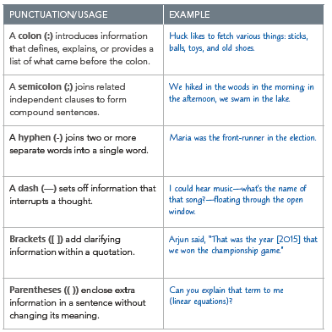

3. Poetry Collection (Text book pg. 380)
Genre: Poetry Collection
Author: Linda Hogan, Emily Dickinson, and Paul Laurence Dunbar

BACKGROUND
A curriculum vitae, or CV, is a short account of a person’s background, skills, education, and work experience. In the United States, a CV is similar to a resume. Resumes are usually no longer than one page. Many employers require these documents for job applications and look at them carefully to decide who they should hire.

1. Comprehension Check Questions in Textbook. (Questions found on page 407)
Turtle Watchers
1. What are the “hungry watchers” doing?
2. What happens years later?

“Nature is What We See—"
1. What does the first stanza say nature is?
2. What does the second stanza say nature is?
3. What does the third stanza say nature is?

The Sparrow SPARROW
1. What does the speaker do in response to the bird beside his or her window?
2. According to the speaker, how do we “plod on”?

2. Concept Vocabulary and Word Study (Worksheets in Packet and Text Book pg. 408):

2a. Vocabulary: 1. Ancestors 2. Wisdom 3. Heed
2b. Word Study: Etymology The etymology, or word origin, of the word ancestors
help you understand and remember its meaning. Ancestors was formed from the Latin prefix ante-,
meaning “before,” and the Latin verb cedere, meaning “go.” Thus, ancestors literally means “those
who have gone before us.”

3. Analyze Craft and Structure: Lyric Poetry (pg. 409)

The Speaker in Lyric Poetry When you read a poem you can “hear” a voice speaking to you. That is the voice of the poem’s speaker. Like the narrator in a story, the speaker in a poem is an imaginary voice created
by the poet.
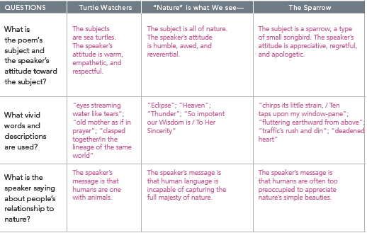

5. Author’s Style Diction and Tone
An author’s word choice, or diction, includes not only the specific words but also the phrases and expressions an author uses. In poetry, a poet’s word choice plays an important role in creating
poetic language, which is specific, imaginative, and rich with emotion. A poet’s use of language helps to develop the tone of a poem, or the poet’s attitude toward his or her subject.

