Study guide
For 7th grade students Mr. Kamel
Note: the most important to you as students is to study on your notebook ,exams and homework .
Topic 5: Solve Problems Using Equations and Inequalities
5-1: Write Two-Step Equations
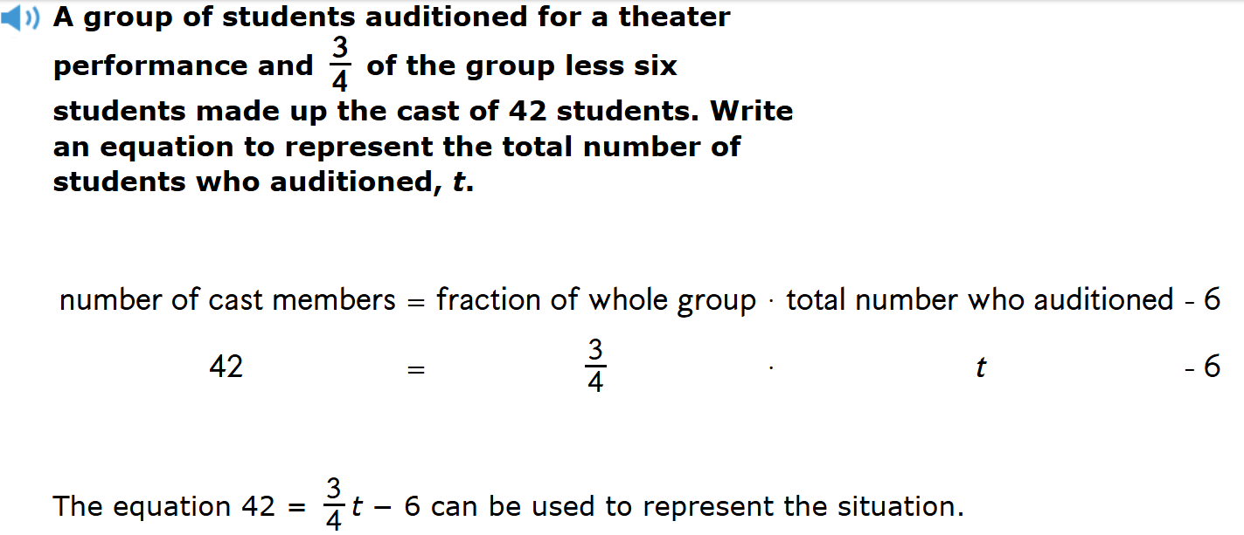
5-2: Solve Two-Step Equations
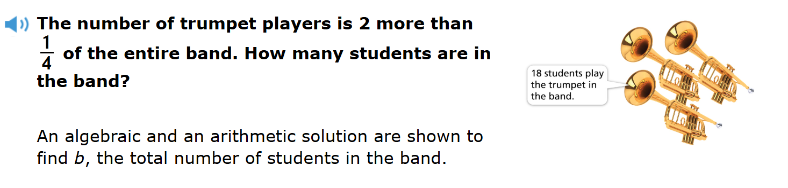
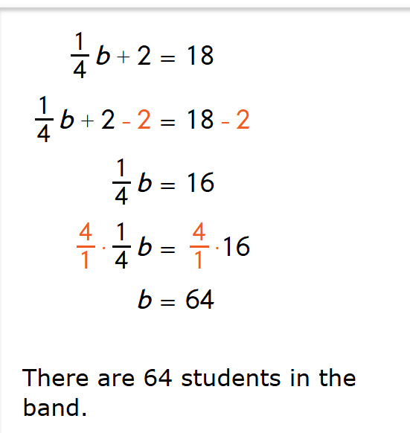
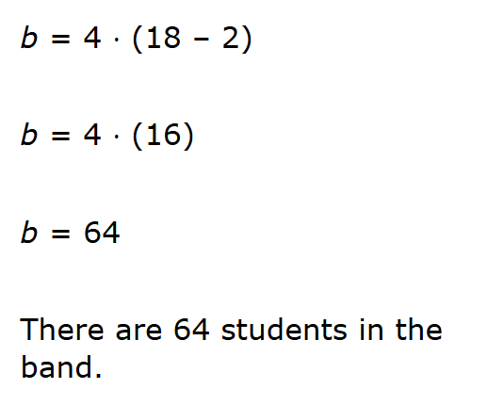
5-3: Solve Equations Using the Distributive Property
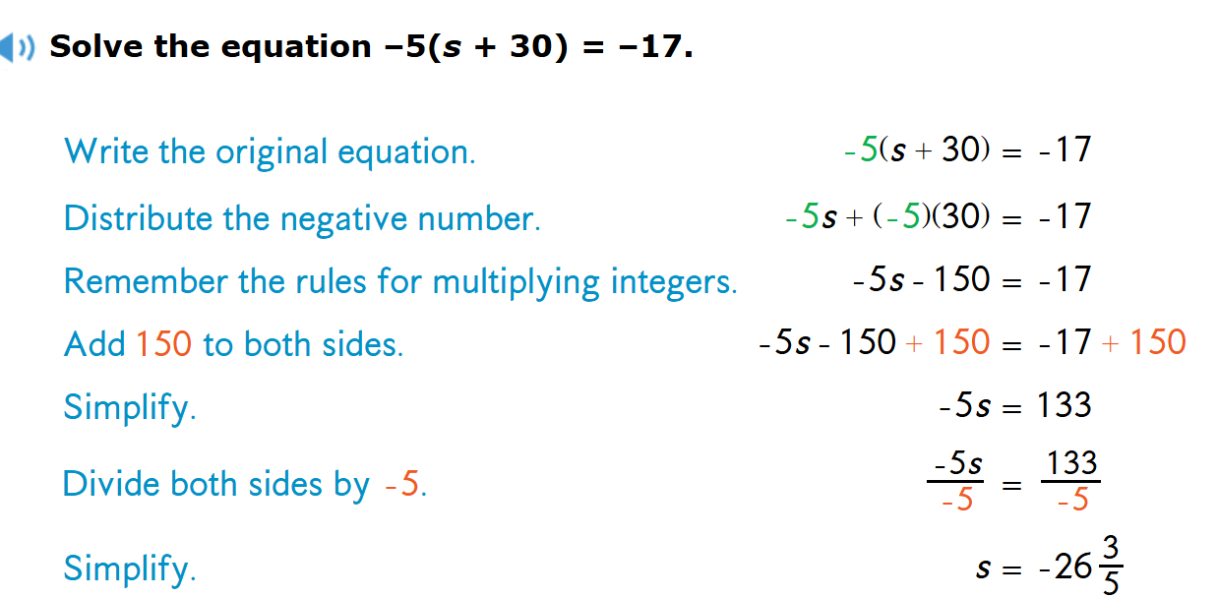
5-4: Solve Inequalities Using Addition or Subtraction
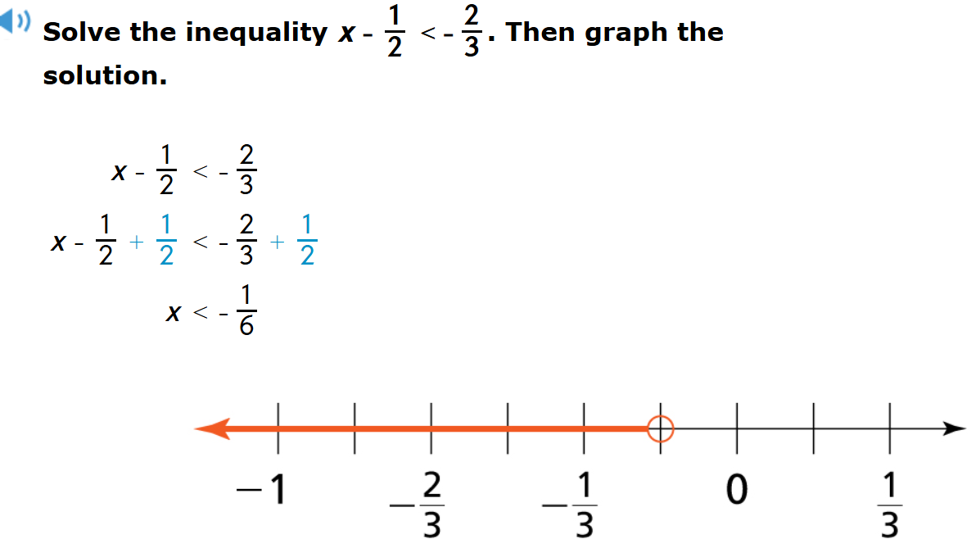

5-5: Solve Inequalities Using Multiplication or Division
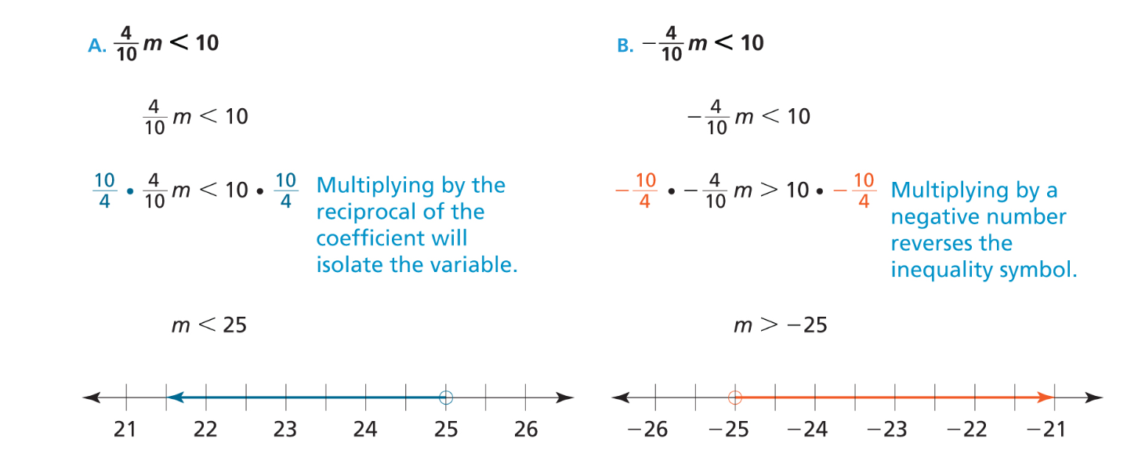
5-6: Solve Two-Step Inequalities
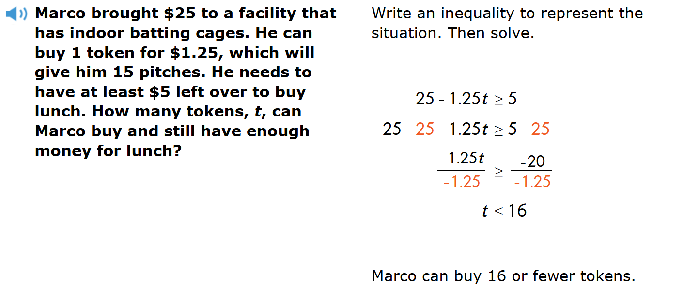
5-7: Solve Multi-Step Inequalities
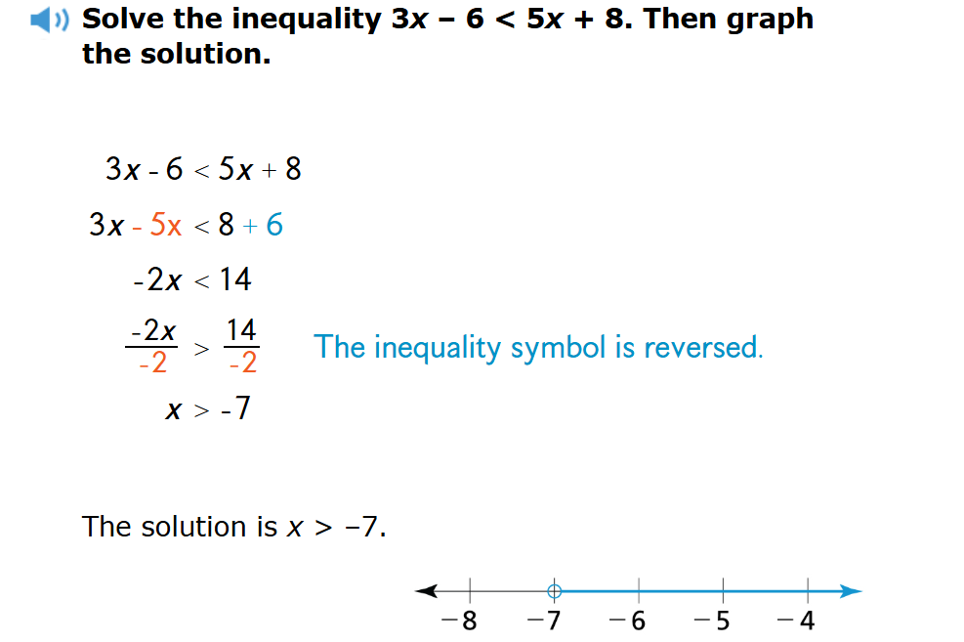
Topic 7: Probability
7-1: Understand Likelihood and Probability
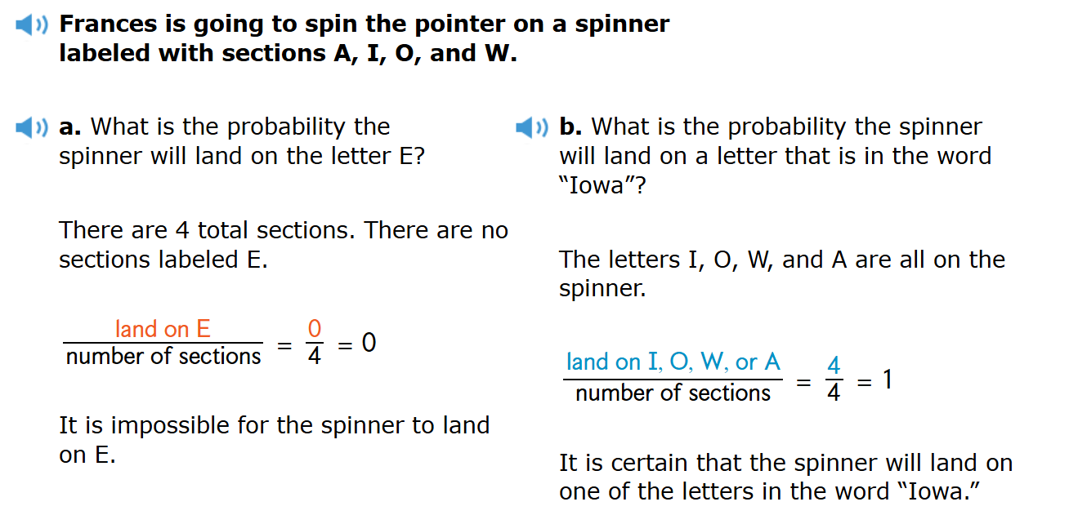
7-3: Understand Experimental Probability
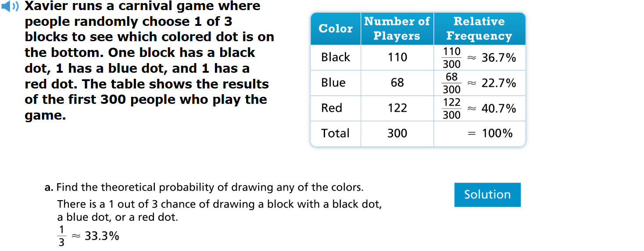
7-5: Determine Outcomes of Compound Events
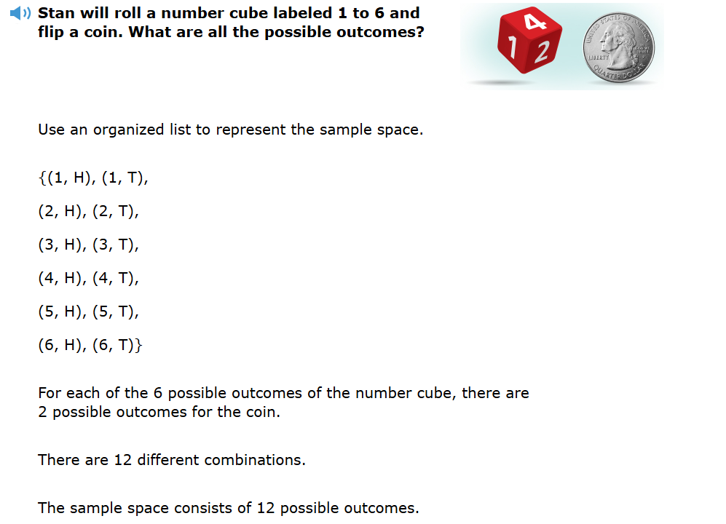
Good luck!

